General City Digital Twin
User Manual
Anderson Wong, Divnoor Chatha
Urban Data Research Centre (urbandatacentre.ca)
School of Cities (schoolofcities.ca)
University of Toronto
16 October 2025

Table of Contents
Table of Contents 1
Introduction 2
Accessing the Dashboard 3
Updating the Graph Database 3
Representation of City Data 5
General Classes and Properties 5
Administrative Areas 6
Address 7
Geospatial Location 8
Census Profiles and Characteristics 9
Toronto Police Service Crime Data 12
OpenStreetMap Tags Mapping 16
Complete Community Walking Distance Indicator 18
Parks 19
Schools 23
Kindergartens 27
Universities 30
Colleges 33
Hospitals 36
Clinics 41
Doctor’s Office 45
Pharmacy 49
Supermarket 53
Greengrocer 57
Restaurant 60
FastFood 62
TransitStop 63
Library 65
Implementation of Library Data in Mapping TTL 76
Library CDT Classes and Properties 77
Representation of Road Data 83
Junction 84
Road 89
RoadLink 90
Integration ofImplementation of ORN Data in Mapping to TTL Generation 102
Custom CDT Classes and Properties 104

Introduction
The City Digital Twin project at the University of Toronto’s Urban Data Research Centre aims to develop a digital twin of the City of Toronto. It builds on existing city data standards such as ISO/IEC 21972:2020, ISO/IEC 5087-1:2024, and ISO/IEC 5087-2:2024, and conforms to Linked Data requirements. The goal of this project is to demonstrate standards-based semantic interoperability of city data. These standard ontologies enable the integration of data from multiple sources, opening up new possibilities for the development of data analysis and visualization tools. Our City Digital Twin is represented as a knowledge graph containing a growing variety of city data (e.g. Canadian Census, Toronto Police Crime Data, City transportation infrastructure, parks, food stores, schools, etc.). Our City Digital Twin also supports a dashboard that can generate data visualizations using the city data from the graph database.
Our City Digital Twin, in general, is the ontologies and standards being used to represent city data are city independent. Therefore, the CDT can be applied to any city with modification.

Accessing the Dashboard
The dashboard can be downloaded from GitHub (https://github.com/csse-uoft/city-digital-twin/tree/main) and run locally. You can run it locally on your computer by completing the following steps:
- Download the code for the City Digital Twin dashboard from our GitHub (https://github.com/csse-uoft/city-digital-twin/tree/main). If you downloaded the code as a .zip file, unzip the file before proceeding to the next step.
- Create a file named “.env” inside the backend folder. The content of this file should contain the following text: ENDPOINT_URL=http://ec2-3-97-59-180.ca-central-1.compute.amazonaws.com:7200/repositories/CityDigitalTwin
- Create a file named “.env” inside the frontend folder. The content of this file should contain the following text: REACT_APP_API_URL=http://localhost:3000
- Run the provided script to automatically install dependencies and start the backend and frontend.
  - For Windows, run the run_windowns.bat script
  - For Mac OS, run the run_shell.sh script
- Once the above steps are completed, the dashboard should be up and running at a localhost address specified in the second Command Prompt window. You can enter this localhost address into a web browser to access the dashboard.

Updating the Graph Database
The graph database for the City Digital Twin project can be accessed here: http://ec2-3-97-59-180.ca-central-1.compute.amazonaws.com:7200/. To update the contents of the graph database, please refer to the steps below as a guide and more detailed information about how to use SPARQL to update graphs along with examples can be found here: https://docs.progress.com/bundle/marklogic-server-develop-with-semantic-graphs-11/page/topics/sparql-update.html. Official SPARQL Update documentation can also be found here: https://www.w3.org/TR/sparql12-update/.
- If triples need to be removed from the graph database:
  - If an entire graph needs to be deleted, you can run a “drop graph” query in SPARQL to remove the specified graph: DROP GRAPH <insert_graph_IRI>
  - If specific triples need to be deleted from the graph database:
    - You can run a “delete data” query if you are deleting individual triples explicitly or:
    - A “delete where” query if you are deleting patterns of triples
- If triples need to be added to the graph database:
  - If an entire RDF file (e.g. a TTL or OWL file) needs to be uploaded to the graph database, you can upload and import the file in GraphDB Workbench using its user interface:
    - Click on the “Import” button on the left sidebar in GraphDB Workbench
    - Click on “Upload RDF files” button and upload your RDF file(s)
    - After the file(s) have been uploaded, click on the “Import” button next to the uploaded file and a popup window will appear
    - It is highly recommended that you specify the name of the target graph by clicking on “Named graph” under the “Target graphs” section and entering a name for the graph in the textbox. Typically, graphs in the City Digital Twin are named “http://example.com/insert_file_name”.
      - You can query for a list of named graphs using the following SPARQL query:
SELECT DISTINCT ?g
WHERE {
GRAPH ?g { ?s ?p ?o }
}
    - Click on the “Import” button in the bottom right corner of the popup window when you are ready to import the data
    - An “Imported successfully” message should show if the update was successful
  - If specific triples need to be added to the graph database:
    - You can run a “insert data” query if you are adding explicitly defined triples or:
    - A “insert where” query if you are adding patterns of triples
Data in the graph database can also be replaced using a “delete and insert where” query, and an example of replacing a property with a different property can be found below:
DELETE {
?s <http://example.org/old#property> ?o .
}
INSERT {
?s <http://example.org/new#property> ?o .
}
WHERE {
?s <http://example.org/old#property> ?o .
}

Representation of City Data
The following sections will provide an overview of how the city data in the graph database is ontologically represented.
The following is a list of namespace prefixes:
- 5087: https://standards.iso.org/iso-iec/5087/-2/ed-1/en/ontology/City/
- cdt: http://ontology.eil.utoronto.ca/CDT#
- cacensus: http://ontology.eil.utoronto.ca/tove/cacensus#
- census: http://ontology.eil.utoronto.ca/tove/census#
- code: https://standards.iso.org/iso-iec/5087/-2/ed-1/en/ontology/Code/
- contact: https://standards.iso.org/iso-iec/5087/-2/ed-1/en/ontology/Contact/
- crime: http://ontology.eil.utoronto.ca/CKGN/Crime#
- foaf: http://xmlns.com/foaf/0.1/
- gcie: http://ontology.eil.utoronto.ca/GCI/Education/GCI-Education.owl#
- gcih: http://ontology.eil.utoronto.ca/GCI/Health/GCI-Health.owl#
- gcir: http://ontology.eil.utoronto.ca/GCI/Recreation/GCIRecreation.owl#
- genprop: https://standards.iso.org/iso-iec/5087/-1/ed-1/en/ontology/GenericProperties/
- geo: http://www.opengis.net/ont/geosparql#
- geof: http://www.opengis.net/def/function/geosparql/
- iso21972: http://ontology.eil.utoronto.ca/ISO21972/iso21972#
- iso50871: http://ontology.eil.utoronto.ca/5087/1/SpatialLoc/
- iso5087m: http://ontology.eil.utoronto.ca/5087/1/Mereology/
- loc: https://standards.iso.org/iso-iec/5087/-1/ed-1/en/ontology/SpatialLoc/
- org: http://www.w3.org/ns/org#
- org_city: https://standards.iso.org/iso-iec/5087/-2/ed-1/en/ontology/Organization/
- rdf: http://www.w3.org/1999/02/22-rdf-syntax-ns#
- rdfs: http://www.w3.org/2000/01/rdf-schema#
- sc: http://schema.org/
- time: http://www.w3.org/2006/time#
- toronto: http://ontology.eil.utoronto.ca/Toronto/Toronto#
- xsd: http://www.w3.org/2001/XMLSchema#

General Classes and Properties
The mappings below are based upon existing ontologies where possible. In some cases, extensions are required to capture domain concepts. These extensions are captured in the City Digital Twin ontology (prefixed “cdt”). Topic-specific classes and properties are introduced in the appropriate section (e.g., cdt:Hospital organization is introduced in the Hospital data section). In some cases, it is useful to introduce more generic classes and properties (e.g. to extend existing ontologies ). These general classes and properties may be used and extended throughout multiple patterns/data mappings and are introduced here for convenience.
(please list and formalize any generic classes and properties here for clarity and to avoid duplication across patterns)
- cdt:Site
- i72:Unit_of_measure: the following individuals are referenced in the CDT as units of measure:
  - i72:metre
  - i72:square_metre
  - i72:population_ratio_unit
  - i72:population_cardinality_unit
  - i72:year
  - cacensus:percentage
  - cacensus:CAD (i.e., Canadian Dollar)
  - cacensus:population_per_square_km
  - cacensus:persons_per_family
  - cacensus:persons_per_household
  - cacensus:rooms_per_dwelling
  - cacensus:week
  - cacensus:square_kilometre
  - crime:crime_per_100k (i.e., number of crimes for every 100,000 people)

Class | Property | Value Restriction

Administrative Areas
Administrative areas are geographic regions that are defined for governance and administrative purposes. Examples include areas like neighborhoods or city wards as seen in the below diagram and are expressed as a subclass of the CityAdministrativeArea class from ISO 5087-2. These administrative areas also have properties such as ”hasNeighborhood” or ”inWard” to describe the relationships between each other. These properties are useful for quickly finding, for example, a list of neighborhoods that can be found inside a given ward.
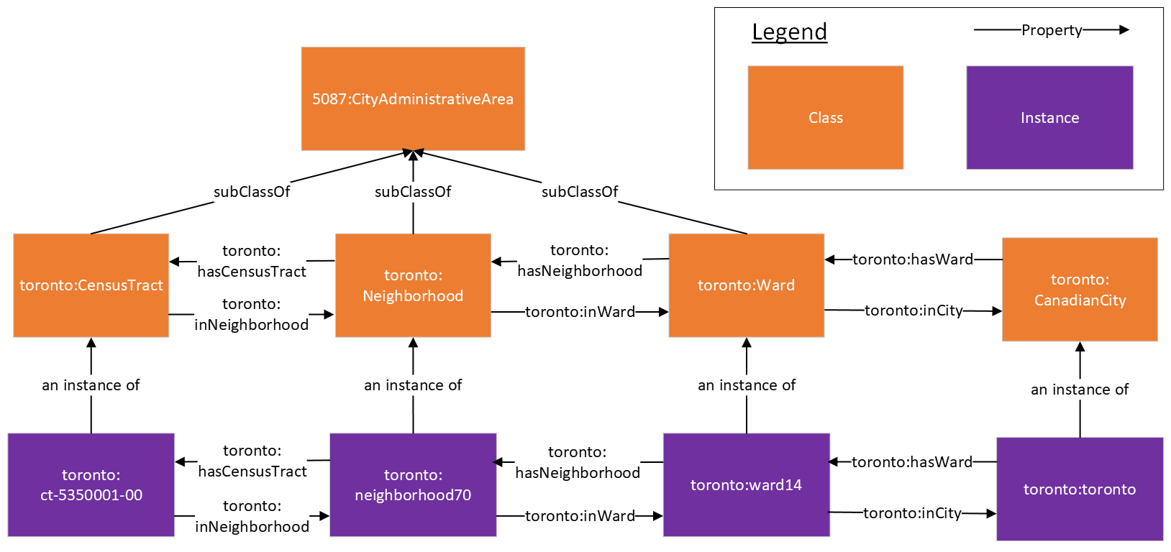
An example SPARQL query for finding a list of neighborhoods in ward 1 (Etobicoke North) can be found below:

PREFIX toronto: <http://ontology.eil.utoronto.ca/Toronto/Toronto#>
SELECT ?neighborhood
WHERE{
toronto:ward1 toronto:hasNeighborhood ?neighborhood
}

Address
The address of an entity is represented using the Address representation from the Contact pattern from ISO 5087-2 where an entity is linked to an Address instance using the “hasAddress” property. This Address instance is then linked to individual components of an address using properties such as hasStreetNumber, hasStreet, hasPostalCode, etc.

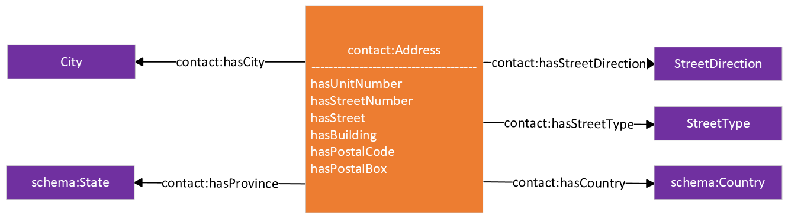

Geospatial Location
The geospatial location of an entity is represented using the Location pattern from ISO 5087-1 where an entity is linked to a Location class instance using the “hasLocation” property. The location instance is then linked to the WKT polygon coordinates using the “asWKT” property.

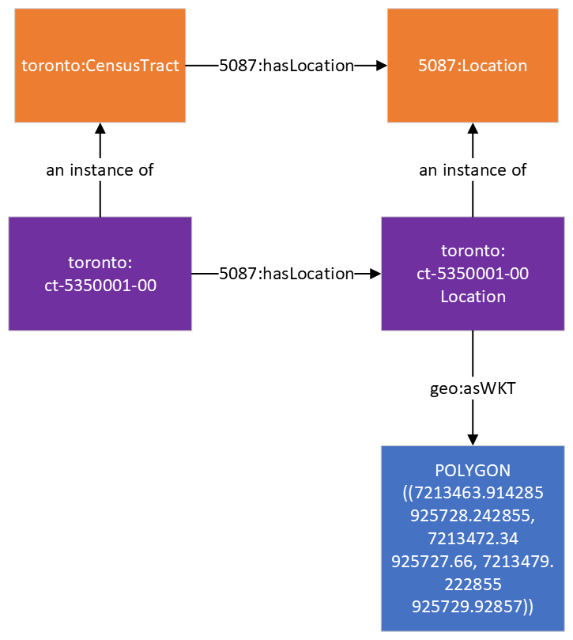

Census Profiles and Characteristics
Census data for geographic areas are organized as datasets called census profiles. Census profiles contain a collection of individual census characteristics, which are a subclass of the Quantity class from ISO/IEC 21972 and linked using the hasCharacteristic property. Each characteristic also has a class that is used to represent it, and this class is also a subclass of the Characteristic class. Subclasses of Characteristic may also be subclasses of the Parameter, Statistic, or Indicator class from ISO/IEC 21972 wherever appropriate. For example, the 0-14Years2016 class in the diagram above represents the characteristic for the number of people who were between the ages 0 to 14 during the 2016 Canadian Census and is also a subclass of 21972:Cardinality which is a subclass of 21972:Parameter. An instance of this class represents the characteristic for a given geographic area. For example, the “ct-5350001-000-14Years2016” instance in the diagram below represents the characteristic for the number of people in the census tract 5350001.00 who were between the ages 0 to 14 in 2016. These characteristic instances are linked to an instance of the Measure class from ISO 21972 using the ”value” property and this measure instance is linked to the value of the characteristic using the ”numerical_value” property.
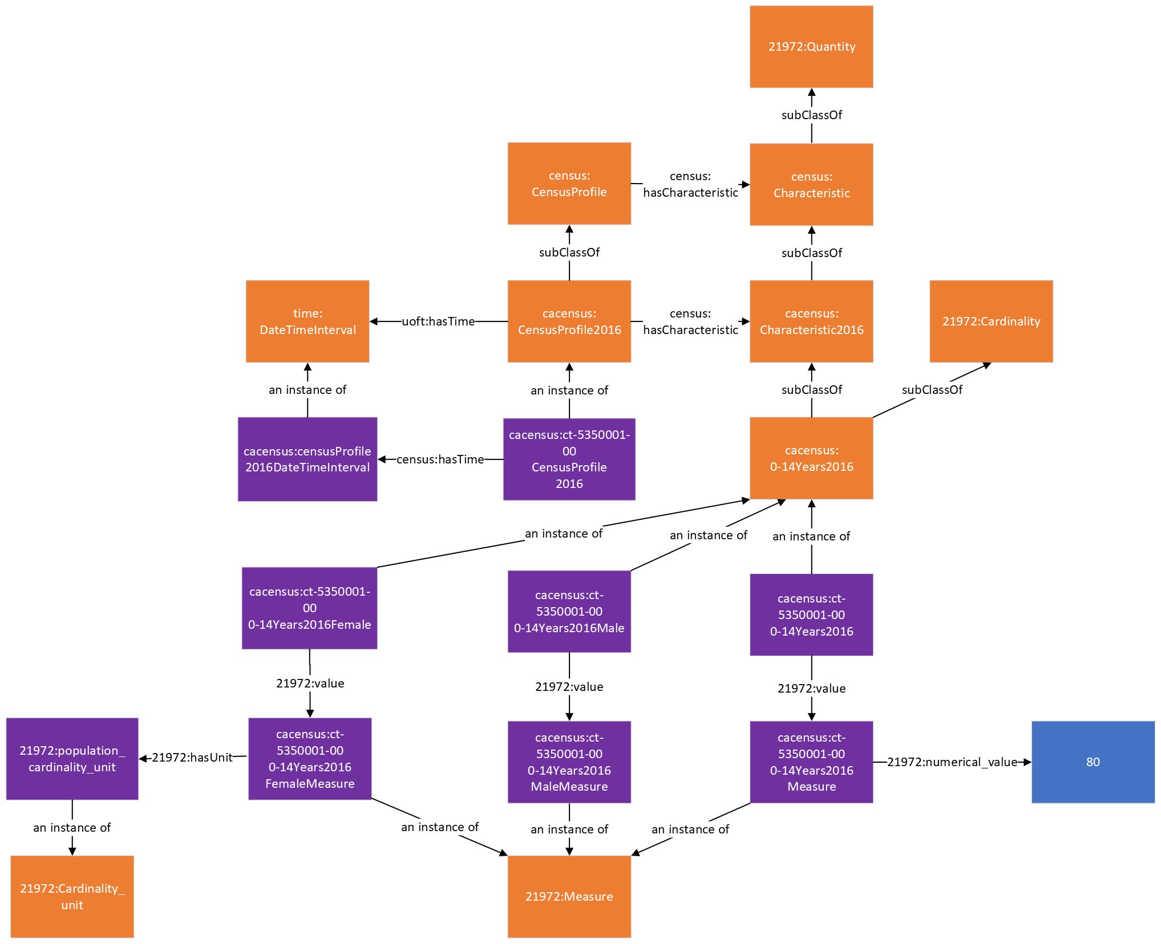
Class | Property | Value Restriction
census:CensusProfile | census:hasCharacteristic | census:Characteristic
 | census:hasTime | time:DateTimeInterval
census:Characteristic | subClassOf | 21972:Quantity
 | 21972:value | 21972:Measure
 | census:hasLocation | 5087:JurisdictionalArea
 | census:hasPart | census:Characteristic

A more in-depth explanation of the Canadian Census ontology can be found in our paper titled “Semantically Interoperable Census Data: Unlocking the Semantics of Census Data Using Ontologies and Linked Data” which can be found here: https://ijpds.org/article/view/2378. More information and data from the 2016 Canadian Census can be found here: https://www12.statcan.gc.ca/census-recensement/2016/index-eng.cfm.
The following table describes the mapping of the 2016 Canadian Census data for the City of Toronto onto the Canadian Census ontology.
 | Subject | Property | Object
Census Profile (the entire dataset for a given jurisdictional area) | cacensus: {jurisdictional area}CensusProfile2016 | rdf:type | census:CensusProfile
 | toronto:{jurisdictional area} | census:hasCensusProfile | cacensus: {jurisdictional area}CensusProfile
 | cacensus: {jurisdictional area}CensusProfile2016 | census:hasLocation | toronto:{jurisdictional area}
 | cacensus: {jurisdictional area}CensusProfile2016 | census:hasTime | cacensus: censusProfile2016DateTimeInterval
 | cacensus: {jurisdictional area}CensusProfile2016 | rdf:type | time:DateTimeInterval
Census Characteristic (referred to as just “Characteristics” in the CSV datasets) | cacensus: {jurisdictional area}{characteristic name} | rdf:type | cacensus:{appropriate subclass of Characteristic2016} (e.g., 0-14Years2016 for the “0 to 14 years” characteristic as seen in the 2016 census datasets)
 | cacensus:{appropriate subclass of Characteristic2016} | rdfs:subClassOf | 21972:{appropriate subclass of Parameter or Statistic}
 | cacensus: {jurisdictional area}{characteristic name} | 21972:value | cacensus: {jurisdictional area}{characteristic name}  Measure
 | cacensus: {jurisdictional area}CensusProfile2016 | census:hasCharacteristic | cacensus:{jurisdictional area}{characteristic name}
Value of the characteristic (referred to as “Total”, “Male”, or “Female” in the CSV datasets depending on what the value is referring to) | cacensus: {jurisdictional area}{characteristic name}  Measure | rdf:type | 21972:Measure
 | cacensus: {jurisdictional area}{characteristic name}  Measure | 21972:numerical_value | “{value of the characteristic}”
 | cacensus: {jurisdictional area}{characteristic name}  Measure | 21972:hasUnit | 21972:{appropriate instance of the Unit class}

Toronto Police Service Crime Data
This is a basic ontology for representing neighborhood crime indicators from the Toronto Police Service using the Indicator pattern from ISO/IEC 21972. Data from the TPS is publicly accessible from their open data portal: https://data.torontopolice.on.ca/pages/open-data. An instance of a crime indicator (e.g. AssualtCrime2016 which measures the number of assault crimes that occurred during the year 2016 in a given location) is defined as a subclass of the Indicator class from ISO/IEC 21972. Crime indicators can be linked to their location using the hasLocation property and its corresponding time period using the hasTime property. The value of a crime indicator is defined as an instance of the Measure class from ISO/IEC 21972 and can be linked to its numerical value using the numerical_value property. Additionally, crime indicators can be linked to its population instance using the cardinality_of property from ISO/IEC 21972.
This section provides a brief description of the column labels found in the data spreadsheet published by the Toronto Police Service.
Toronto Police Service Label | Description
HoodName,C,35 | Name of the neighborhood
HoodID,C,3 | The neighborhood number
Assault_20,N,3,0 | Number of assault crime incidents in 2014
Assault_1,N,3,0 | Number of assault crime incidents in 2015
Assault_2,N,3,0 | Number of assault crime incidents in 2016
Assault_3,N,3,0 | Number of assault crime incidents in 2017
Assault_4,N,3,0 | Number of assault crime incidents in 2018
Assault_5,N,3,0 | Number of assault crime incidents in 2019
Assault_6,N,3,0 | Number of assault crime incidents in 2020
Assault_7,N,3,0 | Number of assault crime incidents in 2021
AutoTheft_,N,3,0 | Number of auto theft crime incidents in 2014
AutoThef_1,N,3,0 | Number of auto theft crime incidents in 2015
AutoThef_2,N,3,0 | Number of auto theft crime incidents in 2016
AutoThef_3,N,3,0 | Number of auto theft crime incidents in 2017
AutoThef_4,N,3,0 | Number of auto theft crime incidents in 2018
AutoThef_5,N,3,0 | Number of auto theft crime incidents in 2019
AutoThef_6,N,3,0 | Number of auto theft crime incidents in 2020
AutoThef_7,N,3,0 | Number of auto theft crime incidents in 2021
BreakAndEn,N,3,0 | Number of break and enter crime incidents in 2014
BreakAnd_1,N,3,0 | Number of break and enter crime incidents in 2015
BreakAnd_2,N,3,0 | Number of break and enter crime incidents in 2016
BreakAnd_3,N,3,0 | Number of break and enter crime incidents in 2017
BreakAnd_4,N,3,0 | Number of break and enter crime incidents in 2018
BreakAnd_5,N,3,0 | Number of break and enter crime incidents in 2019
BreakAnd_6,N,3,0 | Number of break and enter crime incidents in 2020
BreakAnd_7,N,3,0 | Number of break and enter crime incidents in 2021
Robbery_20,N,3,0 | Number of robbery crime incidents in 2014
Robbery__1,N,3,0 | Number of robbery crime incidents in 2015
Robbery__2,N,3,0 | Number of robbery crime incidents in 2016
Robbery__3,N,3,0 | Number of robbery crime incidents in 2017
Robbery__4,N,3,0 | Number of robbery crime incidents in 2018
Robbery__5,N,3,0 | Number of robbery crime incidents in 2019
Robbery__6,N,3,0 | Number of robbery crime incidents in 2020
Robbery__7,N,3,0 | Number of robbery crime incidents in 2021
TheftOver_,N,2,0 | Number of thefts over $5000 crime incidents in 2014
TheftOve_1,N,2,0 | Number of thefts over $5000 crime incidents in 2015
TheftOve_2,N,2,0 | Number of thefts over $5000 crime incidents in 2016
TheftOve_3,N,2,0 | Number of thefts over $5000 crime incidents in 2017
TheftOve_4,N,2,0 | Number of thefts over $5000 crime incidents in 2018
TheftOve_5,N,2,0 | Number of thefts over $5000 crime incidents in 2019
TheftOve_6,N,2,0 | Number of thefts over $5000 crime incidents in 2020
TheftOve_7,N,2,0 | Number of thefts over $5000 crime incidents in 2021
Homicide_2,N,1,0 | Number of homicide crime incidents in 2014
Homicide_1,N,1,0 | Number of homicide crime incidents in 2015
Homicide_3,N,1,0 | Number of homicide crime incidents in 2016
Homicide_4,N,1,0 | Number of homicide crime incidents in 2017
Homicide_5,N,1,0 | Number of homicide crime incidents in 2018
Homicide_6,N,1,0 | Number of homicide crime incidents in 2019
Homicide_7,N,1,0 | Number of homicide crime incidents in 2020
Homicide_8,N,1,0 | Number of homicide crime incidents in 2021
Shootings_,N,2,0 | Number of shooting crime incidents in 2014
Shooting_1,N,2,0 | Number of shooting crime incidents in 2015
Shooting_2,N,2,0 | Number of shooting crime incidents in 2016
Shooting_3,N,2,0 | Number of shooting crime incidents in 2017
Shooting_4,N,2,0 | Number of shooting crime incidents in 2018
Shooting_5,N,2,0 | Number of shooting crime incidents in 2019
Shooting_6,N,2,0 | Number of shooting crime incidents in 2020
Shooting_7,N,2,0 | Number of shooting crime incidents in 2021
TheftfromM,N,3,0 | Number of thefts from motor vehicle crime incidents in 2014
Theftfro_1,N,3,0 | Number of thefts from motor vehicle crime incidents in 2015
Theftfro_2,N,3,0 | Number of thefts from motor vehicle crime incidents in 2016
Theftfro_3,N,3,0 | Number of thefts from motor vehicle crime incidents in 2017
Theftfro_4,N,3,0 | Number of thefts from motor vehicle crime incidents in 2018
Theftfro_5,N,3,0 | Number of thefts from motor vehicle crime incidents in 2019
Theftfro_6,N,3,0 | Number of thefts from motor vehicle crime incidents in 2020
Theftfro_7,N,3,0 | Number of thefts from motor vehicle crime incidents in 2021

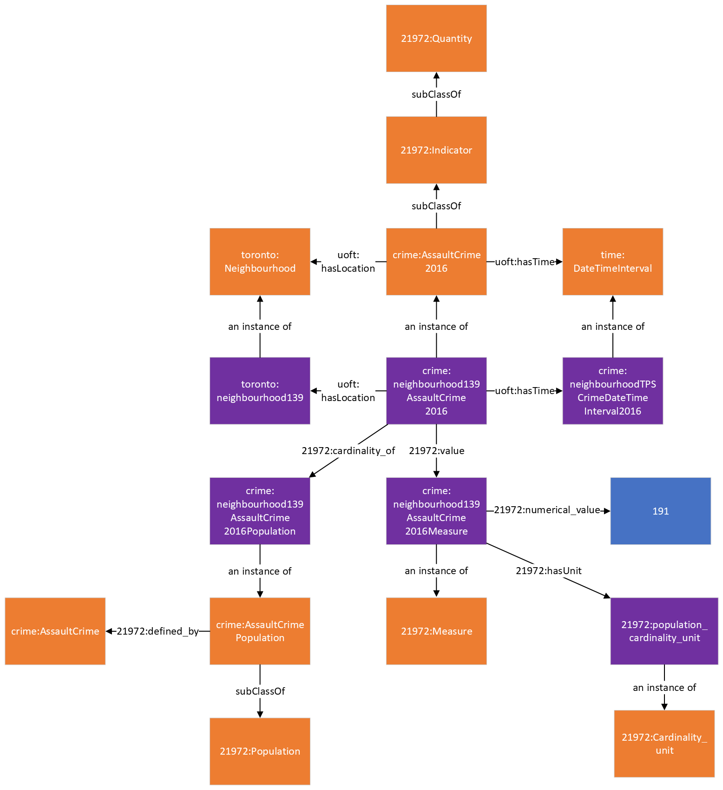

OpenStreetMap Tags Mapping
This section provides a brief summary of how the tags used in OpenStreetMap were mapped into the ontology used in the City Digital Twin. OpenStreetMap data can be exported as a GeoJSON, KML, or GPX file using Overpass Turbo (https://overpass-turbo.eu/). More information about Overpass Turbo can be found on OpenStreetMap’s wiki webpage: https://wiki.openstreetmap.org/wiki/Overpass_turbo.

OpenStreetMap Tag | OpenStreetMap Description | CDT Equivalent
name | The primary name: in general, the most prominent signposted name or the most common name in the local language(s). | genprop:hasName
id | OSM ID is a numerical identifier that is assigned to every element in the OpenStreetMap (OSM) database. | genprop:hasIdentifier
addr:street | The street name that this address is (and any others in this location) grouped by. This street name should match that of a nearby road, track or path. | contact:hasStreet (street name)  contact:hasStreetType (street type)  contact:hasStreetDirection(street direction)
addr:housenumber | The house (or building) number that is included in the address. The number may contain non-digits and if recording multiple house numbers separate them by "," (e.g. "12b,12c"). | contact:hasStreetNumber
addr:postcode | The postal code / zip code that is included in the address. | contact:hasPostalCode
website  contact:website | Specifies the link to the official website for a feature. | cdt:website
surface | The surface key is used to provide additional information about the physical surface of roads/footpaths and some other features, particularly regarding material composition and/or structure. | cdt:surface
opening_hours | Describes when something is open or closed in a standard format | org_city:operatingHours
phone | A telephone number associated with the object. Use +CC XXX XXX XXX format, where CC is a country code. | contact:hasTelephone
email  contact:email | An email address associated with the object | cdt:email
lit | The key lit=* indicates the presence of lighting and can be used on nodes, ways, areas, or relations. | cdt:lit
wheelchair | Indicate if a special place can be used with wheelchairs | cdt:wheelchairAccess
emergency | Used to indicate whether a hospital is equipped to deal with emergencies | cdt:providesService
geometry | "Geometry" in this case means the shape and position of a node or way | geo:asWKT  Note: the geometry is converted to WKT format using Shapely’s to_wkt function if the geometry is not initially in WKT format
dispensing | Whether a pharmacy dispenses prescription drugs or not | cdt:providesService
cuisine | Describes the type of food served at a place | cdt:cuisine
delivery | Indicates whether a restaurant or shop offers delivery of meals or goods | cdt:providesService
takeaway | Indicates whether the restaurant offers meals for pick-up that can be consumed elsewhere | cdt:providesService
smoking | Used to describe whether smoking is allowed or not in a facility or on a property | cdt:smoking
outdoor_seating | To indicate if a feature offers outdoor seating | cdt:outdoorSeating
capacity | Describes the capacity a facility is suitable for | cdt:capacity
drive_through | To indicate whether an amenity offers a drive-through service | cdt:providesService

Complete Community Walking Distance Indicator
This is an ontological representation of a complete community walking distance indicator that shows the percentage of residential buildings in a geographic area that are within a specified distance of a complete community amenity. The diagram below shows the representation of a walking distance indicator for parks where individual instances of an indicator represent the walking distance indicator for a geographic area specified by the “hasLocation” property. This indicator is linked to a measure instance using the “value” property, and the measure instance is linked to the value of the indicator using the “numerical_value” property. In the diagram below, we can see that the numerical value for the “neighborhood1PercentWalkingDistance400Park” indicator is 0.81, which means that 81% of the residential buildings in neighborhood1 are within a 400m distance of a park. This indicator is calculated by dividing the number of residential buildings that are within a 400m distance of a park by the total number of residential buildings in the area and this relationship is represented using the “numerator” and “denominator” properties, respectively. Similar indicators are also available for other Complete Community amenities.

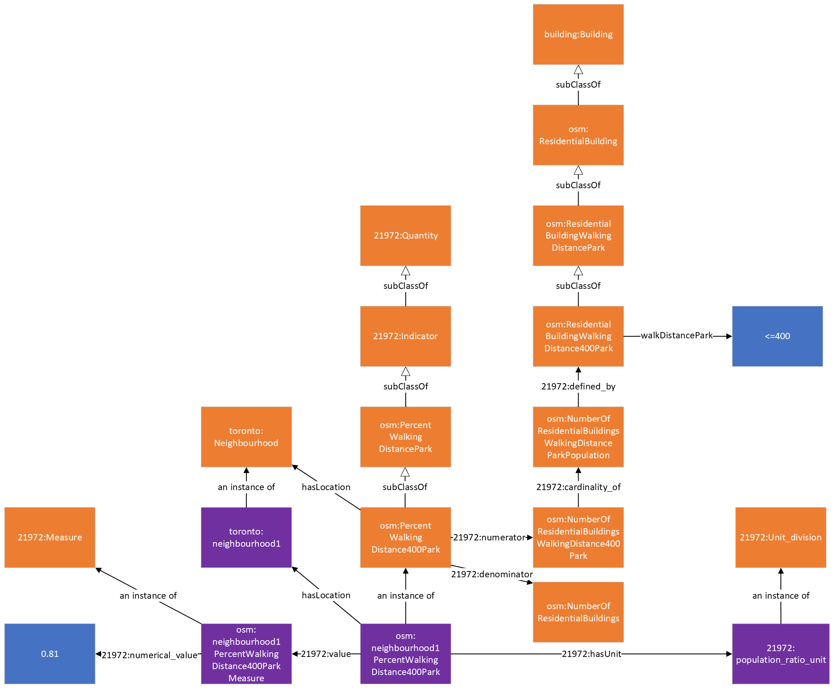

Parks
This is an ontological representation of park data. Parks are represented as instances of the Park class from the Recreation Ontology for Global City Indicators which is also a subclass of an Organization. Parks can have a name which is linked via the hasName property, a unique identifier which is linked via the hasIdentifier property, an address which is linked via the orgAddress property, a telephone number which is linked via the telephone property, services that it provides via the providesService property, a website which is linked via the website property, and a site that represents the physical premise of the park which is linked via the hasSite property. They are also linked to their corresponding NAICS industry category using the hasIndustryType property. The site of a Park can have an indicator for whether the park is lit or not via the lit property, a value describing the physical surface of the park which is linked via the surface property, a hasArea property that links the park to its area instance and area value using the numerical_value property, a Location instance and a set of geospatial coordinates linked using the hasLocation and asWKT property respectively.
The value of a park’s surface area is calculated using the Pyproj (a cartographic projections and coordinate transformations library for Python) and its polygon coordinates. The Shapely Python package is also used to convert the coordinates into a Shapely shape for use with Pyproj functions.
Class | Property | Value
gcir:Park | subClassOf | cdt:Organization
 | genprop:hasName | xsd:string
 | genprop:hasIdentifier | xsd:string
 | cdt:website | xsd:string
 | org_city:orgAddress | contact:Address
 | contact:hasTelephone | contact:PhoneNumber
 | cdt:providesService | cdt:Service
 | org_city:hasIndustyType | org_city:IndustryType
 | org:hasSite | cdt:Site
cdt:Site | subClassOf | org:Site
 | loc:hasLocation | loc:Location
 | cityunits:hasArea | cityunits:Area
 | cdt:lit | xsd:string
 | cdt:surface | xsd:string

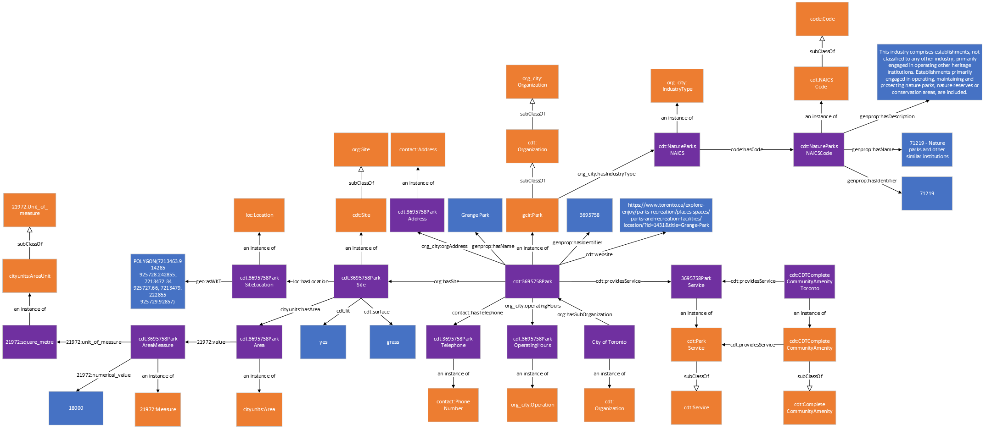
The following table describes the mapping of the OpenStreetMap Park data onto the City Digital Twin ontology.
 | Subject | Property | Object
Park  In a GeoJSON export of OpenStreetMap data each entity is represented as an GeoJSON Feature object in a GeoJSON FeatureCollection array) | cdt: {OSM ID}Park | rdf:type | cdt:Park
opening_hours  Specifies the operating hours using the specialized format specified by OpenStreetMap. The operating hour information here is converted and separated by day of week so it can be mapped according to the Operation class from ISO/IEC 5087. | cdt: {OSM ID}ParkOperatingHours{day of week} | rdf:type | org_city:Operation
 | cdt: {OSM ID}Park | org_city:operatingHours | cdt: {OSM ID}ParkOperatingHours{day of week}
 | cdt: {OSM ID}ParkOperatingHours{day of week} | org_city:hasOpeningTime | “{opening_hours}” (only the opening time for the specified day of week, expressed in xsd.time format)
 | cdt: {OSM ID}ParkOperatingHours{day of week} | org_city:hasClosingTime | “{opening_hours}” (only the closing time for the specified day of week, expressed in xsd.time format)
 | cdt: {OSM ID}ParkOperatingHours{day of week} | recurringevent:hasDayOfWeek | recurringevent:{day of week}
geometry  The geospatial coordinates of the entity in GeoJSON format. The geometries are converted to WKT format in the City Digital Twin. | cdt: {OSM ID} Park | org:hasSite | cdt: {OSM ID} ParkSite
 | cdt: {OSM ID}ParkSite | rdf:type | cdt:Site
 | cdt: {OSM ID}ParkSite | loc:Location | “{geometry}” (the geometry here is converted to WKT format)
id  The OSM ID that serves as the unique identifier, usually written as {OpenStreetMap element}/{numeric ID} in the GeoJSON data (e.g., “relation/14073745”). The ID used in the City Digital Twin only includes the numeric ID for brevity. | cdt: {OSM ID}Park | genprop:hasIdentifier | “{OSM ID}”
name | cdt: {OSM ID}Park | genprop:hasName | “{name}”
website | cdt: {OSM ID}Park | cdt:website | “{website}”
Address  Generally, the address information in OpenStreetMap is represented using multiple properties such as addr:housenumber, addr:street, and addr:postcode. | cdt: {OSM ID}ParkAddress | rdf:type | contact:Address
 | cdt: {OSM ID}Park | org_city:orgAddress | cdt: {OSM ID}ParkAddress
 | cdt: {OSM ID}ParkAddress | contact:hasStreetNumber | “{addr:housenumber}”
 | cdt: {OSM ID}ParkAddress | contact:hasStreet (where appropriate, the information in addr:street is separated and represented in more detail using additional properties from the contact ontology e.g., contact:hasStreetType) | “{addr:street}”
 | cdt: {OSM ID}ParkAddress | contact:hasPostalCode | “{addr:postcode}”
phone  Phone number information in OpenStreetMap is stored using a single property but is separated and mapped in the Digital Twin by using the contact:hasCountryCode, contact:hasAreaCode, and contact.hasPhoneNumber properties | cdt: {OSM ID}ParkTelephone | rdf:type | contact:PhoneNumber
 | cdt: {OSM ID}Park | contact:hasTelephone | cdt: {OSM ID}ParkTelephone
 | cdt: {OSM ID}ParkTelephone | contact:hasCountryCode | “{phone}” (only the country code part of {phone})
 | cdt: {OSM ID}ParkTelephone | contact:hasAreaCode | “{phone}” (only the area code part of {phone})
 | cdt: {OSM ID}ParkTelephone | contact.hasPhoneNumber | “{phone}” (only the phone number part of {phone})
operator  Name of the operator in charge of operating the entity. The name is converted to CamelCase when it is used as an IRI. | cdt:{operator} | rdf:type | cdt:Organization
 | cdt:{operator} | org:hasSubOrganization | cdt: {OSM ID}Park
lit  Indicates whether the feature is lit (i.e., has lighting) | cdt: {OSM ID}ParkSite | cdt:lit | “{lit}”
surface  Provides information about the physical surface of the feature (e.g., “grass”) | cdt: {OSM ID}ParkSite | cdt:surface | “{surface}”
Surface Area  The surface area information of the feature is not directly provided in the dataset but can be calculated using the geospatial geometries. | cdt: {OSM ID}ParkArea | rdf:type | cityunits:Area
 | cdt: {OSM ID}ParkSite | cityunits:hasArea | cdt: {OSM ID}ParkArea
 | cdt: {OSM ID}ParkArea | 21972:value | cdt: {OSM ID}ParkAreaMeasure
 | cdt: {OSM ID}ParkAreaMeasure | rdf:type | 21972:Measure
 | cdt: {OSM ID}ParkAreaMeasure | 21972:numerical_value | “{surface area}”

Schools
This is an ontological representation of school data. School are represented as instances of the School class from the GCI Education Ontology (GCIE) which is also a subclass of the EducationFacility class from GCIE which is also a subclass of an Organization. School can have a name which is linked via the hasName property, a unique identifier which is linked via the hasIdentifier property, its language of instruction which is linked via the languageOfInstruction property, an address which is linked via the orgAddress property, services that it provides via the providesService property, a website which is linked via the website property, and a site that represents the physical premise of the school which is linked via the hasSite property. They are also linked to their corresponding NAICS industry category using the hasIndustryType property. The site of a School can have an indicator for whether it is wheelchair accessible using the wheelchairAccess property, and a Location instance and a set of geospatial coordinates linked using the hasLocation and asWKT property respectively.
Schools with different operator types (e.g. public, private) and level of education are placed in the appropriate school subclass from the GCIE ontology (e.g. a primary school that is publicly operated would be an instance of the gcie:PublicPrimarySchool class).
Class | Property | Value
gcie:School | subClassOf | cdt:Organization
 | subClassOf | gcie:EducationFacility
 | genprop:hasName | xsd:string
 | genprop:hasIdentifier | xsd:string
 | cdt:website | xsd:string
 | cdt:languageOfInstruction | xsd:string
 | org_city:orgAddress | contact:Address
 | contact:hasTelephone | contact:PhoneNumber
 | cdt:providesService | cdt:Service
 | org_city:hasIndustyType | org_city:IndustryType
 | org:hasSite | cdt:Site
cdt:Site | subClassOf | org:Site
 | loc:hasLocation | loc:Location
 | cdt:wheelchairAccess | xsd:string

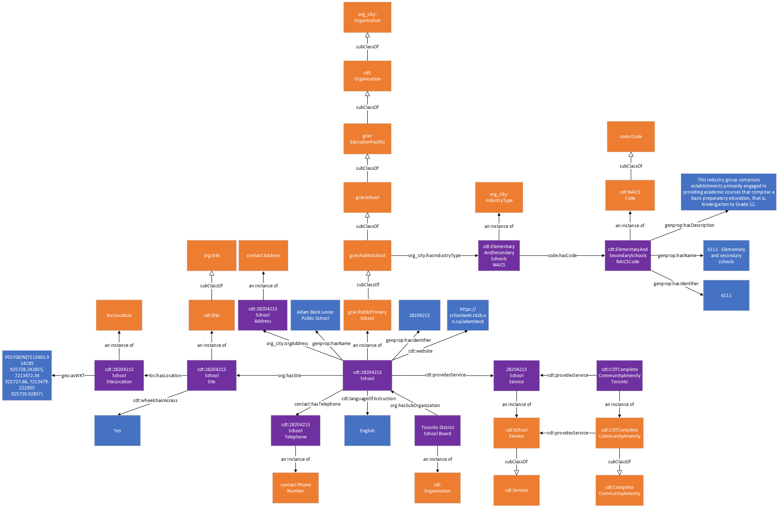

The following table describes the mapping of the OpenStreetMap school data onto the City Digital Twin ontology.
 | Subject | Property | Object
School  In a GeoJSON export of OpenStreetMap data each entity is represented as an GeoJSON Feature object in a GeoJSON FeatureCollection array) | cdt: {OSM ID}School | rdf:type | gcie:School (or appropriate GCIE subclass of school, e.g., gcie:PublicSchool)
geometry  The geospatial coordinates of the entity in GeoJSON format. The geometries are converted to WKT format in the City Digital Twin. | cdt: {OSM ID}School | org:hasSite | cdt: {OSM ID}SchoolSite
 | cdt: {OSM ID}SchoolSite | rdf:type | cdt:Site
 | cdt: {OSM ID}SchoolSite | loc:Location | “{geometry}” (the geometry here is converted to WKT format)
id  The OSM ID that serves as the unique identifier, usually written as {OpenStreetMap element}/{numeric ID} in the GeoJSON data (e.g., “relation/14073745”). The ID used in the City Digital Twin only includes the numeric ID for brevity. | cdt: {OSM ID}School | genprop:hasIdentifier | “{OSM ID}”
name | cdt: {OSM ID}School | genprop:hasName | “{name}”
website | cdt: {OSM ID}School | cdt:website | “{website}”
Address  Generally, the address information in OpenStreetMap is represented using multiple properties such as addr:housenumber, addr:street, and addr:postcode. | cdt: {OSM ID}SchoolAddress | rdf:type | contact:Address
 | cdt: {OSM ID}School | org_city:orgAddress | cdt: {OSM ID}SchoolAddress
 | cdt: {OSM ID}SchoolAddress | contact:hasStreetNumber | “{addr:housenumber}”
 | cdt: {OSM ID}SchoolAddress | contact:hasStreet (where appropriate, the information in addr:street is separated and represented in more detail using additional properties from the contact ontology e.g., contact:hasStreetType) | “{addr:street}”
 | cdt: {OSM ID}SchoolAddress | contact:hasPostalCode | “{addr:postcode}”
phone  Phone number information in OpenStreetMap is stored using a single property but is separated and mapped in the Digital Twin by using the contact:hasCountryCode, contact:hasAreaCode, and contact.hasPhoneNumber properties | cdt: {OSM ID}SchoolTelephone | rdf:type | contact:PhoneNumber
 | cdt: {OSM ID}School | contact:hasTelephone | cdt: {OSM ID}SchoolTelephone
 | cdt: {OSM ID}SchoolTelephone | contact:hasCountryCode | “{phone}” (only the country code part of {phone})
 | cdt: {OSM ID}SchoolTelephone | contact:hasAreaCode | “{phone}” (only the area code part of {phone})
 | cdt: {OSM ID}SchoolTelephone | contact.hasPhoneNumber | “{phone}” (only the phone number part of {phone})
operator  Name of the operator in charge of operating the entity. The name is converted to CamelCase when it is used as an IRI. | cdt:{operator} | rdf:type | cdt:Organization
 | cdt:{operator} | org:hasSubOrganization | cdt: {OSM ID}School
school:language  The language of instruction used at the school | cdt: {OSM ID}School | cdt:languageOfInstruction | “{school:language  }”
wheelchair  Provides wheelchair accessibility information | cdt: {OSM ID}SchoolSite | cdt:wheelchairAccess | “{wheelchair}”

Kindergartens
This is an ontological representation of kindergarten data. Kindergartens are represented as instances of the Kindergarten class which is a subclass of the EducationFacility class from GCIE which is also a subclass of an Organization. Kindergartens can have a name which is linked via the hasName property, a unique identifier which is linked via the hasIdentifier property, an address which is linked via the orgAddress property, services that it provides via the providesService property, a website which is linked via the website property, and a site that represents the physical premise of the school which is linked via the hasSite property. They are also linked to their corresponding NAICS industry category using the hasIndustryType property. The site of a Kindergarten can have an indicator for whether it is wheelchair accessible using the wheelchairAccess property, and a Location instance and a set of geospatial coordinates linked using the hasLocation and asWKT property respectively.
Class | Property | Value
cdt:Kindergarten | subClassOf | cdt:Organization
 | subClassOf | gcie:EducationFacility
 | genprop:hasName | xsd:string
 | genprop:hasIdentifier | xsd:string
 | cdt:website | xsd:string
 | org_city:orgAddress | contact:Address
 | contact:hasTelephone | contact:PhoneNumber
 | cdt:providesService | cdt:Service
 | org_city:hasIndustyType | org_city:IndustryType
 | org:hasSite | cdt:Site
cdt:Site | subClassOf | org:Site
 | loc:hasLocation | loc:Location
 | cdt:wheelchairAccess | xsd:string

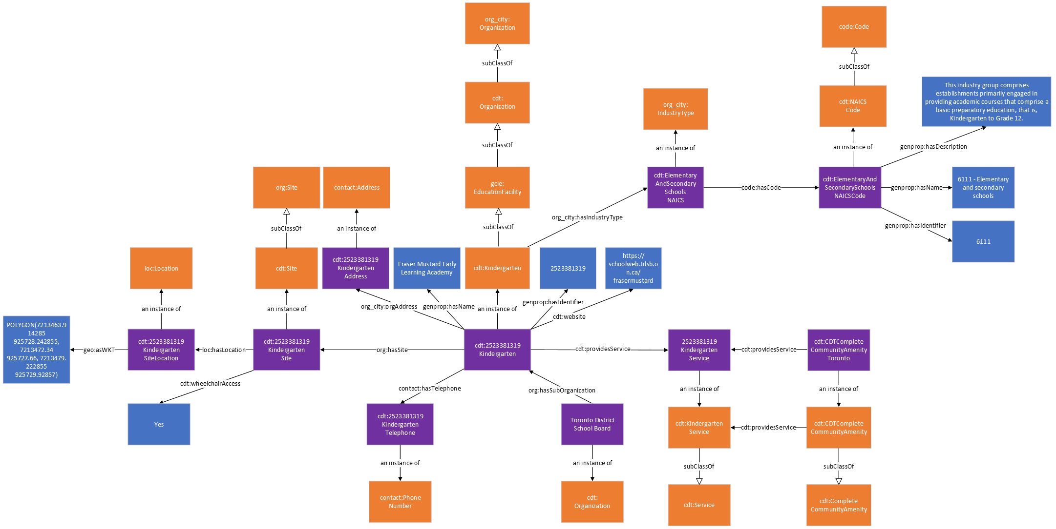
The following table describes the mapping of the OpenStreetMap kindergarten data onto the City Digital Twin ontology.
 | Subject | Property | Object
Kindergarten  In a GeoJSON export of OpenStreetMap data each entity is represented as an GeoJSON Feature object in a GeoJSON FeatureCollection array) | cdt: {OSM ID}Kindergarten | rdf:type | cdt:Kindergarten
geometry  The geospatial coordinates of the entity in GeoJSON format. The geometries are converted to WKT format in the City Digital Twin. | cdt: {OSM ID} Kindergarten | org:hasSite | cdt: {OSM ID} KindergartenSite
 | cdt: {OSM ID}KindergartenSite | rdf:type | cdt:Site
 | cdt: {OSM ID}KindergartenSite | loc:Location | “{geometry}” (the geometry here is converted to WKT format)
id  The OSM ID that serves as the unique identifier, usually written as {OpenStreetMap element}/{numeric ID} in the GeoJSON data (e.g., “relation/14073745”). The ID used in the City Digital Twin only includes the numeric ID for brevity. | cdt: {OSM ID}Kindergarten | genprop:hasIdentifier | “{OSM ID}”
name | cdt: {OSM ID}Kindergarten | genprop:hasName | “{name}”
website | cdt: {OSM ID}Kindergarten | cdt:website | “{website}”
Address  Generally, the address information in OpenStreetMap is represented using multiple properties such as addr:housenumber, addr:street, and addr:postcode. | cdt: {OSM ID}KindergartenAddress | rdf:type | contact:Address
 | cdt: {OSM ID}Kindergarten | org_city:orgAddress | cdt: {OSM ID}KindergartenAddress
 | cdt: {OSM ID}KindergartenAddress | contact:hasStreetNumber | “{addr:housenumber}”
 | cdt: {OSM ID}KindergartenAddress | contact:hasStreet (where appropriate, the information in addr:street is separated and represented in more detail using additional properties from the contact ontology e.g., contact:hasStreetType) | “{addr:street}”
 | cdt: {OSM ID}KindergartenAddress | contact:hasPostalCode | “{addr:postcode}”
phone  Phone number information in OpenStreetMap is stored using a single property but is separated and mapped in the Digital Twin by using the contact:hasCountryCode, contact:hasAreaCode, and contact.hasPhoneNumber properties | cdt: {OSM ID}KindergartenTelephone | rdf:type | contact:PhoneNumber
 | cdt: {OSM ID}Kindergarten | contact:hasTelephone | cdt: {OSM ID}KindergartenTelephone
 | cdt: {OSM ID}KindergartenTelephone | contact:hasCountryCode | “{phone}” (only the country code part of {phone})
 | cdt: {OSM ID}KindergartenTelephone | contact:hasAreaCode | “{phone}” (only the area code part of {phone})
 | cdt: {OSM ID}KindergartenTelephone | contact.hasPhoneNumber | “{phone}” (only the phone number part of {phone})
operator  Name of the operator in charge of operating the entity. The name is converted to CamelCase when it is used as an IRI. | cdt:{operator} | rdf:type | cdt:Organization
 | cdt:{operator} | org:hasSubOrganization | cdt: {OSM ID}Kindergarten
wheelchair  Provides wheelchair accessibility information | cdt: {OSM ID}KindergartenSite | cdt:wheelchairAccess | “{wheelchair}”

Universities
This is an ontological representation of university data. Universities are represented as instances of the University class which is a subclass of the EducationFacility class from GCIE which is also a subclass of an Organization. Universities can have a name which is linked via the hasName property, a unique identifier which is linked via the hasIdentifier property, an address which is linked via the orgAddress property, services that it provides via the providesService property, a website which is linked via the website property, and a site that represents the physical premise of the school which is linked via the hasSite property. They are also linked to their corresponding NAICS industry category using the hasIndustryType property. The site of a University can have an indicator for whether it is wheelchair accessible using the wheelchairAccess property, and a Location instance and a set of geospatial coordinates linked using the hasLocation and asWKT property respectively.
Class | Property | Value
cdt:University | subClassOf | cdt:Organization
 | subClassOf | gcie:EducationFacility
 | genprop:hasName | xsd:string
 | genprop:hasIdentifier | xsd:string
 | cdt:website | xsd:string
 | org_city:orgAddress | contact:Address
 | contact:hasTelephone | contact:PhoneNumber
 | cdt:providesService | cdt:Service
 | org_city:hasIndustyType | org_city:IndustryType
 | org:hasSite | cdt:Site
cdt:Site | subClassOf | org:Site
 | loc:hasLocation | loc:Location
 | cdt:wheelchairAccess | xsd:string

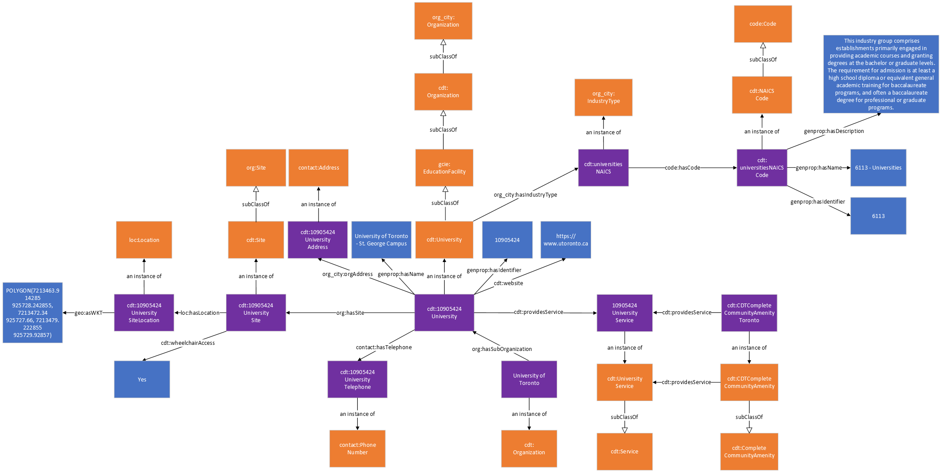
The following table describes the mapping of the OpenStreetMap university data onto the City Digital Twin ontology.
 | Subject | Property | Object
University  In a GeoJSON export of OpenStreetMap data each entity is represented as an GeoJSON Feature object in a GeoJSON FeatureCollection array) | cdt: {OSM ID}University | rdf:type | cdt:University
geometry  The geospatial coordinates of the entity in GeoJSON format. The geometries are converted to WKT format in the City Digital Twin. | cdt: {OSM ID} University | org:hasSite | cdt: {OSM ID} UniversitySite
 | cdt: {OSM ID}UniversitySite | rdf:type | cdt:Site
 | cdt: {OSM ID}UniversitySite | loc:Location | “{geometry}” (the geometry here is converted to WKT format)
id  The OSM ID that serves as the unique identifier, usually written as {OpenStreetMap element}/{numeric ID} in the GeoJSON data (e.g., “relation/14073745”). The ID used in the City Digital Twin only includes the numeric ID for brevity. | cdt: {OSM ID}University | genprop:hasIdentifier | “{OSM ID}”
name | cdt: {OSM ID}University | genprop:hasName | “{name}”
website | cdt: {OSM ID}University | cdt:website | “{website}”
Address  Generally, the address information in OpenStreetMap is represented using multiple properties such as addr:housenumber, addr:street, and addr:postcode. | cdt: {OSM ID}UniversityAddress | rdf:type | contact:Address
 | cdt: {OSM ID}University | org_city:orgAddress | cdt: {OSM ID}UniversityAddress
 | cdt: {OSM ID}UniversityAddress | contact:hasStreetNumber | “{addr:housenumber}”
 | cdt: {OSM ID}UniversityAddress | contact:hasStreet (where appropriate, the information in addr:street is separated and represented in more detail using additional properties from the contact ontology e.g., contact:hasStreetType) | “{addr:street}”
 | cdt: {OSM ID}UniversityAddress | contact:hasPostalCode | “{addr:postcode}”
phone  Phone number information in OpenStreetMap is stored using a single property but is separated and mapped in the Digital Twin by using the contact:hasCountryCode, contact:hasAreaCode, and contact.hasPhoneNumber properties | cdt: {OSM ID}UniversityTelephone | rdf:type | contact:PhoneNumber
 | cdt: {OSM ID}University | contact:hasTelephone | cdt: {OSM ID}UniversityTelephone
 | cdt: {OSM ID}UniversityTelephone | contact:hasCountryCode | “{phone}” (only the country code part of {phone})
 | cdt: {OSM ID}UniversityTelephone | contact:hasAreaCode | “{phone}” (only the area code part of {phone})
 | cdt: {OSM ID}UniversityTelephone | contact.hasPhoneNumber | “{phone}” (only the phone number part of {phone})
operator  Name of the operator in charge of operating the entity. The name is converted to CamelCase when it is used as an IRI. | cdt:{operator} | rdf:type | cdt:Organization
 | cdt:{operator} | org:hasSubOrganization | cdt: {OSM ID}University
wheelchair  Provides wheelchair accessibility information | cdt: {OSM ID}UniversitySite | cdt:wheelchairAccess | “{wheelchair}”

Colleges
This is an ontological representation of college data. Colleges are represented as instances of the College class which is a subclass of the EducationFacility class from GCIE which is also a subclass of an Organization. Colleges can have a name which is linked via the hasName property, a unique identifier which is linked via the hasIdentifier property, an address which is linked via the orgAddress property, services that it provides via the providesService property, a website which is linked via the website property, and a site that represents the physical premise of the school which is linked via the hasSite property. They are also linked to their corresponding NAICS industry category using the hasIndustryType property. The site of a College can have an indicator for whether it is wheelchair accessible using the wheelchairAccess property, and a Location instance and a set of geospatial coordinates linked using the hasLocation and asWKT property respectively.
Class | Property | Value
cdt:College | subClassOf | cdt:Organization
 | subClassOf | gcie:EducationFacility
 | genprop:hasName | xsd:string
 | genprop:hasIdentifier | xsd:string
 | cdt:website | xsd:string
 | org_city:orgAddress | contact:Address
 | contact:hasTelephone | contact:PhoneNumber
 | cdt:providesService | cdt:Service
 | org_city:hasIndustyType | org_city:IndustryType
 | org:hasSite | cdt:Site
cdt:Site | subClassOf | org:Site
 | loc:hasLocation | loc:Location
 | cdt:wheelchairAccess | xsd:string

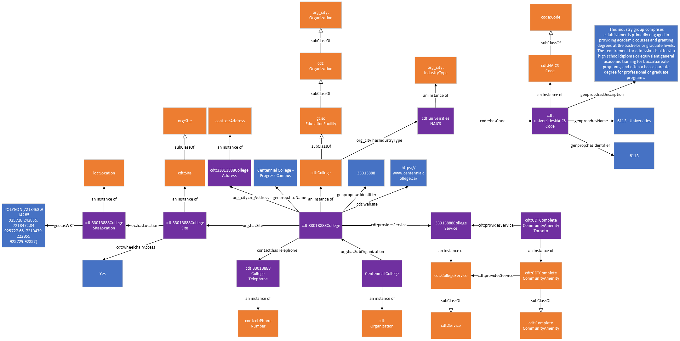
The following table describes the mapping of the OpenStreetMap college data onto the City Digital Twin ontology.
 | Subject | Property | Object
College  In a GeoJSON export of OpenStreetMap data each entity is represented as an GeoJSON Feature object in a GeoJSON FeatureCollection array) | cdt: {OSM ID}College | rdf:type | cdt:College
geometry  The geospatial coordinates of the entity in GeoJSON format. The geometries are converted to WKT format in the City Digital Twin. | cdt: {OSM ID} College | org:hasSite | cdt: {OSM ID} CollegeSite
 | cdt: {OSM ID}CollegeSite | rdf:type | cdt:Site
 | cdt: {OSM ID}CollegeSite | loc:Location | “{geometry}” (the geometry here is converted to WKT format)
id  The OSM ID that serves as the unique identifier, usually written as {OpenStreetMap element}/{numeric ID} in the GeoJSON data (e.g., “relation/14073745”). The ID used in the City Digital Twin only includes the numeric ID for brevity. | cdt: {OSM ID}College | genprop:hasIdentifier | “{OSM ID}”
name | cdt: {OSM ID}College | genprop:hasName | “{name}”
website | cdt: {OSM ID}College | cdt:website | “{website}”
Address  Generally, the address information in OpenStreetMap is represented using multiple properties such as addr:housenumber, addr:street, and addr:postcode. | cdt: {OSM ID}CollegeAddress | rdf:type | contact:Address
 | cdt: {OSM ID}College | org_city:orgAddress | cdt: {OSM ID}CollegeAddress
 | cdt: {OSM ID}CollegeAddress | contact:hasStreetNumber | “{addr:housenumber}”
 | cdt: {OSM ID}CollegeAddress | contact:hasStreet (where appropriate, the information in addr:street is separated and represented in more detail using additional properties from the contact ontology e.g., contact:hasStreetType) | “{addr:street}”
 | cdt: {OSM ID}CollegeAddress | contact:hasPostalCode | “{addr:postcode}”
phone  Phone number information in OpenStreetMap is stored using a single property but is separated and mapped in the Digital Twin by using the contact:hasCountryCode, contact:hasAreaCode, and contact.hasPhoneNumber properties | cdt: {OSM ID}CollegeTelephone | rdf:type | contact:PhoneNumber
 | cdt: {OSM ID}College | contact:hasTelephone | cdt: {OSM ID}CollegeTelephone
 | cdt: {OSM ID}CollegeTelephone | contact:hasCountryCode | “{phone}” (only the country code part of {phone})
 | cdt: {OSM ID}CollegeTelephone | contact:hasAreaCode | “{phone}” (only the area code part of {phone})
 | cdt: {OSM ID}CollegeTelephone | contact.hasPhoneNumber | “{phone}” (only the phone number part of {phone})
operator  Name of the operator in charge of operating the entity. The name is converted to CamelCase when it is used as an IRI. | cdt:{operator} | rdf:type | cdt:Organization
 | cdt:{operator} | org:hasSubOrganization | cdt: {OSM ID}College
wheelchair  Provides wheelchair accessibility information | cdt: {OSM ID}CollegeSite | cdt:wheelchairAccess | “{wheelchair}”

Hospitals
This is an ontological representation of hospital data. Hospitals are represented as instances of the Hospital class from Schema.org which is a subclass of an Organization and also has subclasses PublicHospital and PrivateHospital from the GCI Healthcare Ontology to indicate whether they are publicly or privately operated. Hospitals can have a name which is linked via the hasName property, a unique identifier which is linked via the hasIdentifier property, an address which is linked via the orgAddress property, services that it provides via the providesService property, a website which is linked via the website property, departments/units with a focus of specific medical needs which is linked via the hasUnit property, its operating hours which is linked via the operatingHours property, and a site that represents the physical premise of the school which is linked via the hasSite property. They are also linked to their corresponding NAICS industry category using the hasIndustryType property. The site of a Hospital can have an indicator for whether it is wheelchair accessible using the wheelchairAccess property, and a Location instance and a set of geospatial coordinates linked using the hasLocation and asWKT property respectively.

Class | Property | Value
cdt:Hospital | subClassOf | cdt:Organization
 | genprop:hasName | xsd:string
 | genprop:hasIdentifier | xsd:string
 | cdt:website | xsd:string
 | org_city:orgAddress | contact:Address
 | contact:hasTelephone | contact:PhoneNumber
 | cdt:providesService | cdt:Service
 | org_city:hasIndustyType | org_city:IndustryType
 | org:hasUnit | org:OrganizationalUnit
 | org_city:operatingHours | org_city:Operation
 | org:hasSite | cdt:Site
cdt:Site | subClassOf | org:Site
 | loc:hasLocation | loc:Location
 | cdt:wheelchairAccess | xsd:string

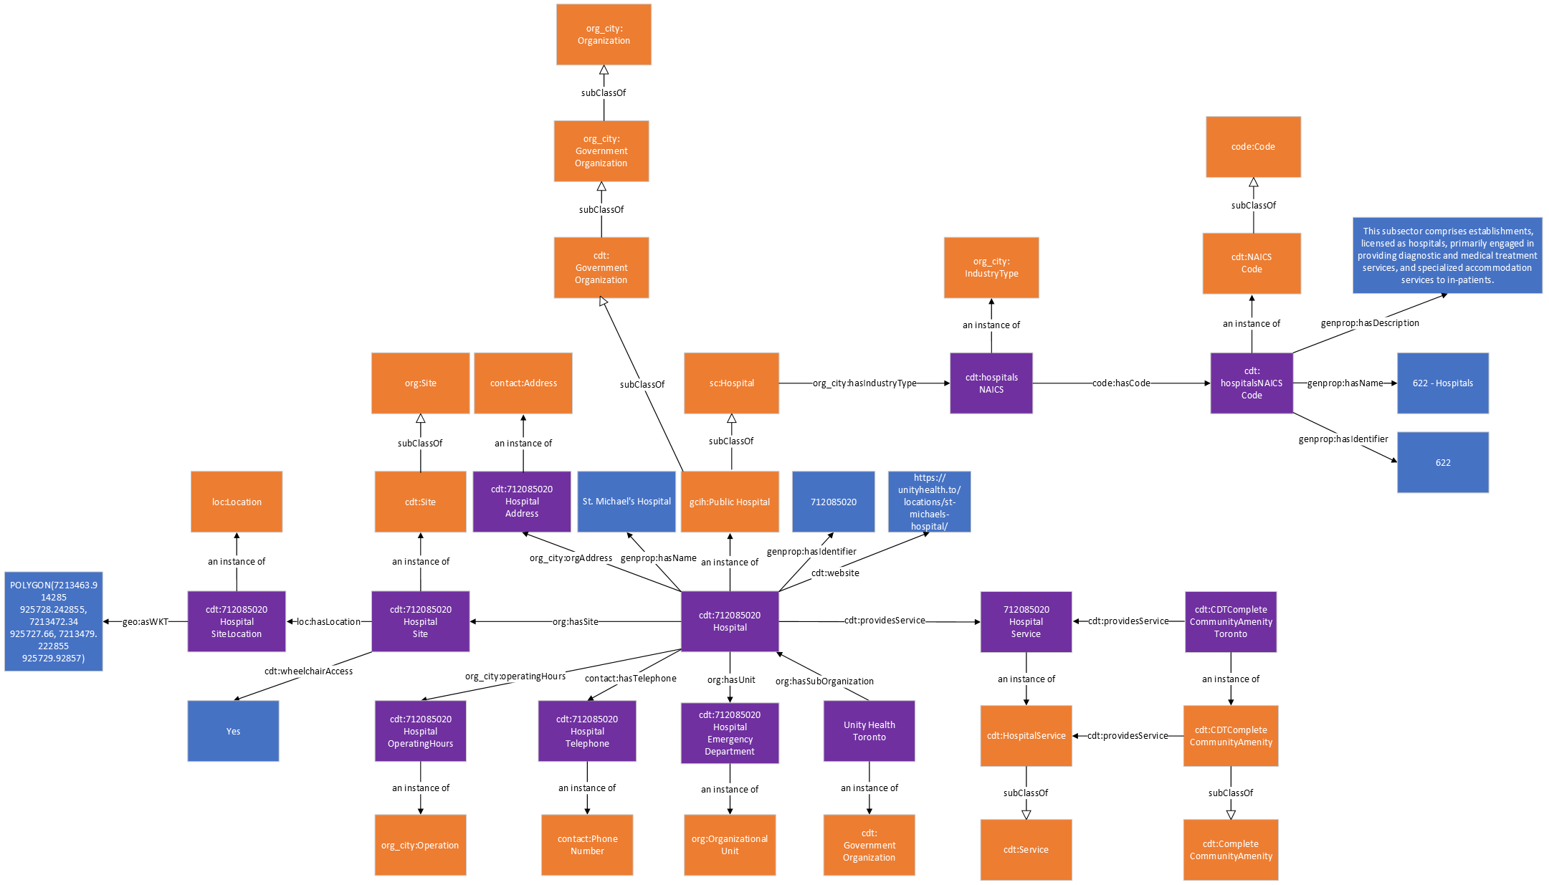
The following table describes the mapping of the OpenStreetMap Hospital data onto the City Digital Twin ontology.
 | Subject | Property | Object
Hospital  In a GeoJSON export of OpenStreetMap data each entity is represented as an GeoJSON Feature object in a GeoJSON FeatureCollection array) | cdt: {OSM ID}Hospital | rdf:type | sc:Hospital (or appropriate subclass of sc:Hospital from the GCIH ontology)
emergency  Indicates whether the hospital provides emergency services | cdt: {OSM ID}HospitalEmergencyDepartment | rdf:type | org:OrganizationalUnit
 | cdt: {OSM ID}Hospital | org:hasUnit | cdt: {OSM ID}HospitalEmergencyDepartment
 | cdt: {OSM ID}HospitalEmergencyService | rdf:type | cdt:HospitalEmergencyService
 | cdt: {OSM ID}Hospital | cdt:providesService | cdt: {OSM ID}HospitalEmergencyService
opening_hours  Specifies the operating hours using the specialized format specified by OpenStreetMap. The operating hour information here is converted and separated by day of week so it can be mapped according to the Operation class from ISO/IEC 5087. | cdt: {OSM ID}HospitalOperatingHours{day of week} | rdf:type | org_city:Operation
 | cdt: {OSM ID}Hospital | org_city:operatingHours | cdt: {OSM ID}HospitalOperatingHours{day of week}
 | cdt: {OSM ID}HospitalOperatingHours{day of week} | org_city:hasOpeningTime | “{opening_hours}” (only the opening time for the specified day of week, expressed in xsd.time format)
 | cdt: {OSM ID}HospitalOperatingHours{day of week} | org_city:hasClosingTime | “{opening_hours}” (only the closing time for the specified day of week, expressed in xsd.time format)
 | cdt: {OSM ID}HospitalOperatingHours{day of week} | recurringevent:hasDayOfWeek | recurringevent:{day of week}
geometry  The geospatial coordinates of the entity in GeoJSON format. The geometries are converted to WKT format in the City Digital Twin. | cdt: {OSM ID} Hospital | org:hasSite | cdt: {OSM ID} HospitalSite
 | cdt: {OSM ID}HospitalSite | rdf:type | cdt:Site
 | cdt: {OSM ID}HospitalSite | loc:Location | “{geometry}” (the geometry here is converted to WKT format)
id  The OSM ID that serves as the unique identifier, usually written as {OpenStreetMap element}/{numeric ID} in the GeoJSON data (e.g., “relation/14073745”). The ID used in the City Digital Twin only includes the numeric ID for brevity. | cdt: {OSM ID}Hospital | genprop:hasIdentifier | “{OSM ID}”
name | cdt: {OSM ID}Hospital | genprop:hasName | “{name}”
website | cdt: {OSM ID}Hospital | cdt:website | “{website}”
Address  Generally, the address information in OpenStreetMap is represented using multiple properties such as addr:housenumber, addr:street, and addr:postcode. | cdt: {OSM ID}HospitalAddress | rdf:type | contact:Address
 | cdt: {OSM ID}Hospital | org_city:orgAddress | cdt: {OSM ID}HospitalAddress
 | cdt: {OSM ID}HospitalAddress | contact:hasStreetNumber | “{addr:housenumber}”
 | cdt: {OSM ID}HospitalAddress | contact:hasStreet (where appropriate, the information in addr:street is separated and represented in more detail using additional properties from the contact ontology e.g., contact:hasStreetType) | “{addr:street}”
 | cdt: {OSM ID}HospitalAddress | contact:hasPostalCode | “{addr:postcode}”
phone  Phone number information in OpenStreetMap is stored using a single property but is separated and mapped in the Digital Twin by using the contact:hasCountryCode, contact:hasAreaCode, and contact.hasPhoneNumber properties | cdt: {OSM ID}HospitalTelephone | rdf:type | contact:PhoneNumber
 | cdt: {OSM ID}Hospital | contact:hasTelephone | cdt: {OSM ID}HospitalTelephone
 | cdt: {OSM ID}HospitalTelephone | contact:hasCountryCode | “{phone}” (only the country code part of {phone})
 | cdt: {OSM ID}HospitalTelephone | contact:hasAreaCode | “{phone}” (only the area code part of {phone})
 | cdt: {OSM ID}HospitalTelephone | contact.hasPhoneNumber | “{phone}” (only the phone number part of {phone})
operator  Name of the operator in charge of operating the entity. The name is converted to CamelCase when it is used as an IRI. | cdt:{operator} | rdf:type | cdt:Organization
 | cdt:{operator} | org:hasSubOrganization | cdt: {OSM ID}Hospital
wheelchair  Provides wheelchair accessibility information | cdt: {OSM ID}HospitalSite | cdt:wheelchairAccess | “{wheelchair}”

Clinics
This is an ontological representation of clinic (i.e., medical centre) data. Clinics are represented as instances of the Clinic class which is a subclass of an Organization. Clinics can have a name which is linked via the hasName property, a unique identifier which is linked via the hasIdentifier property, an address which is linked via the orgAddress property, services that it provides via the providesService property, a website which is linked via the website property, an email which is linked via the email property, its operating hours which is linked via the operatingHours property, and a site that represents the physical premise of the school which is linked via the hasSite property. They are also linked to their corresponding NAICS industry category using the hasIndustryType property. The site of a Clinic can have an indicator for whether it is wheelchair accessible using the wheelchairAccess property, and a Location instance and a set of geospatial coordinates linked using the hasLocation and asWKT property respectively.

Class | Property | Value
cdt:Clinic | subClassOf | cdt:Organization
 | genprop:hasName | xsd:string
 | genprop:hasIdentifier | xsd:string
 | cdt:website | xsd:string
 | cdt:email | xsd:string
 | org_city:orgAddress | contact:Address
 | contact:hasTelephone | contact:PhoneNumber
 | cdt:providesService | cdt:Service
 | org_city:hasIndustyType | org_city:IndustryType
 | org_city:operatingHours | org_city:Operation
 | org:hasSite | cdt:Site
cdt:Site | subClassOf | org:Site
 | loc:hasLocation | loc:Location
 | cdt:wheelchairAccess | xsd:string

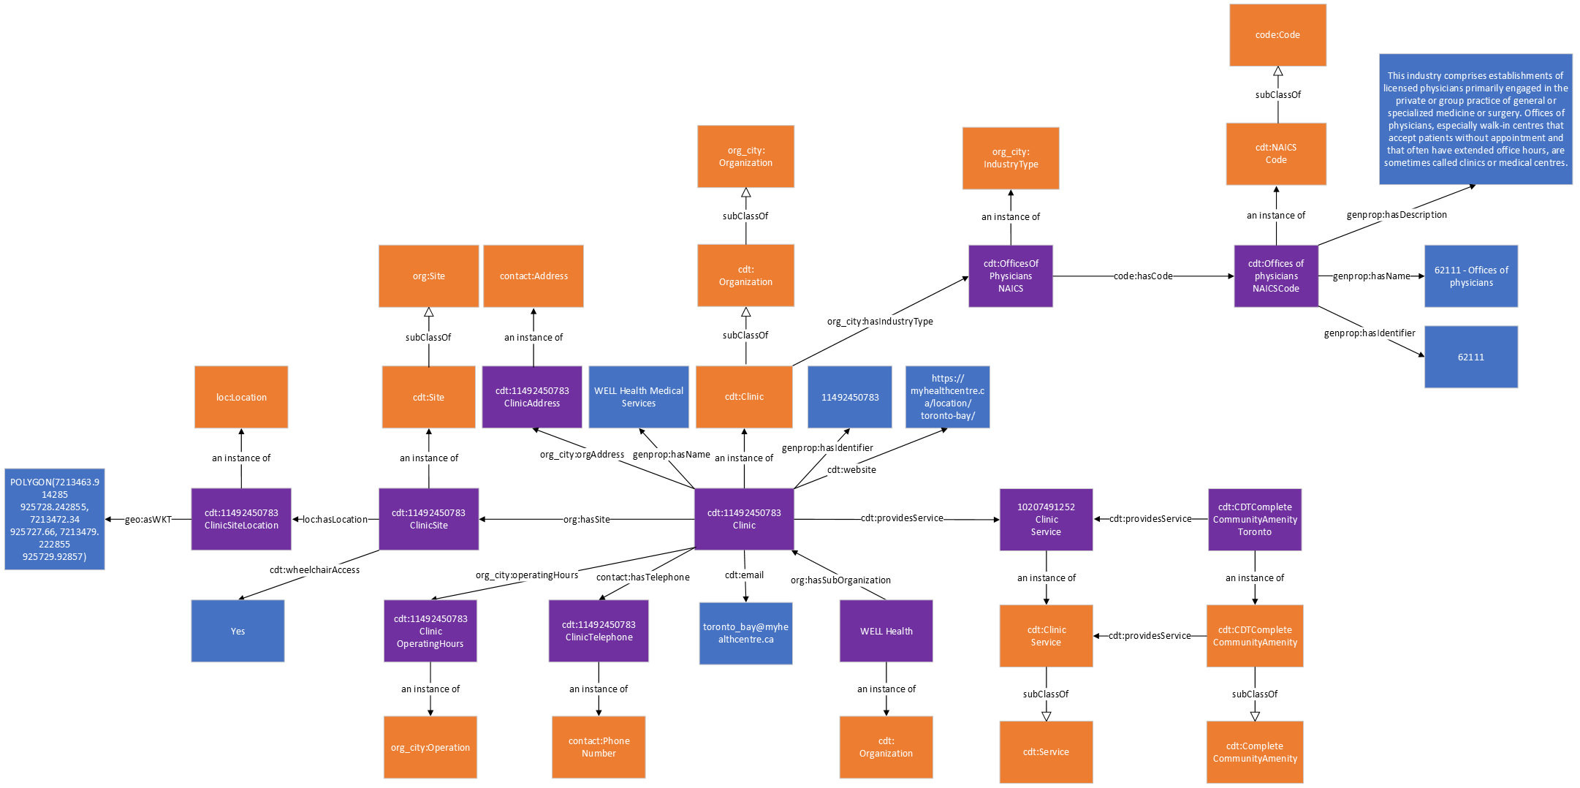
The following table describes the mapping of the OpenStreetMap Clinic data onto the City Digital Twin ontology.
 | Subject | Property | Object
Clinic  In a GeoJSON export of OpenStreetMap data each entity is represented as an GeoJSON Feature object in a GeoJSON FeatureCollection array) | cdt: {OSM ID}Clinic | rdf:type | cdt:Clinic
email | cdt: {OSM ID}Clinic | cdt:email | "{email}”
opening_hours  Specifies the operating hours using the specialized format specified by OpenStreetMap. The operating hour information here is converted and separated by day of week so it can be mapped according to the Operation class from ISO/IEC 5087. | cdt: {OSM ID}ClinicOperatingHours{day of week} | rdf:type | org_city:Operation
 | cdt: {OSM ID}Clinic | org_city:operatingHours | cdt: {OSM ID}ClinicOperatingHours{day of week}
 | cdt: {OSM ID}ClinicOperatingHours{day of week} | org_city:hasOpeningTime | “{opening_hours}” (only the opening time for the specified day of week, expressed in xsd.time format)
 | cdt: {OSM ID}ClinicOperatingHours{day of week} | org_city:hasClosingTime | “{opening_hours}” (only the closing time for the specified day of week, expressed in xsd.time format)
 | cdt: {OSM ID}ClinicOperatingHours{day of week} | recurringevent:hasDayOfWeek | recurringevent:{day of week}
geometry  The geospatial coordinates of the entity in GeoJSON format. The geometries are converted to WKT format in the City Digital Twin. | cdt: {OSM ID} Clinic | org:hasSite | cdt: {OSM ID} ClinicSite
 | cdt: {OSM ID}ClinicSite | rdf:type | cdt:Site
 | cdt: {OSM ID}ClinicSite | loc:Location | “{geometry}” (the geometry here is converted to WKT format)
id  The OSM ID that serves as the unique identifier, usually written as {OpenStreetMap element}/{numeric ID} in the GeoJSON data (e.g., “relation/14073745”). The ID used in the City Digital Twin only includes the numeric ID for brevity. | cdt: {OSM ID}Clinic | genprop:hasIdentifier | “{OSM ID}”
name | cdt: {OSM ID}Clinic | genprop:hasName | “{name}”
website | cdt: {OSM ID}Clinic | cdt:website | “{website}”
Address  Generally, the address information in OpenStreetMap is represented using multiple properties such as addr:housenumber, addr:street, and addr:postcode. | cdt: {OSM ID}ClinicAddress | rdf:type | contact:Address
 | cdt: {OSM ID}Clinic | org_city:orgAddress | cdt: {OSM ID}ClinicAddress
 | cdt: {OSM ID}ClinicAddress | contact:hasStreetNumber | “{addr:housenumber}”
 | cdt: {OSM ID}ClinicAddress | contact:hasStreet (where appropriate, the information in addr:street is separated and represented in more detail using additional properties from the contact ontology e.g., contact:hasStreetType) | “{addr:street}”
 | cdt: {OSM ID}ClinicAddress | contact:hasPostalCode | “{addr:postcode}”
phone  Phone number information in OpenStreetMap is stored using a single property but is separated and mapped in the Digital Twin by using the contact:hasCountryCode, contact:hasAreaCode, and contact.hasPhoneNumber properties | cdt: {OSM ID}ClinicTelephone | rdf:type | contact:PhoneNumber
 | cdt: {OSM ID}Clinic | contact:hasTelephone | cdt: {OSM ID}ClinicTelephone
 | cdt: {OSM ID}ClinicTelephone | contact:hasCountryCode | “{phone}” (only the country code part of {phone})
 | cdt: {OSM ID}ClinicTelephone | contact:hasAreaCode | “{phone}” (only the area code part of {phone})
 | cdt: {OSM ID}ClinicTelephone | contact.hasPhoneNumber | “{phone}” (only the phone number part of {phone})
operator  Name of the operator in charge of operating the entity. The name is converted to CamelCase when it is used as an IRI. | cdt:{operator} | rdf:type | cdt:Organization
 | cdt:{operator} | org:hasSubOrganization | cdt: {OSM ID}Clinic
wheelchair  Provides wheelchair accessibility information | cdt: {OSM ID}ClinicSite | cdt:wheelchairAccess | “{wheelchair}”

Doctor’s Office
This is an ontological representation of doctor’s office data. Doctor’s offices are represented as instances of the DoctorsOffice class which is a subclass of an Organization. Doctor’s offices can have a name which is linked via the hasName property, a unique identifier which is linked via the hasIdentifier property, an address which is linked via the orgAddress property, services that it provides via the providesService property, a website which is linked via the website property, an email which is linked via the email property, its operating hours which is linked via the operatingHours property, and a site that represents the physical premise of the school which is linked via the hasSite property. They are also linked to their corresponding NAICS industry category using the hasIndustryType property. The site of a DoctorsOffice can have an indicator for whether it is wheelchair accessible using the wheelchairAccess property, and a Location instance and a set of geospatial coordinates linked using the hasLocation and asWKT property respectively.

Class | Property | Value
cdt:DoctorsOffice | subClassOf | cdt:Organization
 | genprop:hasName | xsd:string
 | genprop:hasIdentifier | xsd:string
 | cdt:website | xsd:string
 | cdt:email | xsd:string
 | org_city:orgAddress | contact:Address
 | contact:hasTelephone | contact:PhoneNumber
 | cdt:providesService | cdt:Service
 | org_city:hasIndustyType | org_city:IndustryType
 | org_city:operatingHours | org_city:Operation
 | org:hasSite | cdt:Site
cdt:Site | subClassOf | org:Site
 | loc:hasLocation | loc:Location
 | cdt:wheelchairAccess | xsd:string

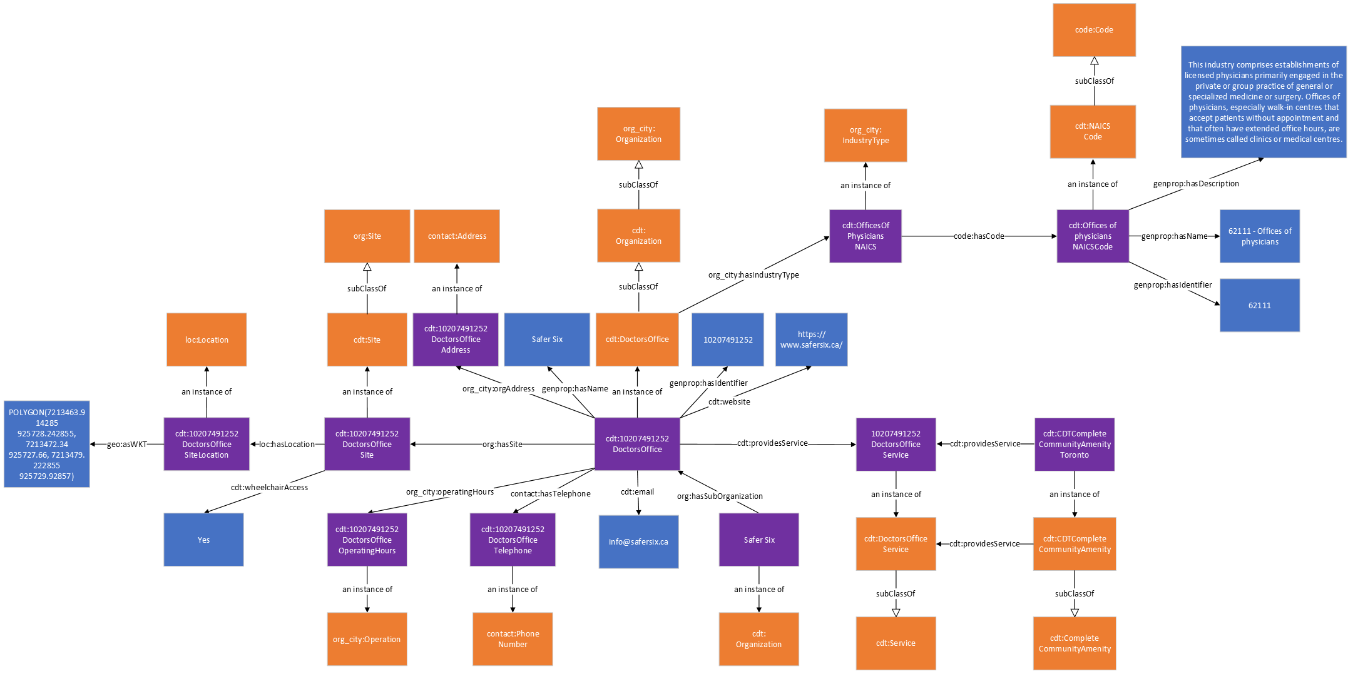
The following table describes the mapping of the OpenStreetMap Doctor’s Office data onto the City Digital Twin ontology.
 | Subject | Property | Object
Doctor’s Office  In a GeoJSON export of OpenStreetMap data each entity is represented as an GeoJSON Feature object in a GeoJSON FeatureCollection array) | cdt: {OSM ID}DoctorsOffice | rdf:type | cdt:DoctorsOffice
email | cdt: {OSM ID}DoctorsOffice | cdt:email | "{email}”
opening_hours  Specifies the operating hours using the specialized format specified by OpenStreetMap. The operating hour information here is converted and separated by day of week so it can be mapped according to the Operation class from ISO/IEC 5087. | cdt: {OSM ID}DoctorsOfficeOperatingHours{day of week} | rdf:type | org_city:Operation
 | cdt: {OSM ID}DoctorsOffice | org_city:operatingHours | cdt: {OSM ID}DoctorsOfficeOperatingHours{day of week}
 | cdt: {OSM ID}DoctorsOfficeOperatingHours{day of week} | org_city:hasOpeningTime | “{opening_hours}” (only the opening time for the specified day of week, expressed in xsd.time format)
 | cdt: {OSM ID}DoctorsOfficeOperatingHours{day of week} | org_city:hasClosingTime | “{opening_hours}” (only the closing time for the specified day of week, expressed in xsd.time format)
 | cdt: {OSM ID}DoctorsOfficeOperatingHours{day of week} | recurringevent:hasDayOfWeek | recurringevent:{day of week}
geometry  The geospatial coordinates of the entity in GeoJSON format. The geometries are converted to WKT format in the City Digital Twin. | cdt: {OSM ID} DoctorsOffice | org:hasSite | cdt: {OSM ID} DoctorsOfficeSite
 | cdt: {OSM ID}DoctorsOfficeSite | rdf:type | cdt:Site
 | cdt: {OSM ID}DoctorsOfficeSite | loc:Location | “{geometry}” (the geometry here is converted to WKT format)
id  The OSM ID that serves as the unique identifier, usually written as {OpenStreetMap element}/{numeric ID} in the GeoJSON data (e.g., “relation/14073745”). The ID used in the City Digital Twin only includes the numeric ID for brevity. | cdt: {OSM ID}DoctorsOffice | genprop:hasIdentifier | “{OSM ID}”
name | cdt: {OSM ID}DoctorsOffice | genprop:hasName | “{name}”
website | cdt: {OSM ID}DoctorsOffice | cdt:website | “{website}”
Address  Generally, the address information in OpenStreetMap is represented using multiple properties such as addr:housenumber, addr:street, and addr:postcode. | cdt: {OSM ID}DoctorsOfficeAddress | rdf:type | contact:Address
 | cdt: {OSM ID}DoctorsOffice | org_city:orgAddress | cdt: {OSM ID}DoctorsOfficeAddress
 | cdt: {OSM ID}DoctorsOfficeAddress | contact:hasStreetNumber | “{addr:housenumber}”
 | cdt: {OSM ID}DoctorsOfficeAddress | contact:hasStreet (where appropriate, the information in addr:street is separated and represented in more detail using additional properties from the contact ontology e.g., contact:hasStreetType) | “{addr:street}”
 | cdt: {OSM ID}DoctorsOfficeAddress | contact:hasPostalCode | “{addr:postcode}”
phone  Phone number information in OpenStreetMap is stored using a single property but is separated and mapped in the Digital Twin by using the contact:hasCountryCode, contact:hasAreaCode, and contact.hasPhoneNumber properties | cdt: {OSM ID}DoctorsOfficeTelephone | rdf:type | contact:PhoneNumber
 | cdt: {OSM ID}DoctorsOffice | contact:hasTelephone | cdt: {OSM ID}DoctorsOfficeTelephone
 | cdt: {OSM ID}DoctorsOfficeTelephone | contact:hasCountryCode | “{phone}” (only the country code part of {phone})
 | cdt: {OSM ID}DoctorsOfficeTelephone | contact:hasAreaCode | “{phone}” (only the area code part of {phone})
 | cdt: {OSM ID}DoctorsOfficeTelephone | contact.hasPhoneNumber | “{phone}” (only the phone number part of {phone})
operator  Name of the operator in charge of operating the entity. The name is converted to CamelCase when it is used as an IRI. | cdt:{operator} | rdf:type | cdt:Organization
 | cdt:{operator} | org:hasSubOrganization | cdt: {OSM ID}DoctorsOffice
wheelchair  Provides wheelchair accessibility information | cdt: {OSM ID}DoctorsOfficeSite | cdt:wheelchairAccess | “{wheelchair}”

Pharmacy
This is an ontological representation of pharmacy data. Pharmacies are represented as instances of the Pharmacy class which is a subclass of an Organization. Pharmacies can have a name which is linked via the hasName property, a unique identifier which is linked via the hasIdentifier property, an address which is linked via the orgAddress property, services that it provides via the providesService property, a website which is linked via the website property, an email which is linked via the email property, its operating hours which is linked via the operatingHours property, and a site that represents the physical premise of the school which is linked via the hasSite property. They are also linked to their corresponding NAICS industry category using the hasIndustryType property. The site of a Pharmacy can have an indicator for whether it is wheelchair accessible using the wheelchairAccess property, and a Location instance and a set of geospatial coordinates linked using the hasLocation and asWKT property respectively.

Class | Property | Value
cdt:Pharmacy | subClassOf | cdt:Organization
 | genprop:hasName | xsd:string
 | genprop:hasIdentifier | xsd:string
 | cdt:website | xsd:string
 | cdt:email | xsd:string
 | org_city:orgAddress | contact:Address
 | contact:hasTelephone | contact:PhoneNumber
 | cdt:providesService | cdt:Service
 | org_city:hasIndustyType | org_city:IndustryType
 | org_city:operatingHours | org_city:Operation
 | org:hasSite | cdt:Site
cdt:Site | subClassOf | org:Site
 | loc:hasLocation | loc:Location
 | cdt:wheelchairAccess | xsd:string

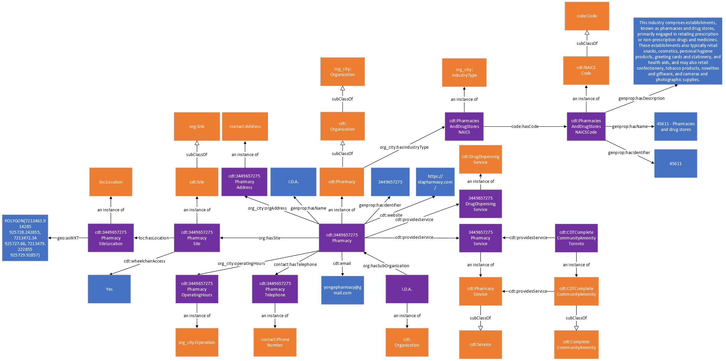

The following table describes the mapping of the OpenStreetMap Pharmacy data onto the City Digital Twin ontology.

 | Subject | Property | Object
Pharmacy  In a GeoJSON export of OpenStreetMap data each entity is represented as an GeoJSON Feature object in a GeoJSON FeatureCollection array) | cdt: {OSM ID}Pharmacy | rdf:type | cdt:Pharmacy
dispensing  Indicates whether the pharmacy provides dispensing services | cdt: {OSM ID}PharmacyDispensingService | rdf:type | cdt:PharmacyDispensingService
 | cdt: {OSM ID}Pharmacy | cdt:providesService | cdt: {OSM ID}PharmacyDispensingService
email | cdt: {OSM ID}Pharmacy | cdt:email | "{email}”
opening_hours  Specifies the operating hours using the specialized format specified by OpenStreetMap. The operating hour information here is converted and separated by day of week so it can be mapped according to the Operation class from ISO/IEC 5087. | cdt: {OSM ID}PharmacyOperatingHours{day of week} | rdf:type | org_city:Operation
 | cdt: {OSM ID}Pharmacy | org_city:operatingHours | cdt: {OSM ID}PharmacyOperatingHours{day of week}
 | cdt: {OSM ID}PharmacyOperatingHours{day of week} | org_city:hasOpeningTime | “{opening_hours}” (only the opening time for the specified day of week, expressed in xsd.time format)
 | cdt: {OSM ID}PharmacyOperatingHours{day of week} | org_city:hasClosingTime | “{opening_hours}” (only the closing time for the specified day of week, expressed in xsd.time format)
 | cdt: {OSM ID}PharmacyOperatingHours{day of week} | recurringevent:hasDayOfWeek | recurringevent:{day of week}
geometry  The geospatial coordinates of the entity in GeoJSON format. The geometries are converted to WKT format in the City Digital Twin. | cdt: {OSM ID} Pharmacy | org:hasSite | cdt: {OSM ID} PharmacySite
 | cdt: {OSM ID}PharmacySite | rdf:type | cdt:Site
 | cdt: {OSM ID}PharmacySite | loc:Location | “{geometry}” (the geometry here is converted to WKT format)
id  The OSM ID that serves as the unique identifier, usually written as {OpenStreetMap element}/{numeric ID} in the GeoJSON data (e.g., “relation/14073745”). The ID used in the City Digital Twin only includes the numeric ID for brevity. | cdt: {OSM ID}Pharmacy | genprop:hasIdentifier | “{OSM ID}”
name | cdt: {OSM ID}Pharmacy | genprop:hasName | “{name}”
website | cdt: {OSM ID}Pharmacy | cdt:website | “{website}”
Address  Generally, the address information in OpenStreetMap is represented using multiple properties such as addr:housenumber, addr:street, and addr:postcode. | cdt: {OSM ID}PharmacyAddress | rdf:type | contact:Address
 | cdt: {OSM ID}Pharmacy | org_city:orgAddress | cdt: {OSM ID}PharmacyAddress
 | cdt: {OSM ID}PharmacyAddress | contact:hasStreetNumber | “{addr:housenumber}”
 | cdt: {OSM ID}PharmacyAddress | contact:hasStreet (where appropriate, the information in addr:street is separated and represented in more detail using additional properties from the contact ontology e.g., contact:hasStreetType) | “{addr:street}”
 | cdt: {OSM ID}PharmacyAddress | contact:hasPostalCode | “{addr:postcode}”
phone  Phone number information in OpenStreetMap is stored using a single property but is separated and mapped in the Digital Twin by using the contact:hasCountryCode, contact:hasAreaCode, and contact.hasPhoneNumber properties | cdt: {OSM ID}PharmacyTelephone | rdf:type | contact:PhoneNumber
 | cdt: {OSM ID}Pharmacy | contact:hasTelephone | cdt: {OSM ID}PharmacyTelephone
 | cdt: {OSM ID}PharmacyTelephone | contact:hasCountryCode | “{phone}” (only the country code part of {phone})
 | cdt: {OSM ID}PharmacyTelephone | contact:hasAreaCode | “{phone}” (only the area code part of {phone})
 | cdt: {OSM ID}PharmacyTelephone | contact.hasPhoneNumber | “{phone}” (only the phone number part of {phone})
operator  Name of the operator in charge of operating the entity. The name is converted to CamelCase when it is used as an IRI. | cdt:{operator} | rdf:type | cdt:Organization
 | cdt:{operator} | org:hasSubOrganization | cdt: {OSM ID}Pharmacy
wheelchair  Provides wheelchair accessibility information | cdt: {OSM ID}PharmacySite | cdt:wheelchairAccess | “{wheelchair}”

Supermarket
This is an ontological representation of supermarket data. Supermarkets are represented as instances of the Supermarket class which is a subclass of an Organization. Supermarkets can have a name which is linked via the hasName property, a unique identifier which is linked via the hasIdentifier property, an address which is linked via the orgAddress property, services that it provides via the providesService property, a website which is linked via the website property, an email which is linked via the email property, its operating hours which is linked via the operatingHours property, and a site that represents the physical premise of the school which is linked via the hasSite property. They are also linked to their corresponding NAICS industry category using the hasIndustryType property. The site of a Supermarket can have an indicator for whether it is wheelchair accessible using the wheelchairAccess property, and a Location instance and a set of geospatial coordinates linked using the hasLocation and asWKT property respectively.
Class | Property | Value
cdt:Supermarket | subClassOf | cdt:Organization
 | genprop:hasName | xsd:string
 | genprop:hasIdentifier | xsd:string
 | cdt:website | xsd:string
 | cdt:email | xsd:string
 | org_city:orgAddress | contact:Address
 | contact:hasTelephone | contact:PhoneNumber
 | cdt:providesService | cdt:Service
 | org_city:hasIndustyType | org_city:IndustryType
 | org_city:operatingHours | org_city:Operation
 | org:hasSite | cdt:Site
cdt:Site | subClassOf | org:Site
 | loc:hasLocation | loc:Location
 | cdt:wheelchairAccess | xsd:string

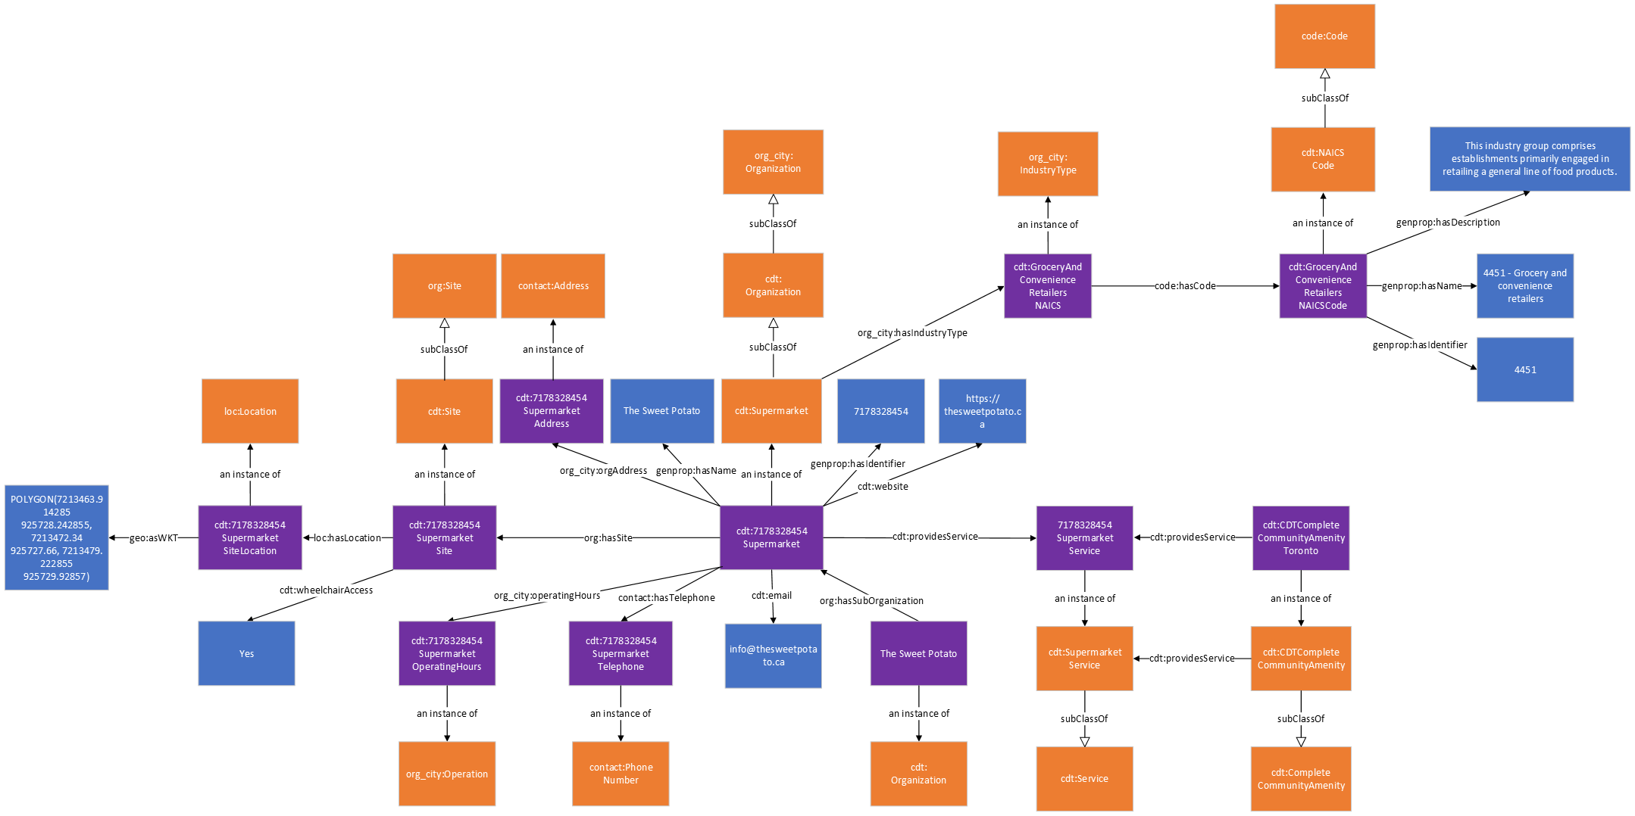
The following table describes the mapping of the OpenStreetMap Supermarket data onto the City Digital Twin ontology.
 | Subject | Property | Object
Supermarket  In a GeoJSON export of OpenStreetMap data each entity is represented as an GeoJSON Feature object in a GeoJSON FeatureCollection array) | cdt: {OSM ID}Supermarket | rdf:type | cdt:Supermarket
email | cdt: {OSM ID}Supermarket | cdt:email | "{email}”
opening_hours  Specifies the operating hours using the specialized format specified by OpenStreetMap. The operating hour information here is converted and separated by day of week so it can be mapped according to the Operation class from ISO/IEC 5087. | cdt: {OSM ID}SupermarketOperatingHours{day of week} | rdf:type | org_city:Operation
 | cdt: {OSM ID}Supermarket | org_city:operatingHours | cdt: {OSM ID}SupermarketOperatingHours{day of week}
 | cdt: {OSM ID}SupermarketOperatingHours{day of week} | org_city:hasOpeningTime | “{opening_hours}” (only the opening time for the specified day of week, expressed in xsd.time format)
 | cdt: {OSM ID}SupermarketOperatingHours{day of week} | org_city:hasClosingTime | “{opening_hours}” (only the closing time for the specified day of week, expressed in xsd.time format)
 | cdt: {OSM ID}SupermarketOperatingHours{day of week} | recurringevent:hasDayOfWeek | recurringevent:{day of week}
geometry  The geospatial coordinates of the entity in GeoJSON format. The geometries are converted to WKT format in the City Digital Twin. | cdt: {OSM ID} Supermarket | org:hasSite | cdt: {OSM ID} SupermarketSite
 | cdt: {OSM ID}SupermarketSite | rdf:type | cdt:Site
 | cdt: {OSM ID}SupermarketSite | loc:Location | “{geometry}” (the geometry here is converted to WKT format)
id  The OSM ID that serves as the unique identifier, usually written as {OpenStreetMap element}/{numeric ID} in the GeoJSON data (e.g., “relation/14073745”). The ID used in the City Digital Twin only includes the numeric ID for brevity. | cdt: {OSM ID}Supermarket | genprop:hasIdentifier | “{OSM ID}”
name | cdt: {OSM ID}Supermarket | genprop:hasName | “{name}”
website | cdt: {OSM ID}Supermarket | cdt:website | “{website}”
Address  Generally, the address information in OpenStreetMap is represented using multiple properties such as addr:housenumber, addr:street, and addr:postcode. | cdt: {OSM ID}SupermarketAddress | rdf:type | contact:Address
 | cdt: {OSM ID}Supermarket | org_city:orgAddress | cdt: {OSM ID}SupermarketAddress
 | cdt: {OSM ID}SupermarketAddress | contact:hasStreetNumber | “{addr:housenumber}”
 | cdt: {OSM ID}SupermarketAddress | contact:hasStreet (where appropriate, the information in addr:street is separated and represented in more detail using additional properties from the contact ontology e.g., contact:hasStreetType) | “{addr:street}”
 | cdt: {OSM ID}SupermarketAddress | contact:hasPostalCode | “{addr:postcode}”
phone  Phone number information in OpenStreetMap is stored using a single property but is separated and mapped in the Digital Twin by using the contact:hasCountryCode, contact:hasAreaCode, and contact.hasPhoneNumber properties | cdt: {OSM ID}SupermarketTelephone | rdf:type | contact:PhoneNumber
 | cdt: {OSM ID}Supermarket | contact:hasTelephone | cdt: {OSM ID}SupermarketTelephone
 | cdt: {OSM ID}SupermarketTelephone | contact:hasCountryCode | “{phone}” (only the country code part of {phone})
 | cdt: {OSM ID}SupermarketTelephone | contact:hasAreaCode | “{phone}” (only the area code part of {phone})
 | cdt: {OSM ID}SupermarketTelephone | contact.hasPhoneNumber | “{phone}” (only the phone number part of {phone})
operator  Name of the operator in charge of operating the entity. The name is converted to CamelCase when it is used as an IRI. | cdt:{operator} | rdf:type | cdt:Organization
 | cdt:{operator} | org:hasSubOrganization | cdt: {OSM ID}Supermarket
wheelchair  Provides wheelchair accessibility information | cdt: {OSM ID}SupermarketSite | cdt:wheelchairAccess | “{wheelchair}”

Greengrocer
This is an ontological representation of greengrocer data. Greengrocers are represented as instances of the Greengrocer class which is a subclass of an Organization. Greengrocers can have a name which is linked via the hasName property, a unique identifier which is linked via the hasIdentifier property, an address which is linked via the orgAddress property, services that it provides via the providesService property, a website which is linked via the website property, its operating hours which is linked via the operatingHours property, and a site that represents the physical premise of the school which is linked via the hasSite property. They are also linked to their corresponding NAICS industry category using the hasIndustryType property. The site of a Greengrocer can have an indicator for whether it is wheelchair accessible using the wheelchairAccess property, and a Location instance and a set of geospatial coordinates linked using the hasLocation and asWKT property respectively.

Class | Property | Value
cdt:Greengrocer | subClassOf | cdt:Organization
 | genprop:hasName | xsd:string
 | genprop:hasIdentifier | xsd:string
 | cdt:website | xsd:string
 | org_city:orgAddress | contact:Address
 | contact:hasTelephone | contact:PhoneNumber
 | cdt:providesService | cdt:Service
 | org_city:hasIndustyType | org_city:IndustryType
 | org_city:operatingHours | org_city:Operation
 | org:hasSite | cdt:Site
cdt:Site | subClassOf | org:Site
 | loc:hasLocation | loc:Location
 | cdt:wheelchairAccess | xsd:string

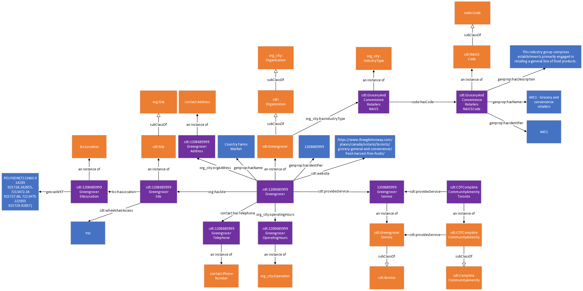
The following table describes the mapping of the OpenStreetMap Greengrocer data onto the City Digital Twin ontology.
 | Subject | Property | Object
Greengrocer  In a GeoJSON export of OpenStreetMap data each entity is represented as an GeoJSON Feature object in a GeoJSON FeatureCollection array) | cdt: {OSM ID}Greengrocer | rdf:type | cdt:Greengrocer
opening_hours  Specifies the operating hours using the specialized format specified by OpenStreetMap. The operating hour information here is converted and separated by day of week so it can be mapped according to the Operation class from ISO/IEC 5087. | cdt: {OSM ID}GreengrocerOperatingHours{day of week} | rdf:type | org_city:Operation
 | cdt: {OSM ID}Greengrocer | org_city:operatingHours | cdt: {OSM ID}GreengrocerOperatingHours{day of week}
 | cdt: {OSM ID}GreengrocerOperatingHours{day of week} | org_city:hasOpeningTime | “{opening_hours}” (only the opening time for the specified day of week, expressed in xsd.time format)
 | cdt: {OSM ID}GreengrocerOperatingHours{day of week} | org_city:hasClosingTime | “{opening_hours}” (only the closing time for the specified day of week, expressed in xsd.time format)
 | cdt: {OSM ID}GreengrocerOperatingHours{day of week} | recurringevent:hasDayOfWeek | recurringevent:{day of week}
geometry  The geospatial coordinates of the entity in GeoJSON format. The geometries are converted to WKT format in the City Digital Twin. | cdt: {OSM ID} Greengrocer | org:hasSite | cdt: {OSM ID} GreengrocerSite
 | cdt: {OSM ID}GreengrocerSite | rdf:type | cdt:Site
 | cdt: {OSM ID}GreengrocerSite | loc:Location | “{geometry}” (the geometry here is converted to WKT format)
id  The OSM ID that serves as the unique identifier, usually written as {OpenStreetMap element}/{numeric ID} in the GeoJSON data (e.g., “relation/14073745”). The ID used in the City Digital Twin only includes the numeric ID for brevity. | cdt: {OSM ID}Greengrocer | genprop:hasIdentifier | “{OSM ID}”
name | cdt: {OSM ID}Greengrocer | genprop:hasName | “{name}”
website | cdt: {OSM ID}Greengrocer | cdt:website | “{website}”
Address  Generally, the address information in OpenStreetMap is represented using multiple properties such as addr:housenumber, addr:street, and addr:postcode. | cdt: {OSM ID}GreengrocerAddress | rdf:type | contact:Address
 | cdt: {OSM ID}Greengrocer | org_city:orgAddress | cdt: {OSM ID}GreengrocerAddress
 | cdt: {OSM ID}GreengrocerAddress | contact:hasStreetNumber | “{addr:housenumber}”
 | cdt: {OSM ID}GreengrocerAddress | contact:hasStreet (where appropriate, the information in addr:street is separated and represented in more detail using additional properties from the contact ontology e.g., contact:hasStreetType) | “{addr:street}”
 | cdt: {OSM ID}GreengrocerAddress | contact:hasPostalCode | “{addr:postcode}”
phone  Phone number information in OpenStreetMap is stored using a single property but is separated and mapped in the Digital Twin by using the contact:hasCountryCode, contact:hasAreaCode, and contact.hasPhoneNumber properties | cdt: {OSM ID}GreengrocerTelephone | rdf:type | contact:PhoneNumber
 | cdt: {OSM ID}Greengrocer | contact:hasTelephone | cdt: {OSM ID}GreengrocerTelephone
 | cdt: {OSM ID}GreengrocerTelephone | contact:hasCountryCode | “{phone}” (only the country code part of {phone})
 | cdt: {OSM ID}GreengrocerTelephone | contact:hasAreaCode | “{phone}” (only the area code part of {phone})
 | cdt: {OSM ID}GreengrocerTelephone | contact.hasPhoneNumber | “{phone}” (only the phone number part of {phone})
wheelchair  Provides wheelchair accessibility information | cdt: {OSM ID}GreengrocerSite | cdt:wheelchairAccess | “{wheelchair}”

Restaurant
This is an ontological representation of restaurant data. Restaurants are represented as instances of the Restaurant class which is a subclass of an Organization. Restaurants can have a name which is linked via the hasName property, a unique identifier which is linked via the hasIdentifier property, an address which is linked via the orgAddress property, services that it provides via the providesService property, a website which is linked via the website property, an email which is linked via the email property, its operating hours which is linked via the operatingHours property, and a site that represents the physical premise of the school which is linked via the hasSite property. They are also linked to their corresponding NAICS industry category using the hasIndustryType property. The site of a Restaurant can have an indicator for whether it is wheelchair accessible using the wheelchairAccess property, and indicator for whether smoking is allowed using the smoking property, an indicator for whether the restaurant provides outdoor seating using the outdoorSeating property, its maximum capacity of people that it can accommodate using the capacity property, and a Location instance and a set of geospatial coordinates linked using the hasLocation and asWKT property respectively.

Class | Property | Value
cdt:Restaurant | subClassOf | cdt:Organization
 | genprop:hasName | xsd:string
 | genprop:hasIdentifier | xsd:string
 | cdt:website | xsd:string
 | cdt:email | xsd:string
 | org_city:orgAddress | contact:Address
 | contact:hasTelephone | contact:PhoneNumber
 | cdt:providesService | cdt:Service
 | org_city:hasIndustyType | org_city:IndustryType
 | org_city:operatingHours | org_city:Operation
 | org:hasSite | cdt:Site
cdt:Site | subClassOf | org:Site
 | loc:hasLocation | loc:Location
 | cdt:capacity | xsd:integer
 | cdt:outdoorSeating | xsd:string
 | cdt:smoking | xsd:string
 | cdt:wheelchairAccess | xsd:string

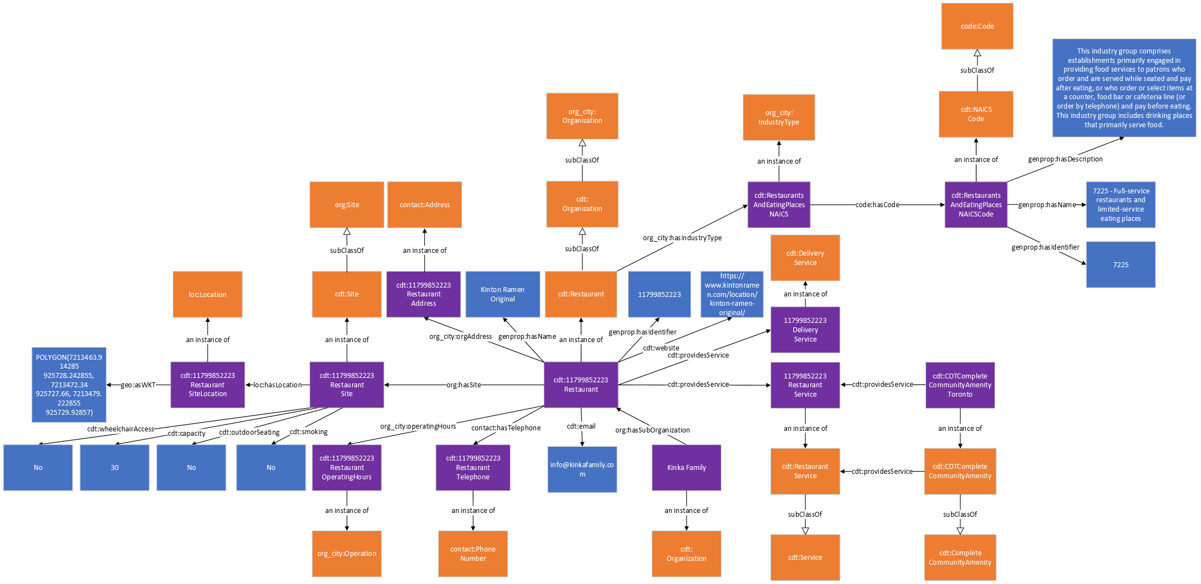

FastFood
This is an ontological representation of fast food vendor data. Fast food vendors are represented as instances of the FastFood class which is a subclass of an Organization. Fast food vendors can have a name which is linked via the hasName property, a unique identifier which is linked via the hasIdentifier property, an address which is linked via the orgAddress property, services that it provides via the providesService property, a website which is linked via the website property, an email which is linked via the email property, its operating hours which is linked via the operatingHours property, and a site that represents the physical premise of the school which is linked via the hasSite property. They are also linked to their corresponding NAICS industry category using the hasIndustryType property. The site of a fast food vendor can have an indicator for whether it is wheelchair accessible using the wheelchairAccess property, and indicator for whether smoking is allowed using the smoking property, an indicator for whether the restaurant provides outdoor seating using the outdoorSeating property, its maximum capacity of people that it can accommodate using the capacity property, and a Location instance and a set of geospatial coordinates linked using the hasLocation and asWKT property respectively.

Class | Property | Value
cdt:FastFood | subClassOf | cdt:Organization
 | genprop:hasName | xsd:string
 | genprop:hasIdentifier | xsd:string
 | cdt:website | xsd:string
 | cdt:email | xsd:string
 | org_city:orgAddress | contact:Address
 | contact:hasTelephone | contact:PhoneNumber
 | cdt:providesService | cdt:Service
 | org_city:hasIndustyType | org_city:IndustryType
 | org_city:operatingHours | org_city:Operation
 | org:hasSite | cdt:Site
cdt:Site | subClassOf | org:Site
 | loc:hasLocation | loc:Location
 | cdt:capacity | xsd:integer
 | cdt:outdoorSeating | xsd:string
 | cdt:smoking | xsd:string
 | cdt:wheelchairAccess | xsd:string

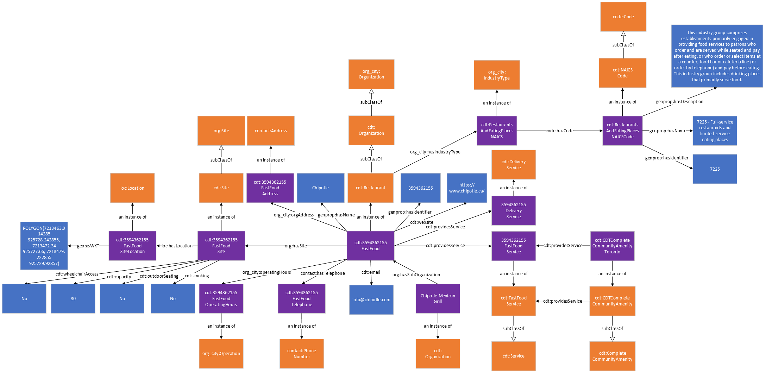

TransitStop
This is an ontological representation of transit stop data. Transit stops are represented as instances of the TransitStop class. Fast food vendors can have a name which is linked via the hasName property, a unique identifier which is linked via the hasIdentifier property, an indicator for whether it is wheelchair accessible which is indicated using the wheelchairAccess property, an operator which is linked via the operator property, and the city in which it is part of via the forCity property. Transit stops can also be linked to their location instance using the hasLocation property, and the location instance can be linked to its geospatial coordinates using the asWKT property.
The dataset for TTC (Toronto Transit Commission) stops can be found here: https://open.toronto.ca/dataset/ttc-routes-and-schedules/. This dataset is published using the GTFS (General Transit Feed Specification) format, and more information about the standard can be found here: https://gtfs.org/.
Class | Property | Value
cdt:TransitStop | loc:hasLocation | loc:Location
 | genprop:hasName | xsd:string
 | genprop:hasIdentifier | xsd:string
 | cdt:wheelchairAccess | xsd:string
 | cdt:operator | xsd:string
 | gci:forCity | 5087:City

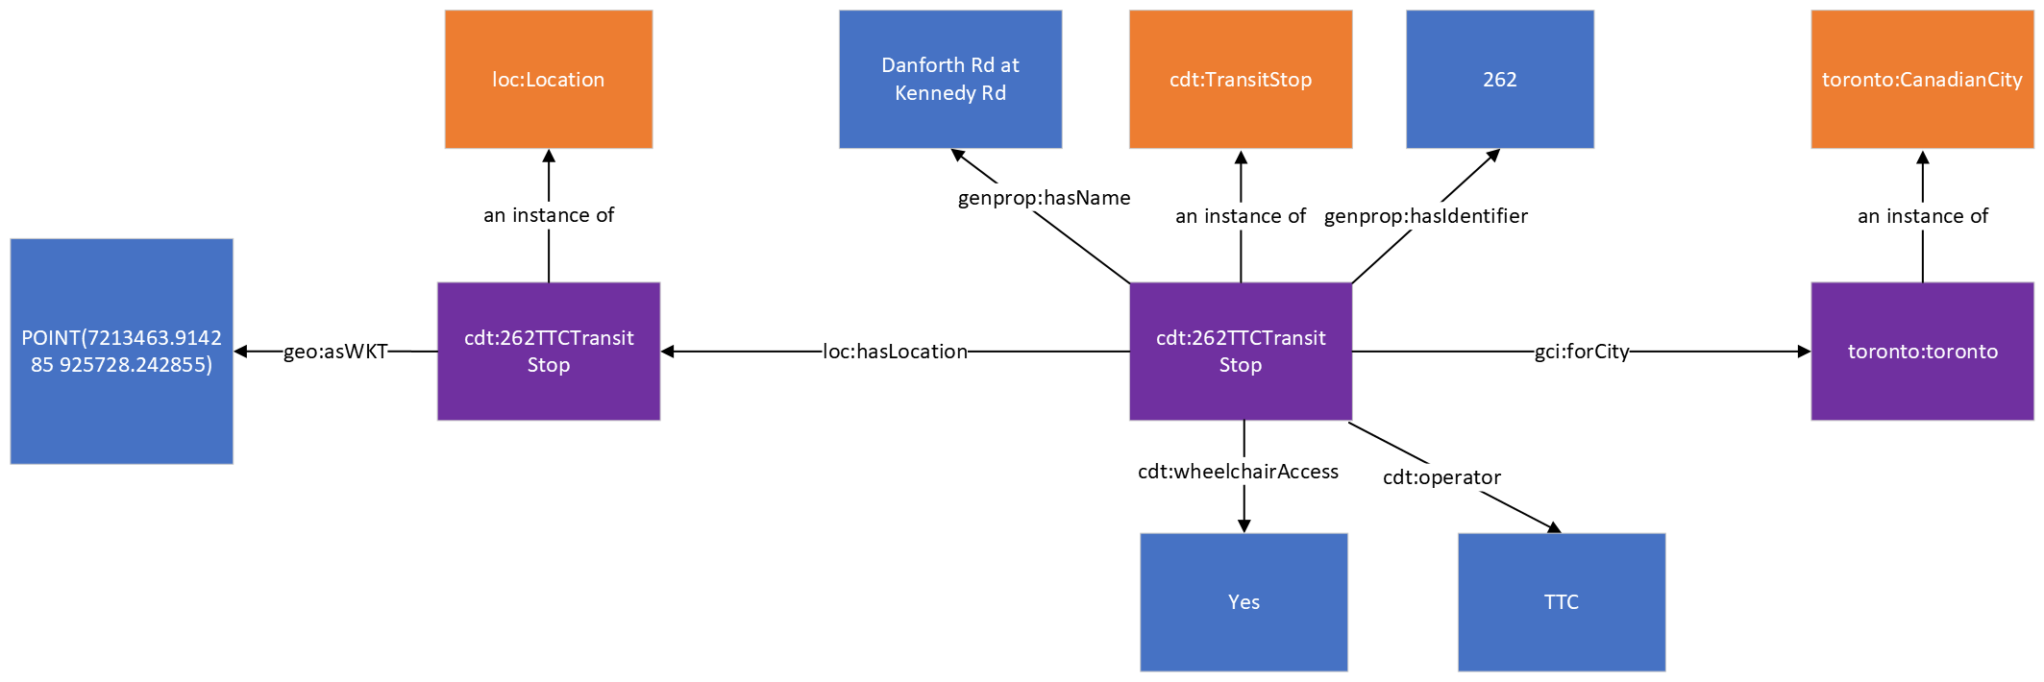
The following table describes the mapping of the OpenStreetMap Supermarket data onto the City Digital Twin ontology.
 | Subject | Property | Value
Stop  Each row in the stops.csv file corresponds to one transit stop | cdt:{stop_id}TransitStop | rdf:type | cdt:TransitStop
Location  The geospatial location of the stop is expressed in latitude and longitude values which are referred to as “stop_lat” and “stop_lon”respectively in the dataset. This information is converted into WKT format in the City Digital Twin. | cdt:{stop_id}TransitStop | loc:hasLocation | loc:Location
stop_name  The name of the stop | cdt:{stop_id}TransitStop | genprop:hasName | xsd:string
stop_id  The unique identifier for the stop | cdt:{stop_id}TransitStop | genprop:hasIdentifier | "{stop_id}”
wheelchair_boarding  Indicates whether the stop is wheelchair accessible | cdt:{stop_id}TransitStop | cdt:wheelchairAccess | “{wheelchair_boarding}”
Operator  The operator information does not directly appear in the CSV file, but all stops in the dataset from the Toronto Open Data portal are operated by the TTC | cdt:{stop_id}TransitStop | cdt:operator | "Toronto Transit Commission"

Library
This is the ontological representation of the library data. Libraries are represented as instances of the Library class which is a subclass of an Organization class. Libraries can have a name which is linked via the hasName property, a unique identifier which is linked via the hasIdentifier property, an address which his linked via the orgAddress property, services that it provides via the providesService property, a website which is linked via the website property, a branch code which is linked via the branchCode property, its operating hours which is linked via the operatingHours property, a site that represents the physical premise of the library which is linked via the hasSite property, and more. The site of a Library, can have an indicator for whether it is wheelchair accessible using the wheelchairAccess property, a Location instance and a set of geospatial coordinates linked using the hasLocation and asWKT property respectively, and more.
The Toronto Open Data Portal, is one of the datasets used. The dataset is strictly around Toronto Public Libraries, where each library contains the same pieces of information. Meanwhile, the OpenStreetMap dataset is a wide collection of various libraries in Toronto. OpenStreetMap also contains a random assortment of properties related to each library, meaning there is no fixed set of properties that each library has.
This section provides a brief summary of how the tags used in OpenStreetMap and Toronto Open Data Portal were mapped into the ontology used in the City Digital Twin.
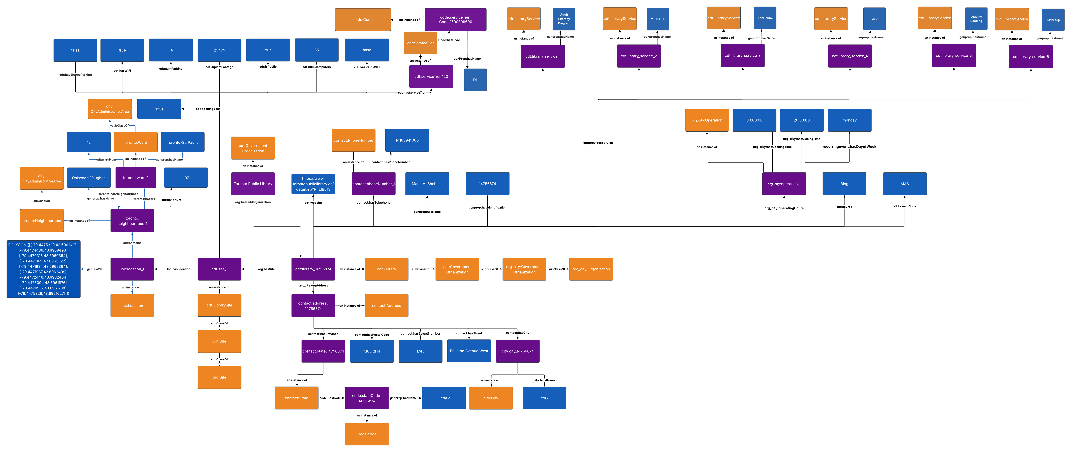Figure 1: Example Mapping for ORN's representation of a Libraries to the City Digitial Twin
Data Provided by OpenStreetMap
Field Name | Subject | Property | Object | Notes
@id | cdt:library_{@id} | genprop: hasIdentifier | {@id} | Not official. Uniquely identifies the OSM object (node, way, or relation).
 | cdt:library_{@id | rdf:type | cdt:Library
 | cdt:addLibrary_{@id} | rdf:type | contact:Address
 | cdt:library_site_{@id} | rdf:type | cdt:Site
access | cdt:library_{@id} | cdt:isPublic | xsd:boolean | For describing the legal accessibility of a feature.
addr:city | cdt:addLibrary_{@id} | contact:hasCity | city:city_{@id} | The name of the largest settlement (city / town / other) that is included in the address.
 | city:city_{@id} | rdf:type | city:City
 | city:city_{@id} | contact:legalName | {addr:city}
addr:floor | cdt:library_site_{@id} | cdt:numFloor | {addr:floor} | The floor where an address feature is located, using locally used method of indicating specific floor.
addr:housename | cdt:library_{@id} | genprop:hasName | {addr:housename} | The house (or building) name that is included in the address. Popular in some countries like England, Spain, Portugal, Latvia instead of, or in addition to, a house number
addr:housenumber | cdt:addLibrary_{@id} | contact: houseNumber | {addr: housenumber} | The house number (may contain letters, dashes or other characters).
addr:postcode | cdt:addLibrary_{@id} | contact: hasPostcode | {addr:postcode} | The postal code / zip code that is included in the address.
addr:province | cdt:addLibrary_{@id} | contact:hasProvince | contact:state_ {@id} | The name of the province that is included in the address. A province is almost always an administrative division within a country or state.
 | contact:state_ {@id} | rdf:type | contact:State
 | contact:state_{@id} | Code:hasCode | code:state_Code_{@id}
 | code:state_Code_{@id} | genprop:hasName | {addr:province}
addr:street | cdt:addLibrary_{@id} | contact:hasStreet | {addr:street} | The street name that this address is (and any others in this location are) grouped by. This street name should match that of a nearby road, track or path.
after_hours_return | cdt:library_site_{@id} | cdt:afterHoursReturns | xsd:boolean | Not official. Indicates the availability of a book/media return slot or similar feature when the facility is closed.
air_conditioning | cdt:library_site_{@id} | cdt:airConditioning | xsd:boolean | Indication whether a feature has air-conditioning
architect | cdt:library_site_{@id} | cdt:architect | {architect} | Name of architect
building | cdt:library_{@id} | cdt:isPublic  if value is ‘yes’ | xsd:boolean | To mark the outline of a building, a man-made structure with a roof, standing more or less permanently in one place.
 | cdt:library_site_{@id} | cdt:hasBuildingType | cdt:buildingType_ {building}
 | cdt:buildingType_ {building} | rdf:type | cdt:BuildingType
building:colour | cdt:library_site_{@id} | cdt:hasColor | cdt:color_ {building:colour} | Indicates colour of the building.
 | cdt:color_ {building:colour} | rdf:type | cdt:Color
building:material | cdt:library_site_{@id} | cdt:material | cdt:material_ {building:material} | Outer material for the building façade
 | cdt:material_ {building:material} | rdf:type | cdt:Material
built_date | cdt:library_site_{@id} | cdt:openingYear | {built_year} | Not official. Specifies the construction date of a building or structure.
capacity | cdt:library_site_{@id} | cdt:maxOccupancy | {maxOccupancy} | Describes the capacity a facility is suitable for.
check_date | cdt:library_site_{@id} | cdt:revisionDate | {check_date} | Date of latest review of the data. Format: YYYY-MM-DD.
description | cdt:library_site_{@id} | genprop: hasDescription | {description} | To provide additional information about the related element to the end map user.
email | cdt:library_site_{@id} | cdt:hasEmail | cdt:email_{@id} | An email address associated with the object
height | cdt:library_site_{@id} | cdt:height | {height} | Height is the measurement of vertical distance. It indicates how "tall" something is.
internet_access | cdt:library_site_{@id} | cdt: hasInternetAccess | xsd:boolean | Indicates if an object offers internet access. The access can be with given computers or WLAN access. The only limitation is that the internet access has to be public.
internet_access:fee | cdt:library_site_{@id} | cdt:hasPaidWIFI | xsd:boolean | Indicates whether a fee is required to access internet service offered at a feature.
internet_access:ssid | cdt:library_site_{@id} | cdt:ssid | {internet_access: ssid} | Specifies the "ssid", also know as the network name, of a WLAN wireless internet network (Wi-Fi).
name | cdt:library_{@id} | genProp:hasName | {name} | The primary name: in general, the most prominent signposted name or the most common name in the local language(s).
name:fr | cdt:library_{@id} | cdt:frName | {name:fr} | A name in French.
name:ta | cdt:library_{@id} | cdt:taName | {name:ta} | A name in Tamil
name:zh | cdt:library_{@id} | cdt:zhName | {name:zh} | A name in Chinese
note | cdt:library_site_{@id} | genprop: hasDescription | {note} | A note to yourself or to other mappers.
opening_hours | cdt:library_{@id} | org_city: operatingHours | org:{day}_{@id} | Describes when something is open or closed in a standard format. {day}, {closing_time} and {opening_time} is gotten from opening_hours.
 | org:{day}_{@id} | org:hasOpeningTime | {opening_time}
 | org:{day}_{@id} | org:hasClosingTime | {closing_time}
 | org:{day}_{@id} | Recurringevent: hasDayofWeek | {day}
 | org:{day}_{@id} | cdt:material_ {building:material} | org:Operator
operator | org:{operator} | org: hasSubOrganization | cdt:library_{@id} | Сompany, corporation, person or any other entity who is directly in charge of the current operation of a map object
operator:type | org:{operator} | rdf:type | org:Government Organization | Defines the type of operator, eg. "public", "private", "government".  if {operator:type} == “government”
parking | cdt:library_site_{@id} | cdt:hasParkingType | cdt:parking_ {parking} | Indicates the type of the parking facility
 | cdt:parking_ {parking} | rdf:type | cdt:ParkingType
phone | cdt:library_{@id} | contact: hasTelephone | contact: phone_{@id} | A telephone number associated with the object. Use +CC XXX XXX XXX format, where CC is a country code
 | phone_{@id} | rdf:type | contact:  PhoneNumber
 | contact: phone_{@id} | contact:has TelephoneNumber | {phone}
ref | cdt:library_{@id} | cdt:branchCode | {ref} | Used for reference numbers or codes. Common for roads, highway exits, routes, entrances to big buildings etc.
return_machine | cdt:library_site_{@id} | cdt: hasReturnMachine | xsd:boolean | Not official. Indicates whether a facility has a machine-based return system, such as an automated book drop or self-service return kiosk.
roof:colour | cdt:library_site_{@id} | cdt:roofColor | cdt:color_ {roof:colour } | Colour of the roof
 | cdt:color_ { roof:colour } | rdf:type | cdt:Color
roof:material | cdt:library_site_{@id} | cdt:roofMaterial | cdt:material_ {roof:material} | Outer material for the building roof.
 | cdt:material_ {roof:material} | rdf:type | cdt:Material
self_checkout | cdt:library_site_{@id} | cdt:hasSelfCheckout | xsd:boolean | If a shop has a self-checkout counter.
source | cdt:library_{@id} | cdt:dataSource | {source} | For indicating the source of all tags added to the OSM database. Show/edit corresponding data item.
stars | cdt:library_site_{@id} | cdt:rating | {stars} | Used to classify or rate certain places (e.g. restaurants, hotels, camp sites).
stars:system | cdt:library_site_{@id} | cdt:rating | {stars:system} | Specifies the rating system used for the stars=* tag.
start_date | cdt:library_site_{@id} | cdt:openingYear | {start_date} | Date when feature opened or the construction of the feature finished.
toilets | cdt:library_site_{@id} | cdt:hasToilets | xsd:boolean | Indicates if a feature has a toilet.
geometry | cdt:library_site_{@id} | loc:hasLocation | loc:location_{@id} | Geometry of the library.
 | loc:location_{@id} | rdf:type | loc:Location
 | loc:location_{@id} | geo:asWKT | {geometry}
website | cdt:library_{@id} | cdt:website | {website} | Specifies the link to the official website for a feature.
wheelchair | cdt:library_site_{@id} | cdt: wheelchairAccess | xsd:boolean | Indicate if a special place can be used with wheelchairs
Table 1: Mapping OpenStreetMap Library Data to City Digital Twin

Data Provided by Toronto Open Data
Field Name | Subject | Property | Object | Notes
_id | cdt:library_{_id} | genprop:hasIdentifier | xsd:string | Unique row identifier for Open Data database
 | cdt:library_{_id | rdf:type | cdt:Library
 | cdt:addLibrary_{_id} | rdf:type | contact:Address
 | cdt:library_site_{_id} | rdf:type | cdt:Site
BranchCode | cdt:library_{_id } | cdt:branchCode | {BranchCode} | A code identifying the TPL branch.
PhysicalBranch | cdt:library_{_id } | cdt:isPublic | xsd:boolean | Library branches with fixed locations are set to 1. Other TPL services and collections are set to 0.
BranchName | cdt:library_{_id } | genprop:hasName | {BranchName} | The name of the library branch.
Address | cdt:addLibrary_{_id } | contact:hasStreet | {street} | The full address of the branch. Address has {street}, {street_number}, {city}, and {province} all in one string.
 |  | contact: hasStreetNumber | {street_number}
 |  | contact:hasCity | city:city_{_id}
 |  | contact:hasProvince | contact:state_ {_id}
 | city:city_{_id} | rdf:type | city:City
 |  | contact:legalName | {city}
 | contact:state_ {_id} | rdf:type | contact:State
 |  | Code:hasCode | code:state_ Code_{_id}
 |  | genprop:hasName | {province}
PostalCode | cdt:addLibrary_{_id } | contact:hasPostcode | {PostalCode} | The branch postal code.
Website | cdt:library_{_id } | cdt:website | {website} | The branch website.
Telephone | cdt:addLibrary_{_id } | contact: hasTelephone | contact: phone_{_id} | The phone number for the branch.
 | phone_{_id} | rdf:type | contact:  PhoneNumber
 | contact: phone_{@id} | contact:has TelephoneNumber | {Telephone }
SquareFootage | cdt:library_site_{_id} | cdt:squareFootage | {SquareFootage} | The total size of the branch in square feet.
PublicParking | cdt:library_site_{_id} | cdt:numParking | {PublicParking} | The number of parking spaces available for the public. If a branch does not have any public parking spaces, this field is set to 0. If a branch shares parking spaces with another location (community centre, mall, etc.), this field is set to “shared”.
 | cdt:library_site_{_id} | cdt: hasSharedParking | xsd:boolean
KidsStop | cdt:library_site_{_id} | cdt:providesService | cdt:kids_ stop_{_id} | This field denotes the presence of a KidsStop (1 for present, 0 for not present). KidsStops are learning and reading spaces created for parents and young children.
 | cdt:kids_stop_{_id} | rdf:type | cdt: LibraryService
 | cdt:kids_stop_{_id} | genprop:hasName | {KidsStop}
Leading Reading | cdt:library_site_{_id} | cdt:providesService | cdt: leadingReading_serv_{_id} | This field denotes the presence of the Leading To Reading service (1 for present, 0 for not present). Leading to Reading is a free service for children to receive one-on-one help and encouragement with their reading and writing skills.
 | cdt:leadingReading_ serv_{_id} | rdf:type | cdt: LibraryService
 | cdt:leadingReading_ serv_{_id} | genprop:hasName | {Leading Reading}
CLC | cdt:library_site_{_id} | cdt:providesService | cdt:clc_serv_ {_id} | This field denotes the presence of a Computer Learning Centre (1 for present, 0 for not present). CLCs are computer labs that offer hands-on technology classes.
 | cdt:clc_serv_{_ id} | rdf:type | cdt: LibraryService
 | cdt:clc_serv_{_ id} | genprop:hasName | {CLC}
DIH | cdt:library_site_{_id} | cdt:providesService | cdt:dih_serv_{_ id} | This field denotes the presence of a Digital Innovation Hub (1 for present, 0 for not present). DIHs are learning and creation spaces with computers, professional software, and a wide variety of equipment, including 3D printers, audio and video production tools, Arduinos, and more.
 | cdt:dih_serv_{_ id} | rdf:type | cdt: LibraryService
 | cdt:dih_serv_{_ id} | genprop:hasName | {DIH}
TeenCouncil | cdt:library_site_{_id} | cdt:providesService | cdt:teenCouncil_serv_{_ id} | This field denotes the presence of a Teen Council (1 for present, 0 for not present). Teen Councils are groups of teens that attend monthly meetings with library staff, collaborate on group projects, and work to benefit their libraries and communities.
 | cdt: teenCouncil_serv_  {_ id} | rdf:type | cdt: LibraryService
 | cdt: teenCouncil_serv_  {_ id} | genprop:hasName | {TeenCouncil}
YouthHub | cdt:library_site_{_id} | cdt:providesService | cdt:youthHub_ serv_{_id} | This field denotes the presence of a Youth Hub (1 for present, 0 for not present). Youth Hubs are drop-in spaces where teens can study, chat with friends, use technology, or take part in activities such as arts and crafts and gaming.
 | cdt:youthHub_ serv_{_ id} | rdf:type | cdt: LibraryService
 | cdt:youthHub_ serv_{_ id} | genprop:hasName | {YouthHub}
AdultLiteracy Program | cdt:library_site_{_id} | cdt:providesService | cdt:adultLiteracy_serv_{_id} | This field denotes the presence of the Adult Literacy Program service (1 for present, 0 for not present). The Adult Literacy Program offers free, one-on-one tutoring in basic reading, writing, and math for English-speaking adults 19 years or older (exceptions may apply)
 | cdt: adultLiteracy_serv_  {_id} | rdf:type | cdt: LibraryService
 | cdt: adultLiteracy_serv_  {_id} | genprop:hasName | {AdultLiteracy Program}
Workstations | cdt:library_site_{_id} | cdt:numComputer | {Workstations} | A count of computers with internet access available for public use in the branch.
ServiceTier | cdt:library_site_{_id} | cdt:hasServiceTier | cdt:serviceTier_{_id} | Service tier refers to the scope and scale of the branch/service.  NL - Neighbourhood branches provide collections and services that meet many of the needs of the immediate community. Bookmobiles and Home Library Service are part of the NL service tier.  DL - District branches offer extensive informational and recreational collections, as well as services that meet the needs of the immediate community and the larger district.  RR - Research and reference branches provide comprehensive and specialized collections, as well asservices with an emphasis on access.  RA - Remote access offers self-serve systems (online and by phone).  OT - Other service activities.  For more information, please refer to Toronto Public Library’s Service Delivery Model
 | cdt:serviceTier_{_id} | rdf:type | cdt:ServiceTier
 | cdt:serviceTier_{_id} | code:Code | code:tierCode_ {_id}
 | code:tierCode_{_id} | genprop:hasName | {ServiceTier}
Lat | cdt:library_site_{_id} | loc:hasLocation | loc:location_ {_id} | The latitude coordinate of the branch.
Long |  |  |  | The longitude coordinate of the branch.
 | loc:location_ {_id} | rdf:type | loc:Location
 | loc:location_ {_id} | geo:asWKT | POINT ({Long} {LAT})
NBHDNo | toronto: neighbourhood_{_id} | rdf:type | toronto: Neighbourhood | The ID number of the neighbourhood associated with the branch. Neighbourhood boundaries are designated by the City of Toronto. For more details, please refer to this website
 | toronto: Neighbourhood | cdt:nbhdNum | {NBHDNo}
NBHDName | toronto: neighbourhood_{_id} | genprop:hasName | {NBHDName} | The name of a neighbourhood.
TPLNIA | cdt:library_site_{_id} | cdt:providesService | cdt:tplnia_serv_ {_id} | This field denotes whether the branch serves a neighbourhood improvement area (1 for yes, 0 for no). A branch serving a NIA may be located inside its boundaries or nearby. NIAs are designated by the City of Toronto. For more details, please refer to this website
 | cdt:tplnia_serv_{_id} | rdf:type | cdt: LibraryService
 | cdt:tplnia_serv_{_id} | genprop:hasName | {TPLNIA}
WardNo | toronto:ward_{_id} | rdf:type | toronto:Ward | The ID of the municipal ward associated with the branch.
 | toronto:ward_{_id} | cdt:wardNum | {WardNo}
WardName | toronto:ward_{_id} | genprop:hasName | {WardName} | The name of the municipal ward.
Present SiteYear | cdt:library_site_{_id} | cdt:openingYear | {PresentSite Year} | The year that the present location of the branch was officially opened to the general public.
Table 2: Mapping Toronto Open Data Portal Library Data to City Digital Twin

Implementation of Library Data in Mapping TTL
All URIs are generated using a consistent base namespace (http://ontology.eil.utoronto.ca/CDT#). Instances of cdt:Library, cdt:LibrarySite, and related classes are assigned URIs using their source dataset identifiers (e.g., _id from the CSV, @id from the GeoJSON) to ensure traceability. For example, Library branches use the format cdt:library_{id} and Sites use the format cdt:library_site_{id}. This ensures each instance is uniquely and consistently defined in the RDF graph.
Inputs:
- tpl-branch-general-information-2023.csv (Toronto Public Library branch metadata)
- Library.geojson (spatial geometries and metadata from OSM)
Outputs:
- Turtle (.ttl) RDF file that semantically represents Toronto’s public library network, instantiating:
  - cdt:Library entities
  - cdt:LibrarySite entities
  - Related organizational, location, and CDT classes
Step 1: Load and Prepare Data
- Load CSV and GeoJSON datasets into memory.
- Map identifiers and merge attributes based on unique branch IDs.
Step 2: Create Library Instances
- For each library branch, instantiate cdt:Library (a subclass of cdt:GovernmentOrganization and org:Organization).
- Add core properties such as cdt:branchCode, cdt:isPublic, multilingual names (cdt:frName, cdt:taName, cdt:zhName), and cdt:website.
Step 3: Link to Address and Contact Information
- Create contact:Address instances and populate street, number, city, province, and postal code.
- Assign telephone numbers via contact:PhoneNumber.
Step 4: Associate Sites with Libraries
- For each branch, create a cdt:LibrarySite entity linked via org:hasSite.
- Populate site-level attributes such as cdt:squareFootage, cdt:publicParking, cdt:numComputers, cdt:openingYear, neighbourhood and ward identifiers, and cdt:hasServiceTier.
Step 5: Add Facilities, Services, and Accessibility Data
- From CSV: Include cdt:tplnia, cdt:LeadingReading, cdt:computerLC, cdt:digitalIH, cdt:TeenCouncil, cdt:YouthHub, and cdt:AdultLiteracyProgram.
- From GeoJSON: Add building details (cdt:hasBuildingType, cdt:hasColor, cdt:madeOf), amenities (cdt:hasToilets, cdt:hasSelfCheckout, cdt:returnMachine), accessibility (cdt:wheelchairAccess), and connectivity (cdt: hasInternetAccess, cdt:hasPaidWIFI, cdt:ssid).
Step 6: Parse and Model Operating Hours
- Extract and normalize opening_hours strings into org:Operation instances, storing opening and closing times and linking them to days of the week via recurringevent:hasDayofWeek.
Step 7: Assign Geospatial Data
- For each site, create a loc:Location entity containing geo:asWKT point geometries derived from the latitude/longitude coordinates in CSV or GeoJSON.
Step 8: Linking Data for Libraries in Both Datasets
- Each Library in the Open Data Portal has an associated name and associated URIs that are added to a global list variable.
  - tpl_library.append([row['BranchName'], branch_uri, site_uri, row['_id']])
- Then, while parsing through the OSM dataset, there is a checking to see if the name of the library is a substring of any of the library names that were in the global list.
  - If yes, then the associated branch and site URIs are used to map any new data that is in the OSM, but not in the open data portal (and skips data that was already accounted for by the open data portal, as the open data portal is more reliable)
  - If no, then entirely new library and site instances are created to map all the associated data given by OSM.

Step 9: Serialize TTL Output
- The complete RDF graph is serialized into Turtle format (toronto_libraries.ttl), suitable for loading into semantic graph databases.

Library CDT Classes and Properties
The following custom classes and properties were are introduced as part of the City Digital Twin ontology, extending the ISO/IEC 5087 ontologies to capture the information defined in OSM and Toronto open data portal.
- Library: defined as a specialization of cdt:Organization. This class introduces additional characteristics specific to library facilities within the City Digital Twin ontology. The full set of additional properties defined for Library are listed below.
  - website: the website property is a defined property for the cdt:Library class. In the context of the OSM and Toronto Open Data mapping, website was defined to record the URL of the library’s official website, providing direct access to online resources and service information.
  - branchCode: the branchCode property is a defined property for the cdt:Library class. In the context of the OSM and Toronto Open Data mapping, branchCode was defined to record a code or identifier assigned to the library branch, typically used for administrative or cataloguing purposes.
  - isPublic: the isPublic property is a defined property for the cdt:Library class. In the context of the OSM and Toronto Open Data mapping, isPublic was defined to indicate whether the library is publicly accessible, represented as a boolean value (true if public, false if private or restricted).
  - frName: the frName property is a defined property for the cdt:Library class. In the context of the OSM and Toronto Open Data mapping, frName was defined to record the French-language name of the library, where available.
  - taName: the taName property is a defined property for the cdt:Library class. In the context of the OSM and Toronto Open Data mapping, taName was defined to record the Tamil-language name of the library, where available.
  - zhName: the zhName property is a defined property for the cdt:Library class. In the context of the OSM and Toronto Open Data mapping, zhName was defined to record the Chinese-language name of the library, where available.
  - dataSource: the dataSource property is a defined property for the cdt:Library class. In the context of the OSM and Toronto Open Data mapping, dataSource was defined to indicate the source dataset or system from which the library record was derived.
- LibrarySite: defined as a specialization of cdt:Organization, and a subClassOf of cdt:LibrarySite. This class introduces additional characteristics describing the physical site of a facility within the City Digital Twin ontology. The full set of additional properties defined for Site are listed below.
  - providesService: the providesService property is a defined property for the cdt:LibrarySite class. In the context of the OSM and Toronto Open Data mapping, providesService was defined to indicate the cdt:LibraryService or services offered at the site.
  - numFloor: the numFloor property is a defined property for the cdt:LibrarySite class. In the context of the OSM and Toronto Open Data mapping, numFloor was defined to record the number of floors in the primary building(s) on the site.
  - airConditioning: the airConditioning property is a defined property for the cdt:LibrarySite class. In the context of the OSM and Toronto Open Data mapping, airConditioning was defined to indicate whether the site’s facility is equipped with air conditioning, represented as a boolean value (true if present).
  - hasBuildingType: the hasBuildingType property is a defined property for the cdt:LibrarySite class. In the context of the OSM and Toronto Open Data mapping, hasBuildingType was defined to classify the site’s main building according to a defined cdt:BuildingType category.
  - hasColor: the hasColor property is a defined property for the cdt:LibrarySite class. In the context of the OSM and Toronto Open Data mapping, hasColor was defined to indicate the color of the facility’s main building exterior.
  - madeOf: the madeOf property is a defined property for the cdt:LibrarySite class. In the context of the OSM and Toronto Open Data mapping, madeOf was defined to indicate the primary construction material of the facility’s main building.
  - openingYear: the openingYear property is a defined property for the cdt:LibrarySite class. In the context of the OSM and Toronto Open Data mapping, openingYear was defined to record the year in which the facility first opened, represented as an xsd:year value.
  - maxOccupancy: the capacity property is a defined property for the cdt:LibrarySite class. In the context of the OSM and Toronto Open Data mapping, capacity was defined to record the maximum number of occupants or users the facility can accommodate.
  - revisionDate: the revisionDate property is a defined property for the cdt:LibrarySite class. In the context of the OSM and Toronto Open Data mapping, revisionDate was defined to record the date when the facility record was last updated in the source database.
  - hasEmail: the hasEmail property is a defined property for the cdt:LibrarySite class. In the context of the OSM and Toronto Open Data mapping, hasEmail was defined to specify the facility’s primary contact email address.
  - height: the height property is a defined property for the cdt:LibrarySite class. In the context of the OSM and Toronto Open Data mapping, height was defined to indicate the vertical height of the building, using the Length class specified in cityunits:Length.
  - hasInternetAccess: the hasInternetAccessproperty is a defined property for the cdt:LibrarySite class. In the context of the OSM and Toronto Open Data mapping, hasInternetAccess was defined to classify if wireless internet service is available at the site.
  - hasPaidWIFI: the hasPaidWIFI property is a defined property for the cdt:LibrarySite class. In the context of the OSM and Toronto Open Data mapping, hasPaidWIFI was defined to indicate whether payment is required to access the site’s WiFi service, represented as a boolean value.
  - ssid: the ssid property is a defined property for the cdt:LibrarySite class. In the context of the OSM and Toronto Open Data mapping, ssid was defined to specify the WiFi network SSID provided at the site.
  - hasParkingType: the hasParkingType property is a defined property for the cdt:LibrarySite class. In the context of the OSM and Toronto Open Data mapping, hasParkingType was defined to indicate the type of parking used by the library.
  - hasSharedParking: the hasSharedParking property is a defined property for the cdt:LibrarySite class. In the context of the OSM and Toronto Open Data mapping, hasSharedParking was defined to specify if the library’s parking arrangement is shared with another organization.
  - numParking: the numParking property is a defined property for the cdt:LibrarySite class. In the context of the OSM and Toronto Open Data mapping, numParking was defined to specify if the number of parking spaces available in the library’s parking arrangement.
  - hasReturnMachine: the hasReturnMachine property is a defined property for the cdt:LibrarySite class. In the context of the OSM and Toronto Open Data mapping, hasReturnMachine was defined to indicate whether the facility has an automated return machine for items, represented as a boolean value.
  - roofColor: the roofColor property is a defined property for the cdt:LibrarySite class. In the context of the OSM and Toronto Open Data mapping, roofColor was defined to indicate the color of the roof of the facility’s main building.
  - roofMaterial: the roofMaterial property is a defined property for the cdt:LibrarySite class. In the context of the OSM and Toronto Open Data mapping, roofMaterial was defined to indicate the construction material of the facility’s roof.
  - hasSelfCheckout: the hasSelfCheckout property is a defined property for the cdt:LibrarySite class. In the context of the OSM and Toronto Open Data mapping, hasSelfCheckout was defined to indicate whether the facility offers self-checkout services, represented as a boolean value.
  - rating: the rating property is a defined property for the cdt:LibrarySite class. In the context of the OSM and Toronto Open Data mapping, rating was defined to indicate a numerical or decimal score representing the facility’s quality, popularity, or service standard.
  - hasToilets: the hasToilets property is a defined property for the cdt:LibrarySite class. In the context of the OSM and Toronto Open Data mapping, hasToilets was defined to indicate whether the facility has public toilet facilities, represented as a boolean value.
  - wheelchairAccess: the wheelchairAccess property is a defined property for the cdt:LibrarySite class. In the context of the OSM and Toronto Open Data mapping, wheelchairAccess was defined to indicate whether the facility is accessible to wheelchair users, represented as a boolean value.
  - squareFootage: the squareFootage property is a defined property for the cdt:LibrarySite class. In the context of the OSM and Toronto Open Data mapping, squareFootage was defined to record the area of the facility in square feet, represented using cityunits:Area.
  - publicParking: the publicParking property is a defined property for the cdt:LibrarySite class. In the context of the OSM and Toronto Open Data mapping, publicParking was defined to indicate the number of public parking spaces available at the site.
  - numComputer: the numComputer property is a defined property for the cdt:LibrarySite class. In the context of the OSM and Toronto Open Data mapping, numComputer was defined to indicate the number of publicly available computers at the facility.
  - hasServiceTier: the hasServiceTier property is a defined property for the cdt:LibrarySite class. In the context of the OSM and Toronto Open Data mapping, hasServiceTier was defined to classify the level of service offered by the facility, according to the cdt:ServiceTier classification.
  - nbhdNum: the nbhdNum property is a defined property for the cdt:LibrarySite class. In the context of the OSM and Toronto Open Data mapping, nbhdNum was defined to indicate the neighborhood number in which the facility is located.
  - wardNum: the wardNum property is a defined property for the cdt:LibrarySite class. In the context of the OSM and Toronto Open Data mapping, wardNum was defined to indicate the ward number in which the facility is located.
  - contains: the contains property is a defined property for the cdt:LibrarySite class. In the context of the OSM and Toronto Open Data mapping, contains was defined to indicate what CityAdministrativeArea are in the location of the library, and in this case which Neighbourhood and Ward.
- LibraryService: defined as a subclass of cdt:Service. In the context of the OSM and Toronto Open Data mapping, this class was introduced to represent a specific service offered by a library. It is linked to a cdt:LibrarySite through the cdt:providesService property and allows categorization, naming, and description of services.
- BuildingType: defined as a controlled vocabulary class (cdt:BuildingType) representing the structural or functional classification of a building. In the context of the OSM and Toronto Open Data mapping, this class was defined to support consistent classification of facility buildings (e.g., library branch, community center, administrative building).
- Color: defined as a controlled vocabulary class (cdt:Color) representing colors used to describe the exterior or roof of a building. In the context of the OSM and Toronto Open Data mapping, this class was defined to capture standardized color values for data such as cdt:hasColor and cdt:roofColor.
- Material: defined as a controlled vocabulary class (cdt:Material) representing the primary construction materials of a facility’s structure or roof. In the context of the OSM and Toronto Open Data mapping, this class was defined to provide standardized descriptors for materials such as brick, concrete, glass, or metal.
- Email: defined as a datatype property class (cdt:Email) representing an email contact address. In the context of the OSM and Toronto Open Data mapping, this class was defined to store standardized email addresses for facilities and organizations.
  - emailAddress: the emailAddress property is a defined property for cdt:Email class. In the context of the OSM and Toronto Open Data mapping, emailAddress indicate the email address of the library as a string value.
- ServiceTier: defined as a controlled vocabulary class (cdt:ServiceTier) representing the level of service offered by a facility. In the context of the OSM and Toronto Open Data mapping, this class was defined to capture distinctions such as basic, standard, or premium service tiers, supporting service-level reporting.
- ParkingType: defined as a controlled vocabulary class (cdt: ParkingType) representing the structural or functional classification of a Parking area. In the context of the OSM and Toronto Open Data mapping, this class was defined to support consistent classification of different types of parking in an area.

Class | Property | Value
cdt:Library | subClassOf | cdt:Organization
 | cdt:website | xsd:string
 | cdt:branchCode | xsd:string
 | cdt:isPublic | xsd:boolean
 | cdt:frName | xsd:string
 | cdt:taName | xsd:string
 | cdt:zhName | xsd:string
 | cdt:dataSource | xsd:string
cdt:LibrarySite | rdfs:subClassOf | cdt:Site
 | cdt:providesService | cdt:LibraryService
 | cdt:numFloor | xsd:integer
 | cdt:airConditioning | xsd:boolean
 | cdt:hasBuildingType | cdt:BuildingType
 | cdt:hasColor | cdt:Color
 | cdt:madeOf | cdt:Material
 | cdt:openingYear | xsd:year
 | cdt:maxOccupancy | xsd:integer
 | cdt:revisionDate | xsd:date
 | cdt:hasEmail | cdt:Email
 | cdt:height | cityunits:Length
 | cdt:hasInternetAccess | xsd:boolean
 | cdt:hasPaidWIFI | xsd:boolean
 | cdt:ssid | org:Organization
 | cdt:numParking | xsd:integer
 | cdt:hasSharedParking | xsd:boolean
 | cdt:hasParkingType | cdt:ParkingType
 | cdt:hasReturnMachine | xsd:boolean
 | cdt:roofColor | cdt:Color
 | cdt:roofMaterial | cdt:Material
 | cdt:hasSelfCheckout | xsd:boolean
 | cdt:rating | xsd:decimal
 | cdt:hasToilets | xsd:boolean
 | cdt:wheelchairAccess | xsd:boolean
 | cdt:squareFootage | cityunits:Area
 | cdt:numComputer | xsd:integer
 | cdt:hasServiceTier | cdt:ServiceTier
 | cdt:nbhdNum | xsd:integer
 | cdt:contains | toronto:Neighbourhood
 | cdt:wardNum | xsd:integer
 | subClassOf | org:Site
Table 3: Key properties in the City Digital Twin Library Entity

Class | Property | Value
cdt:LibraryService | subClassOf | cdt:Service
cdt:BuildingType | code:hasCode | code:Code
cdt:Color | code:hasCode | code:Code
cdt:Material | code:hasCode | code:Code
cdt:Email | cdt:emailAddress | xsd:string
cdt:ServiceTier | code:hasCode | code:Code
Table 4: Key classes in the City Digital Twin Library Entity

Representation of Road Data
The Ontario Road Network (ORN) dataset represents the provincial road infrastructure and is segmented at real-world intersections or junctions. The primary dataset consists of a shapefile (ORN_ROAD_NET_ELEMENT.shp) that describes road geometries and includes fields such as OGF_ID (a unique identifier for each road element), FROM_JCT, and TO_JCT, which indicate the junctions that bound each segment, and more. These junction references establish a topological connection between road elements. Supplementary CSV files (e.g., ORN_ROAD_CLASS.csv, ORN_SPEED_LIMIT.csv) enrich the dataset with additional attributes, including road names, speed limits, lane counts, and more. The following is an Eexample of dData in the shp file for a road element:
FROM_JCT:1500091661 TO_JCT:1500045335
LENGTH:254.258 ACCURACY:3.0
NID:9bed6561cdbd438590abec7bf592d722 DIRECTION:Both
EXIT_NUM:18 ELEM_TYPE:ROAD ELEMENT
TOLL_ROAD:Yes ACQTECH:VECTOR DATA
CREDATE:20020401000000 REVDATE:None
GEO_UPDATE_DT:None EFF_DATE:20090123155815
In theThe above example defines, this is a road element identified by OGF_ID = 1509876543, that runs from junction 1501234567 to junction 1507654321, with a total length of 254.258 meters, has with a positional accuracy of 3.0 meters, and a unique national identifier of 9bed6561cdbd438590abec7bf592d722. It is a toll road that was created using vector data,, it has traffic flowing in both directions, an exit number of 18, it’s a type of road element, it is a toll road, it was created using vector data, had a creation date of April 1st 2002, a revision and geometry update date that is unknown, and a record creation date effective date (when record was created) of January 23rd 2009 (15 hours, 58 minutes, and 15 seconds). More information about these attributes is provided below.
Each road network element is bounded by a FROM_JCT and a TO_JCT, making it semantically aligned with corresponds to an instance of the RoadLink class in the ISO/IEC 5087-3 ontology. Each RoadLink begins and ends at a TransportNode, which corresponds to a Junction in the ontology
Thus, in our mapping the road network data to the City Digital Twin:
- ORN road net elements → transnet:RoadLink (subclass of TravelledWayLink)
- ORN junctions → transnet:Junction (subclass of TransportNode)
- A group of RoadLinks sharing the same street name → transnet:Road

The data was also filtered around only Toronto roads using the Toronto Bound Filter:
lat_min: 43.5810, lat_max: 43.8555, lon_min: -79.6393, lon_max: -79.1152

The following is a list of namespace prefixes used in the mappings and ontology definitions that follow:
- geo: http://www.opengis.net/ont/geosparql#
- transnet: https://standards.iso.org/isoiec/5087/3/ed1/en/ontology/TransportaionNetwork/
- transinfras: https://standards.iso.org/isoiec/5087/2/ed1/en/ontology/TransportationInfrastructure/
- loc: https://standards.iso.org/iso-iec/5087/-1/ed-1/en/ontology/SpatialLoc/>
- partwhole: https://standards.iso.org/iso-iec/5087/-1/ed-1/en/ontology/Mereology/
- cityunits: https://standards.iso.org/iso-iec/5087/-1/ed-1/en/ontology/CityUnits/
- cdt: http://ontology.eil.utoronto.ca/CDT#
- rdfs: http://www.w3.org/2000/01/rdf-schema#
- i72: http://ontology.eil.utoronto.ca/5087/2/iso21972/
- genprop: https://standards.iso.org/iso-iec/5087/-1/ed-1/en/ontology/GenericProperties/
- rdf: http://www.w3.org/1999/02/22-rdf-syntax-ns#
- contact: https://standards.iso.org/iso-iec/5087/-2/ed-1/en/ontology/Contact/
- code: https://standards.iso.org/iso-iec/5087/-2/ed-1/en/ontology/Code/
- infras: https://standards.iso.org/iso-iec/5087/-2/ed-1/en/ontology/Infrastructure/
- road: https://standards.iso.org/iso-iec/5087/-3/ed-1/en/ontology/RoadNetwork
- org_city: https://standards.iso.org/iso-iec/5087/-2/ed-1/en/ontology/Organization/
- xsd: http://www.w3.org/2001/XMLSchema#
- hp: http://ontology.eil.utoronto.ca/HPCDM#
- res: https://standards.iso.org/iso-iec/5087/-1/ed-1/en/ontology/Resource/
- orn: http://ontology.eil.toronto.ca/Ontario/OMNR/ORNELEM#

Junction
Junctions are an instance of a subclass/specialization of transnet:Junction and are a subclass of TransportNode. These entities connect travellers from one TravelledWayLink to another, in particular servingserving a connection between one or more RoadLinks. and is They are uniquely identified using ORN-provided IDs. Geospatial coordinates are linked using geo:Geometry pointing to a geo:asWKT. Each Junction participates in one or more ingress and egress relationships with RoadLinks, ensuring accurate topological representation of the network.
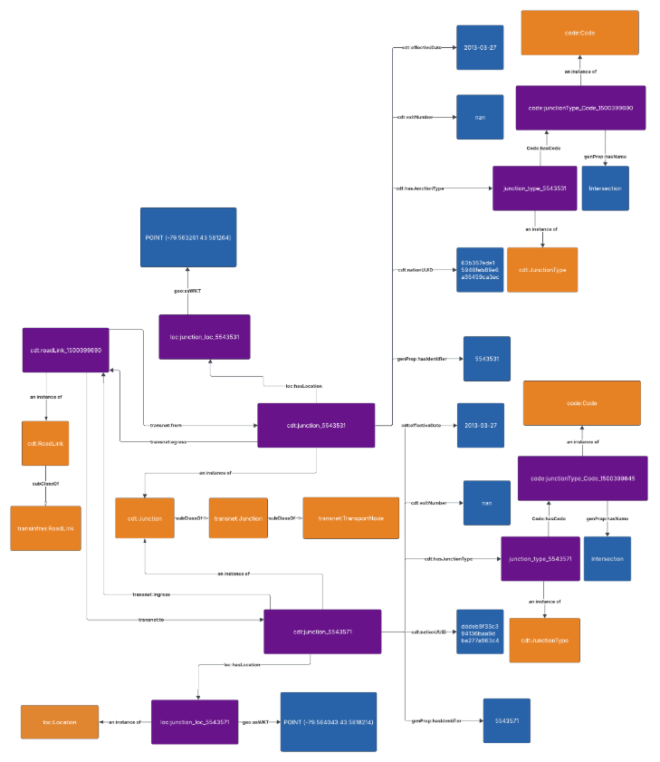

Figure 1: Example Mapping for ORN's representation of a Junction to the City Digitial Twin Road Network Pattern

Figure : Example Mapping for ORN’s representation of a Junction to the City Digital Twin Road Network Pattern.
F igure 1: Example Mapping for ORN’s representation of a Junction to the City Digital Twin Road Network Pattern.
Although the shp file does not have any information around the junctions beside which junctions bound the element, all the necessary iInformation regarding all the junctions in the dataset are in a specialis specified in the ORN_JUNCTIONS.csv file. And ID of the junction are specified in the csv along with its location, type, etc. (more on this below)
Note: All the CSV files had a data tag ORN_ROAD_NET_ELEMENT_ID, an Integer representing a system-generated identifier unique at the application level. This identifier corresponds to the OGF_ID in the shapefile, enabling consistent linkage between data in the CSV files and in the shapefile.
All tThe following properties are for associated with instances of the cdt:Junction class, which is a subclass of the Junction class in the TransportationNetwork ontology.
ORN_Junction.csv: A unique national identifier assigned to a road net element, junction and selected event data such as Toll Point, Blocked Passage and Structure which are required to support the National Road Network (NRN).
Note: All the following CSV files had a data tag ORN_ROAD_NET_ELEMENT_ID, an Integer representing a system-generated identifier unique at the application level.

Data Provided by ORN_JUNCTION.csv
Field Name | Subject | Property | Object | Notes
JUNCTION_ID | orn:Junction_ {JUNCTION_ID} | genprop:hasIdentifier | {JUNCTION_ID} | System-generated identifier, unique at the application level.
 | orn:Junction_ {JUNCTION_ID} | rdf:type | cdt:Junction
LATITUDE_DECIMAL_DEGREES | orn:Junction_ {JUNCTION_ID} | loc:hasLocation | loc:junction_loc_{JUNCTION_ID} | The latitude in decimal degrees.  The longitude in negative decimal degrees.  For each Junction individual, a new geo:Geometry individual is created and linked via  loc:hasLocation.  This geometry uses is defined with the geo:asWKT property using the LATITUDE_DECIMAL_DEGREES and LONGITUDE_DECIMAL_DEGREES with the POINT (lon lat) format.
LONGITUDE_DECIMAL_DEGREES
 | loc:junction_loc_{JUNCTION_ID} | rdf:type | loc:Location
 | loc:junction_loc_{JUNCTION_ID} | geo:asWKT | POINT ({LONGITUDE_ DECIMAL_ DEGREES } { LATITUDE_ DECIMAL_ DEGREES })
JUNCTION_TYPE | orn:Junction_{JUNCTION_ID} | cdt:hasJunctionType | orn:junction_ type_{JUNCTION_ID} | The classification of a junction is based on the valency of the junction. The number of road elements or ferry connections joining at a junction is termed the valency of a junction.  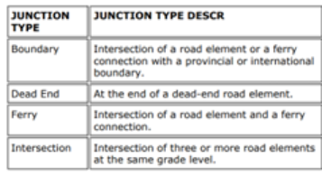
 | orn:junction_ type_{JUNCTION_ID} | rdf:type | cdt:JunctionType
 | orn:junction_ type_{JUNCTION_ID} | code:Code | code:junction Type_Code_ {JUNCTION_ID}
 | code:junction Type_Code_ {JUNCTION_ID} | genprop:hasName | {JUNCTION_ TYPE}
EXIT_NUMBER | orn:Junction_{JUNCTION_ID} | cdt:exitNumber | {EXIT_NUMBER} | The number of an exit on or off a freeway, expressway or highway, assigned by an administrating body and is represented by a valid number or character
NATIONAL_UUID | orn:Junction_{JUNCTION_ID} | cdt:nationUUID | {NATIONAL_ UUID} | A unique national identifier assigned to a road net element, junction and selected event data such as Toll Point, Blocked Passage and Structure which are required to support the National Road Network (NRN).
EFFECTIVE_ DATETIME | orn:Junction_{JUNCTION_ID} | cdt:effectiveDate | {EFFECTIVE_ DATETIME} | Date/time the record was created or last modified in the source database.

Table 1: Mapping ORN_JUNCTION.csv to City Digital Twin
Table 1: Mapping ORN_JUNCTION.csv to City Digital Twin

NOTE: The TO_JCT and FROM_JCT; are both junction IDs that are within the ORN_JUNCTION.csv files. So, using the ID, we can find the URI for the junction that has already been created. When the junction entities are found, then we use the properties above on the corresponding RoadLinks.
Data Provided by ORN_ROAD_NET_ELEMENT.shp:
Field Name | Subject | Property | Object | Notes
TO_JCT | orn:Junction_{JUNCTION_ID} | transnet:ingress | orn:roadLink_{OGF_ID} | The end junction for a road element or ferry connection.
FROM_JCT | orn:Junction_{JUNCTION_ID} | transnet:egress | orn:roadLink_{OGF_ID} | The beginning junction for a road element or ferry connection.

Table 2: Mapping ORN_ROAD_NET_ELEMENT.shp Junction data to City Digital Twin
Table 2: Mapping ORN_ROAD_NET_ELEMENT.shp Junction data to City Digital Twin

Road
A Road is modeled as a transinfras:Road, a subclass of TravelledWay, and is defined as a continuous sequence of RoadLinks that share a common entity (e.g., Highway 401, Dundas Street). A single RoadLink may be part of multiple Roads to accommodate overlapping entities. Each Road is linked to a unique designator (road name or number), and its extent is defined by the collective geometry of its constituent RoadLinks.
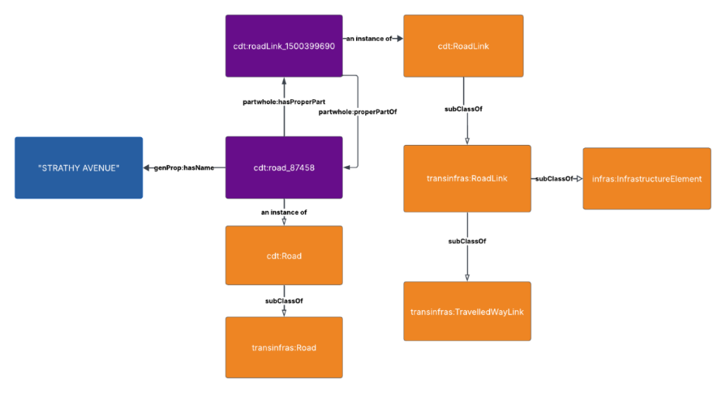
Figure 2: Example Mapping for ORN’s representation of a Road to the City Digital Twin Road Network Pattern.

Figure 2: Example Mapping for ORN’s representation of a Road to the City Digital Twin Road Network Pattern.

ORN_OFFICIAL_STREET_NAME.csv: An event identifying an official street name and may be associated with a bilingual name.
Data Provided by ORN_OFFICIAL_STREET_NAME.csv:
Field Name | Subject | Property | Object | Notes
FULL_STREET_NAME | orn:Road | genprop:hasName | {FULL_STREET_NAME} | This attribute is derived from the individual street name components where present, namely directional prefix, street type prefix, street name body, street type suffix and directional suffix and is stored in upper case text.
Table 3: Mapping ORN_OFFICIAL_STREET_NAME.csv Road data to City Digital Twin
Table 2: Mapping ORN_OFFICIAL_STREET_NAME.csv Road data to City Digital Twin
The ORN data is grouped using the road name to identify the collection of RoadLinks that form a single Road. A unique URI is generated for each Road entity, and all corresponding RoadLinks are created and linked to that Road using the partwhole:hasProperPart property.

RoadLink
A RoadLink is the fundamental linear segment between two TransportNodes (to and from junctions) and is represented using the transinfras:RoadLink class. Roadlinks are grouped together to form a Road.
FROM_JCT and TO_JCT represent the identifiers for the start and end junctions, respectively.
- In the RDF output, these are used to construct the transnet:forth and transnet:to properties for the corresponding RoadLink.
Each RoadLink instance is generated using the unique OGF_ID as an identifier (e.g. transnet:roadLink_12345). This ensures consistent referencing across other entities such as Roads and Junctions. The OGF_ID also serves as the subject for attaching additional metadata like speed limits, surface type, and geometry (WKT). All supplementary CSV data is joined to the shapefile using this key during pre-processing.
Each RoadLink can be one of three element types: Ferry Connection, Road Element, and Virtual Road. We use the ELEM_TYPE attribute in the shapefile to filter out all the roads that are of type “Virtual Road.”
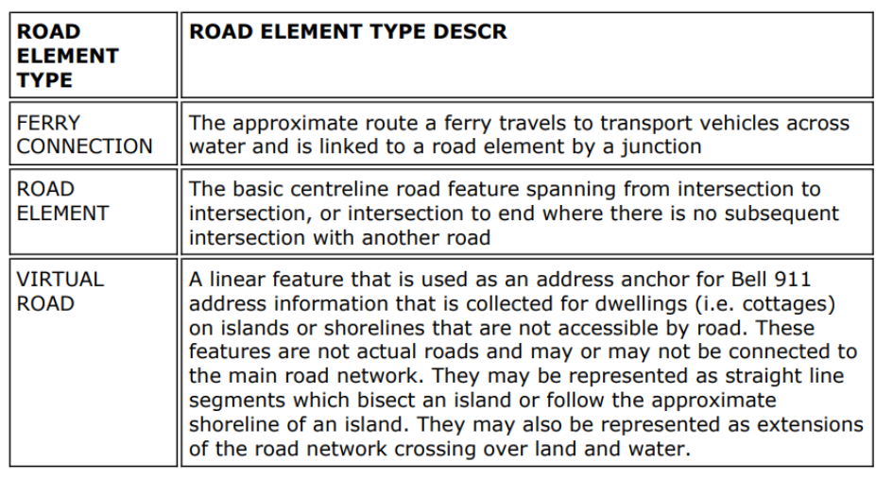
Figure 3: Descriptions of road element types from the ORN dataset, including ferry connections, standard road elements, and virtual roads used for addressing in inaccessible areas
Figure 3: Descriptions of road element types from the ORN dataset, including ferry connections, standard road elements, and virtual roads used for addressing in inaccessible areas.
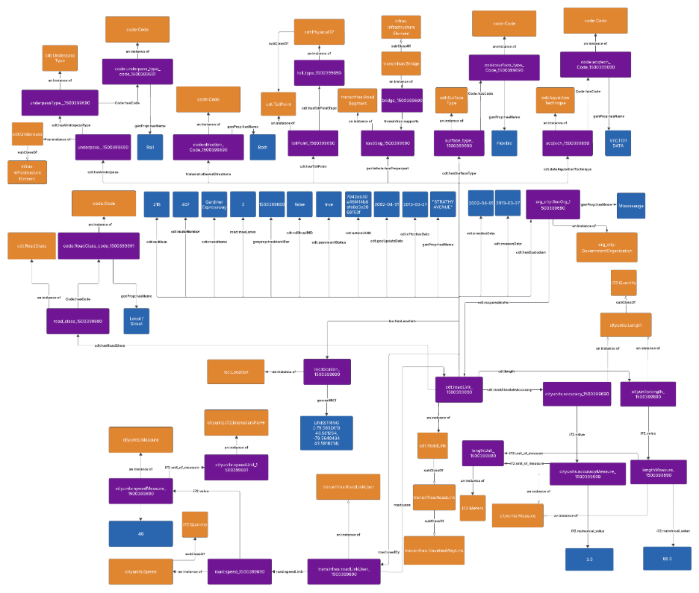

Figure 4: Example Mapping for ORN’s representation of a Road Link to the City Digital Twin Road Network Pattern.

All the following properties are for associated with the cdt:RoadLink class, which is a subclass of the RoadLink class in the TransportationInfrastructure ontology.

Data Provided by ORN_ROAD_NET_ELEMENT.shp:
Field Name | Subject | Property | Object | Notes
OGF_ID | orn:roadLink_{OGF_ID} | genprop:hasIdentifier | {OGF_ID} | A unique numeric provincial identifier assigned to each object.
 | orn:roadLink_{OGF_ID} | rdf:type | cdt:RoadLink
TO_JCT | orn:roadLink_{OGF_ID} | transnet:to | orn:Junction_{JUNCTION_ID} | The end junction for a road element or ferry connection.
FROM_JCT | orn:roadLink_{OGF_ID} | transnet:from | orn:Junction_{JUNCTION_ID} | The beginning junction for a road element or ferry connection.
NID | orn:roadLink_{OGF_ID} | cdt:nationUUID | {NID} | A unique national identifier assigned to a road net element, junction and selected event data such as Toll Point, Blocked Passage and Structure which are required to support the National Road Network (NRN).
DIRECTION | orn:roadLink_{OGF_ID} | transnet:allowedDirections | code:Code | The direction(s) of vehicular or motor traffic flow. All road elements must have a direction of traffic flow assigned. Mapped using an enumeration class to capture semantic direction values (Positive, Negative, Both) in accordance with ISO 5087-3.
EXIT_NUM | orn:roadLink_{OGF_ID} | cdt:exitNum | {EXIT_NUM} | The number of an exit on or off a freeway, expressway or highway, assigned by an administrating body and is represented by a valid number or character.
TOLL_ROAD | orn:roadLink_{OGF_ID} | cdt:tollRoad | xsd:boolean | Indicates if the road net element is a toll road.
ACQTECH | orn:roadLink_{OGF_ID} | cdt:dataAquisitionTechnique | orn:acqtech_ {OGF_ID} | The type of data source or technique used to create or revise the road net element.  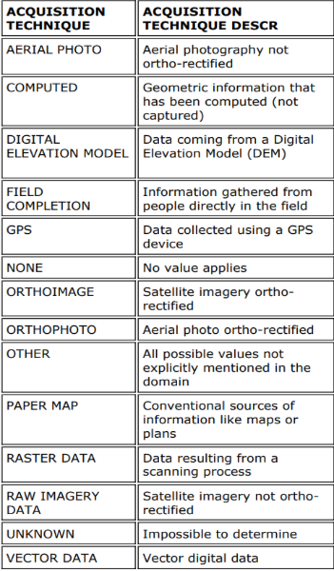
 | orn:acqtech_ {OGF_ID} | rdf:type | cdt: AquisitionTechnique
 | orn:acqtech_ {OGF_ID} | code:Code | code:acqtech Code_ {OGF_ID}
 | code:acqtech Code_ {OGF_ID} | genprop:hasName | {ACQTECH}
CREDATE | orn:roadLink_{OGF_ID} | cdt:creationDate | {CREDATE} | The date the road net element was originally created.
REVDATE | orn:roadLink_{OGF_ID} | cdt:revisionDate | {REVDATE} | The date the road net element was last revised or updated.
GEO_UPD_DT | orn:roadLink_{OGF_ID} | cdt:geoUpdateDate | {GEO_UPD_DT} | Date/time the geometry was created or last modified in the source database.
EFF_DATE | orn:roadLink_{OGF_ID} | cdt:effectiveDate | {EFF_DATE} | Date/time the record was created or last modified in the source database.
LENGTH | orn:roadLink_{OGF_ID} | cdt:length | cityunits:length_{OGF_ID} | The measured planimetric length of a road net element in meters.
 | cityunits:length_{OGF_ID} | rdf:type | cityunits:Length
 | cityunits:length_{OGF_ID} | i72:hasValue | cityunits: lengthMeasure_{OGF_ID}
 | cityunits: lengthMeasure_{OGF_ID} | rdf:type | cityunits: Measure
 | cityunits: lengthMeasure_{OGF_ID} | i72:hasUnit | i72:metre
 | cityunits: lengthMeasure_{OGF_ID} | i72:hasNumericalValue | {LENGTH}
ACCURACY | orn:roadLink_{OGF_ID} | cdt:roadAbsoluteAccuracy | cityunits: accuracy_{OGF_ID} | A statement that identifies the positional accuracy of the ORN road geometry, in metres.
 | cityunits: accuracy_{OGF_ID} | rdf:type | cityunits:Length
 | cityunits:accuracy_{OGF_ID} | i72:hasValue | cityunits:accuracy Measure_ {OGF_ID}
 | cityunits:accuracy Measure_ {OGF_ID} | rdf:type | cityunits: Measure
 | cityunits:accuracy Measure_ {OGF_ID} | i72:hasUnit | i72:metre
 | cityunits:accuracy Measure_ {OGF_ID} | i72:hasNumericalValue | {LENGTH}
geometry | orn:roadLink_{OGF_ID} | loc:hasLocation | loc:roadLinkLocation_{OGF_ID} | Geometry attribute.
 | loc:roadLinkLocation_{OGF_ID} | geo:asWKT | {geometry}

Table 4: Mapping ORN_ROAD_NET_ELEMENT.shp Road Link data to City Digital Twin
Table 3: Mapping ORN_ROAD_NET_ELEMENT.shp Road Link data to City Digital Twin

ORN_SPEED_LIMIT.csv: The maximum speed limit assigned to a road element in kilometres per hour in accordance with Municipal By-Laws or Provincial Law. In cases where a road element has more than one speed limit value, the speed limit of the longest portion of the road element is supplied.
Data Provided by ORN_SPEED_LIMIT.csv:
Field Name | Subject | Property | Object | Notes
SPEED_LIMIT | orn: typicalRoadLinkUser | rdf:type | cdt:RoadLinkUser | The maximum speed limit assigned to a road element in kilometres per hour in accordance with Municipal By-Laws or Provincial Law.  Property of a RoadLinkUser, and is linked with corresponding RoadLink using road:usedBy and road:uses properties.  cityunits:Speed
 | orn: typicalRoadLinkUser | cdt:speedLimit | cityunits:speed_{OGF_ID}
 | cityunits:speed_{OGF_ID} | rdf:type | cityunits: speedLimit
 | cityunits:speed_{OGF_ID} | i72:hasValue | cityunits: speedMeasure_{OGF_ID}
 | cityunits: speedMeasure_{OGF_ID} | rdf:type | cityunits: Measure
 | cityunits: speedMeasure_{OGF_ID} | i72: hasNumericalValue | {SPEED_LIMIT}
Table 5: Mapping ORN_SPEED_LIMIT.csv to City Digital Twin
Table 3: Mapping ORN_SPEED_LIMIT.csv to City Digital Twin

ORN_ROAD_CLASS.csv: A linear event identifying the class of road based on a functional classification schema.
Data Provided by ORN_ROAD_CLASS.csv:
Field Name | Subject | Property | Object | Notes
ROAD_CLASS | orn:roadLink_{OGF_ID} | cdt:hasRoadClass | orn:roadClass_{OGF_ID} | The classification of a road.  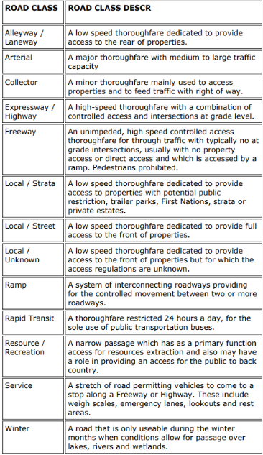
 | orn:roadClass_{OGF_ID} | rdf:type | cdt:RoadClass
 | orn:roadClass_{OGF_ID} | code:Code | code:roadClass_ Code_ {OGF_ID}
 | code:roadClass_ Code_ {OGF_ID} | genprop:hasName | {ROAD_CLASS}
Table 6: Mapping ORN_ROAD_CLASS.csv to City Digital Twin
Table 4: Mapping ORN_ROAD_CLASS.csv to City Digital Twin

ORN_OFFICIAL_STREET_NAME.csv: An event identifying an official street name and may be associated with a bilingual name.

Data Provided by ORN_OFFICIAL_STREET_NAME.csv:
Field Name | Subject | Property | Object | Notes
FULL_STREET_NAME | orn:roadLink_{OGF_ID} | genProp:hasName | { FULL_STREET_NAME} | This attribute is derived from the individual street name components where present, namely directional prefix, street type prefix, street name body, street type suffix and directional suffix and is stored in upper case text.

Table 7: Mapping ORN_OFFICIAL_STREET_NAME.csv Road Link data to City Digital Twin
Table 5: Mapping ORN_OFFICIAL_STREET_NAME.csv Road Link data to City Digital Twin

Table 6: Mapping ORN_BLOCKED_PASSAGE.csv to City Digital Twin
ORN_JURISDICTION.csv: Identifies jurisdictional, or custodianship, responsibility of the road
Data Provided by ORN_JURISDICTION.csv:
Field Name | Subject | Property | Object | Notes
JURISDICTION | orn:roadLink_{OGF_ID} | cdt:hasCustodian | org:govOrg_{OGF_ID} | An indication of who has the jurisdictional, or custodianship responsibility for a road net element. The custodian would have the responsibility to ensure maintenance occurs, but is not necessarily the one who undertakes the maintenance directly.
 | org:govOrg_{OGF_ID} | rdf:type | org:Government Organization
 | org:govOrg_{OGF_ID} | genprop:hasName | {JURISDICTION}
Table 9: Mapping ORN_JURISDICTION.csv to City Digital Twin
Table 7: Mapping ORN_JURISDICTION.csv to City Digital Twin
ORN_ROAD_SURFACE.csv: The surface type of a road element.
Data Provided by ORN_ROAD_SURFACE.csv:
Field Name | Subject | Property | Object | Notes
SURFACE_TYPE | orn:roadLink_{OGF_ID} | cdt:hasSurfaceType | orn:surface_type_{OGF_ID} | A linear event indicating the surface type of a road element.  
 | orn:surface_type_{OGF_ID} | rdf:type | cdt:SurfaceType
 | orn:surface_ type_{OGF_ID} | code:Code | code:surfaceType_Code_{OGF_ID}
 | code:surface Type_Code_ {OGF_ID} | genprop:hasName | {SURFACE_TYPE }
PAVEMENT_STATUS | orn:roadLink_{OGF_ID} | cdt:pavementStatus | xsd:boolean | The surface type of a road element.
Table 10: Mapping ORN_ROAD_SURFACE.csv to City Digital Twin
Table 8: Mapping ORN_ROAD_SURFACE.csv to City Digital Twin

ORN_NUMBER_OF_LANES.csv: A linear event indicating the number of lanes.
Data Provided by ORN_NUMBER_OF_LANES.csv:
Field Name | Subject | Property | Object | Notes
NUMBER_OF_LANES | orn:roadLink_{OGF_ID} | cdt:numLanes | {NUMBER_OF_ LANES} | The number of lanes of a road.
Table 11: Mapping ORN_NUMBER_OF_LANES.csv to City Digital Twin
Table 9: Mapping ORN_NUMBER_OF_LANES.csv to City Digital Twin

ORN_ROUTE_NAME.csv: The name attached to a road net element as defined by a Municipality, Provincial Ministry, or Federal Agency and is associated to an established and/or maintained route.
Data Provided by ORN_ROUTE_NAME.csv
Field Name | Subject | Property | Object | Notes
ROUTE_NAME_ENGLISH | orn:roadLink_{OGF_ID} | cdt:routeName | {ROUTE_NAME_ENGLISH} | The English name that is attached to a road net element as defined by a Municipality, Provincial Ministry, or Federal Agency and is associated to an established and/or maintained route.
Table 12: Mapping ORN_ROUTE_NAME.csv to City Digital Twin
Table 10: Mapping ORN_ROUTE_NAME.csv to City Digital Twin
ORN_ROUTE_NUMBER.csv: The route number attached to a road net element as defined by a Municipality, Provincial Ministry, or Federal Agency and is typically associated with provincial highways, secondary highways, county roads and regional roads
Data Provided by ORN_ROUTE_NUMBER.csv:
Field Name | Subject | Property | Object | Notes
ROUTE_NUMBER | orn:roadLink_{OGF_ID} | cdt:routeNumber | {ROUTE_ NUMBER} | The route number assigned to a road typically associated with provincial highways, secondary highways, county roads and regional roads and is represented by a numeric and/or an alpha-numeric character. A road can be assigned multiple route numbers.
Table 13: Mapping ORN_ROUTE_NUMBER.csv to City Digital Twin
Table 11: Mapping ORN_ROUTE_NUMBER.csv to City Digital Twin

ORN_STRUCTURE.csv: The classification of a structure, that exists on a road element and is managed as a linear event. The types are mutually exclusive.

Data Provided by ORN_STRUCTURE.csv:
Field Name | Subject | Property | Object | Notes
STRUCTURE_TYPE | transnet: RoadSegment | transinfras:supports | Infras: {STRUCTURE_ TYPE}_{OGF_ID} | The classification of a structure, that exists on a road element and is managed as a linear event.  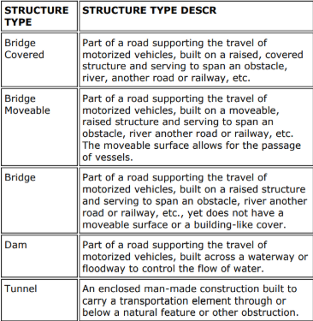
 | Infras: {STRUCTURE_ TYPE}_{OGF_ID} | rdf:type | Infras:  Infrastructure Element
Table 14: Mapping ORN_STRUCTURE.csv to City Digital Twin
Table 12: Mapping ORN_STRUCTURE.csv to City Digital Twin

ORN_TOLL_POINT.csv: A point event along a road element indicating the presence of a toll point.
Data Provided by ORN_TOLL_POINT.csv:
Field Name | Subject | Property | Object | Notes
TOLL_POINT_TYPE | orn:roadLink_{OGF_ID} | cdt:hasTollPoint | orn:tollPoint_ {OGF_ID} | A point event on a road element identifying the existence of an underpass. An underpass occurs where the road element runs underneath a passage accommodating the movement of water, a building, road, rail, pedestrian or wildlife.  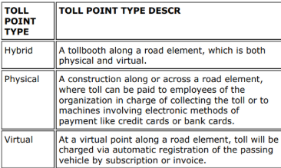
 | orn:tollPoint_ {OGF_ID} | rdf:type | cdt:TollPoint
 | orn:tollPoint_ {OGF_ID} | cdt:hasTollPointType | orn: {TOLL_POINT_ TYPE}_{OGF_ID}
 | orn: {TOLL_POINT_ TYPE}_{OGF_ID} | rdf:type | orn:{TOLL_POINT_TYPE}TP
Table 15: Mapping ORN_TOLL_POINT.csv to City Digital Twin
Table 13: Mapping ORN_TOLL_POINT.csv to City Digital Twin
ORN_UNDERPASS.csv: A point event on a road element identifying the existence of an underpass. An underpass occurs where the road element runs underneath a passage accommodating the movement of water, a building, road, rail, pedestrian or wildlife.

Data Provided by ORN_UNDERPASS.csv:
Field Name | Subject | Property | Object | Notes
UNDERPASS_TYPE | orn:roadLink_{OGF_ID} | cdt:hasUnderpass | orn:underpass_{OGF_ID} | Identifies the type of underpass present at this road location.  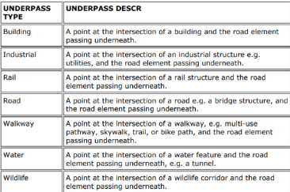
 | orn:underpass_{OGF_ID} | rdf:type | cdt:Underpass
 | orn:underpass_{OGF_ID} | cdt:hasUnderpass | orn: underpass_type_  {OGF_ID}
 | orn:underpass_type_{OGF_ID} | rdf:type | cdt:Underpass Type
 | orn:underpass_type_{OGF_ID | code:Code | code:underpass TypeCode_ {OGF_ID}
 | code:underpass TypeCode_ {OGF_ID} | genprop:hasName | {UNDERPASS_TYPE}
Table 16: Mapping ORN_UNDERPASS.csv to City Digital Twin
Table 14: Mapping ORN_UNDERPASS.csv to City Digital Twin
Data Provided by ORN Capacities
Field Name | Subject | Property | Object | Notes
Capacity | orn:roadLink_{OGF_ID} | res:hasCapacity | orn:roadLinkCapacity_{OGF_ID} | { SPEED_LIMIT}*{NUMBER_OF_LANES}*{C_DENSITY({ROAD_CLASS})} is a very rough approximation where C_DENSITY is a value dependent on ROAD_CLASS  {Capacity} * random.uniform(0.5, 0.95) is randomized use based on capacity;  Note that we can't really tell if it's over or under capacity without observing speed  C_DENSITY(ROAD_CLASS) = "Freeway",26,  "Expressway / Highway",24,  "Arterial",20,  "Collector",18,  "Ramp",22,  "Local / Street",12,  "Local / Strata",12,  "Local / Unknown",12,  "Service",10,  "Alleyway / Laneway",10,  "Resource / Recreation",16,  "Rapid Transit",28,  "Winter",18,  20 /* default if unmatched */
 | orn:roadLinkCapacity_{OGF_ID} | rdf:type | hp:VehicleThroughputRate
 | orn:roadLinkCapacity_{OGF_ID} | i72:hasValue | orn:roadLinkCapacityMeasure_{OGF_ID}
 | orn:roadLinkCapacityMeasure_{OGF_ID} | i72:hasNumericalValue | {SPEED_LIMIT}*{NUMBER_OF_LANES}*{C_DENSITY({ROAD_CLASS})}
 | orn:roadLinkCapacityMeasure_{OGF_ID} | i72:hasUnit | hp:vehicles_per_hour
 | orn:roadLink_{OGF_ID} | res:capacityInUse | orn:roadLinkCapacityUse_{OGF_ID}
 | orn:roadLinkCapacityUse_{OGF_ID} | rdf:type | hp:VehicleThroughputRate
 | orn:roadLinkCapacityUse_{OGF_ID} | i72:hasValue | orn:roadLinkCapacityUseMeasure_{OGF_ID}
 | orn:roadLinkCapacityUseMeasure_{OGF_ID} | i72:hasNumericalValue | {Capacity} * random.uniform(0.5, 0.95)
 | orn:roadLinkCapacityUseMeasure_{OGF_ID} | i72:hasUnit | hp:vehicles_per_hour
 | orn:roadLink_{OGF_ID} | res:hasAvailableCapacity | orn:roadLinkCapacityAvail_{OGF_ID}
 | orn:roadLinkCapacityAvail_{OGF_ID} | rdf:type | hp:AvailableVehicleThroughputRate
 | orn:roadLinkCapacityAvail_{OGF_ID} | i72:hasValue | orn:roadLinkCapacityAvailMeasure_{OGF_ID}
 | orn:roadLinkCapacityAvailMeasure_{OGF_ID} | i72:hasNumericalValue | {Capacity} - {Capacity In Use}
 | orn:roadLinkCapacityAvailMeasure_{OGF_ID} | i72:hasUnit | hp:vehicles_per_hour
Table 17: Mapping ORN Capacity to City Digital Twin

Integration ofImplementation of ORN Data in Mapping to TTL Generation
All URIs are generated using a consistent base namespace (https://standards.iso.org/iso-iec/5087/-3/ed-1/en/ontology/TransportationNetwork/). Instances of RoadLink, Junction, and related classes are assigned URIs using their source dataset identifiers (e.g., OGF_ID, FROM_JCT) to ensure traceability. For example, RoadLinks use the format trans:roadLink_{OGF_ID} and Junctions use trans:junction_{JCT_ID}. This ensures each instance is uniquely and consistently defined in the RDF graph.
Inputs:
- ORN_ROAD_NET_ELEMENT.shp (road geometries and metadata)
- ORN_OFFICIAL_STREET_NAME.csv (maps road segments to names)
- ORN_JUNCTION.csv (contains coordinates and types of junctions)
- Other CSVs: speed limits, number of lanes, surface type, jurisdiction, etc.
Outputs
- Turtle (.ttl) RDF file that semantically represents Toronto's road network that instantiates:
  - transinfras:Road entities
  - transinfras:RoadLink entities
  - transinfras:Junction entities

Step 1: Load and Prepare Data
- Load the shapefile and merge it with all relevant CSV files based on OGF_ID and ORN_ROAD_NET_ELEMENT_ID.
- Convert key identifiers to strings to ensure compatibility for merging and URI construction.

Step 2: Filter Geographic Bounds
- Define a bounding box for the City of Toronto.
- Ensure only roads and junctions within these bounds are processed.

Step 3: Create Junction Instances
- For each junction in ORN_JUNCTION.csv, create a transinfras:Junction (a subclass of transnet:TransportNode).
- Assign each junction a geospatial location using geo:asWKT within the geo:Geometry class.

Step 4: Group and Construct Road Entities
- Group road segments by FULL_STREET_NAME_road_names.
- For each unique group (i.e., road name), create a transinfras:Road entity.
- Assign metadata like road name, jurisdiction, and pavement status.

Step 5: Construct Road Links
- For each segment in the road group:
  - Instantiate a transinfras:RoadLink.
  - Set partwhole:properPartOf to point to the parent Road.
  - Set geo:asWKT location geometry.
  - Add attributes like speed limit, number of lanes, direction, road class, and others.
  - Set transnet:from and transnet:to relationships to link the RoadLink to its associated Junction entities.

Step 6: Associate RoadLinks with Roads
- After creating RoadLinks, collect and link them to their parent Road using partwhole:hasProperPart.

Step 7: Serialize TTL Output
- The final RDF graph is serialized to Turtle (.ttl) format for loading into graph systems.

Notes:
- The OGF_ID is used as the unique identifier for road links (ensuring traceability back to the source dataset).
- Dates (creation, revision, geo update, and effective) are formatted using a utility function to XSD-compatible ‘YYYY-MM-DD’ format.
- Optional attributes are conditionally added based on their availability.
- All custom or non-ISO properties use the CDT namespace.
- This structured pipeline ensures that each ORN road element is correctly modeled according to ISO 5087-3, respecting semantic constraints and spatial relationships.

Custom CDT Classes and Properties
The following custom classes and properties were are introduced as part of the City Digital Twin project ontology, extending the ISO/IEC 5087 ontologies to capture the information defined in the ORN data.
- Junction: defined as a specialization of transnet:Junction. This class introduces additional characteristics of a junction, such as the junction type and exit number. The full set of additional properties defined for Junction are listed below.
  - hasJunctionType: the hasJunctionType property is a defined property for the cdt:Junction class. In the context of the ORN mapping, hasJunctionType was defined to identify the number of road elements or ferry connections that converge at that point, thus making the junction classified under a JunctionType
  - exitNumber: the exitNumber property is a defined property for the cdt:Junction class. In the context of the ORN mapping, exitNumber was defined to identify the exit number assigned to a freeway, expressway, or highway by an administrative authority, represented by a valid number or character.
  - nationUUID: the nationUUID is a defined property for the cdt:Junction class. In the context of the ORN mapping, nationUUID was defined to assign the unique identifier for the junction, which is required to support the National Road Network (NRN).
  - effectiveDate: the effectiveDate is a defined property for the cdt:Junction class. In the context of the ORN mapping, effectiveDate was defined to assign the date and time when the record of the junction was initially created or most recently updated in the source database.
- RoadLink: defined as a specialization of transnet:RoadLink. This class introduces additional characteristics of a roadlink, such as the surface type and structure type. The full set of additional properties defined for RoadLink are listed below.
  - exitNumber: the exitNumber property is a defined property for the cdt:RoadLink class. In the context of the ORN mapping, exitNumber was defined to identify the exit number assigned to a freeway, expressway, or highway by an administrative authority, represented by a valid number or character.
  - numLanes: the numLanes property is a defined property for the cdt:RoadLink class. In the context of the ORN mapping, numLanes was defined to identify the number of lanes of a road.
  - nationUUID: the nationUUID is a defined property for the cdt:RoadLink class. In the context of the ORN mapping, nationUUID was defined to assign the unique identifier for the Road Link, which is required to support the National Road Network (NRN).
  - effectiveDate: the effectiveDate is a defined property for the cdt:RoadLink class. In the context of the ORN mapping, effectiveDate was defined to assign the date and time when the record of the Road Link was initially created or most recently updated in the source database.
  - roadAbsoluteAccuracy: the roadAbsoluteAccuracy is a defined property for the cdt:RoadLink class. In the context of the ORN mapping, roadAbsoluteAccuracy was defined to indicate the positional accuracy of the ORN road geometry, measured in meters using the Length class specified in the ISO/IEC 5087-1.
  - Length: the Length is a defined property for the cdt:RoadLink class. In the context of the ORN mapping, Length was defined to indicate the measured horizontal (planimetric) length of a road network element, expressed in meters, using the Length class specified in ISO/IEC 5087-1.
  - tollRoad: the tollRoad is a defined property for the cdt:RoadLink class. In the context of the ORN mapping, tollRoad was defined to specify whether the road network element is designated as a toll road.
  - dataAquisitionTechnique: the dataAquisitionTechnique is a defined property for the cdt:RoadLink class. In the context of the ORN mapping, dataAquisitionTechnique was defined to indicate the type of data source or method used to create or update the road network element.
  - creationDate: the creationDate is a defined property for the cdt:RoadLink class. In the context of the ORN mapping, creationDate was defined to assign the date and time when the record of the Road Link was initially created in the source database.
  - revisionDate: the revisionDate is a defined property for the cdt:RoadLink class. In the context of the ORN mapping, revisionDate was defined to assign the date and time when the record of the Road Link was last revised or updated in the source database.
  - geoUpdateDate: the geoUpdateDate is a defined property for the cdt:RoadLink class. In the context of the ORN mapping, geoUpdateDate was defined to assign he date and time when the geometry was originally created or most recently modified in the source database.
  - hasSurfaceType: the hasSurfaceType is a defined property for the cdt:RoadLink class. In the context of the ORN mapping, hasSurfaceType was defined to indicate the linear event that describes the type of surface for a road element.
  - pavementStatus: the hasSurfaceType is a defined property for the cdt:RoadLink class. In the context of the ORN mapping, hasSurfaceType was defined to indicate whether the surface of the road element is paved or not.
  - routeName: the routeName is a defined property for the cdt:RoadLink class. In the context of the ORN mapping, routeName was defined to indicate the English name assigned to a road network element by a municipality, provincial ministry, or federal agency, associated with an established and/or maintained route.
  - routeNumber: the routeNumber is a defined property for the cdt:RoadLink class. In the context of the ORN mapping, routeNumber was defined to indicate the route number assigned to a road, commonly linked to provincial highways, secondary highways, county roads, or regional roads, represented by a numeric or alphanumeric character. A single road may have multiple route numbers.
  - hasTollPoint: the hasTollPoint is a defined property for the cdt:RoadLink class. In the context of the ORN mapping, hasTollPoint was defined to indicate a point event that specifies the type of toll point located along a road element. These can instances of PhysicalTP, VirtualTP, or HybridTP (sub classes of TollPoint class).
  - hasUnderpass: the hasUnderpass is a defined property for the cdt:RoadLink class. In the context of the ORN mapping, hasUnderpass was defined to indicate the underpass object that is on the road element. An underpass occurs where the road element runs underneath a passage accommodating the movement of water, a building, road, rail, pedestrian or wildlife.
  - hasRoadClass: the hasRoadClass is a defined property for the cdt:RoadLink class. In the context of the ORN mapping, hasRoadClass was defined to indicate the classification of the road in which the road element makes up.
  - hasCustodian: the hasCustodian is a defined property for the cdt:RoadLink class. In the context of the ORN mapping, hasCustodian was defined to indicate that the road element has a government organization as its custodian.
  - responsibleFor: the responsibleFor property is a defined property for the org:Organization class. It is defined with the following property chain, according to properties already specified in ISO/IEC 5087-1 and ISO/IEC 5087-2:
org_s:hasPost o org_s:role o org:hasResource -> responsibleFor
The relationship is depicted in Figure 1. Note that the property is defined in terms of a post rather than an agent because an Organization will be responsible for a Resource regardless of whether an Agent (responsible for playing the role involved with the resource) exists. In the context of the ORN mapping, responsibleFor was defined to identify the relationship between a road element and the government organization that is responsible for it.
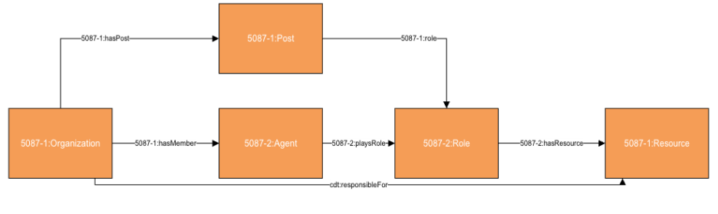
Figure 1: Definition of the responsibleFor property.
- Underpass: It describes a road or path that passes underneath another road. The full set of additional properties defined for Underpass are listed below:
  - hasUnderpassType: the hasUnderpassType is a defined property for the cdt:Underpass class. In the context of the ORN mapping, hasUnderpassType was defined to indicate the type of the underpass present in the location of the road element.
- UnderpassType: It describes the type of underpass intersecting a road (e.g., road, rail, water). The full set of additional properties defined for UnderpassType are listed below:

- SurfaceType: It describes the material used on the road surface (e.g., gravel, paved, dirt).. The full set of additional properties defined for SurfaceType are listed below:

- JunctionType: It describes the type of road junction based on connectivity (e.g., intersection, dead end). The full set of additional properties defined for JunctionType are listed below:

- AquisitionTechnique: It describes the method used to collect road data (e.g., GPS, aerial photo, field survey). The full set of additional properties defined for AquisitionTechnique are listed below:

- RoadClass: It describes a functional classification of the road (e.g., arterial, collector, freeway). The full set of additional properties defined for RoadClass are listed below:

- TollPoint: It describes a location where a fee must be paid in order to access an infrastructure element. The full set of additional properties defined for TollPoint are listed below:
  - hasTollPointType: the hasTollPointType is a defined property for the cdt:TollPoint class. In the context of the ORN mapping, hasTollPointType was defined indicate the type of toll system used at a toll point (e.g., physical, virtual).
- HybridTP: defined as a specialization of cdt:TollPoint. It’s a class describing a tollbooth along a road element, which is both physical and virtual. This class introduces additional characteristics of a toll point, such … type and … . The full set of additional properties defined for HybridTP are listed below.

- PhysicalTP: defined as a specialization of cdt:TollPoint. It’s a class describing a construction along or across a road element, where toll can be paid to employees of the organization in charge of collecting the toll or to machines involving electronic methods of payment like credit cards or bank cards. This class introduces additional characteristics of a toll point, such as … and … . The full set of additional properties defined for PhysicalTP are listed below.

- VirtualTP: defined as a specialization of cdt:TollPoint. It’s a class describing a virtual point along a road element, toll will be charged via automatic registration of the passing vehicle by subscription or invoice. This class introduces additional characteristics of a junction, such as ... and … .The full set of additional properties defined for VirtualTP are listed below.

- BridgeCovered: defined as a specialization of transinfras:Bridge. Its a class describing part of a road supporting the travel of motorized vehicles, built on a raised, covered structure and serving to span an obstacle, river, another road or railway, etc. This class introduces additional characteristics of a junction, such as … and … . The full set of additional properties defined for BridgeCovered are listed below.

- BridgeMoveable: defined as a specialization of transinfras:Bridge. Its a class describing part of a road supporting the travel of motorized vehicles, built on a moveable, raised structure and serving to span an obstacle, river another road or railway, etc. The moveable surface allows for the passage of vessels. This class introduces additional characteristics of a bridge, such as … type and … . The full set of additional properties defined for BridgeMoveable are listed below.

- Dam: A Dam is a type of Infrastructure Element. It describes a part of the road supporting the travel of motorized vehicles, built across a waterway or floodway to control the flow of water. It may contain some Dam Segments. A Dam is identified as such by a governing body. The full set of additional properties defined for Dam are listed below:
  - Identifies Travelled Way Segments that are supported by (i.e. travel over) the Dam, if any.
- RoadLinkUser: A RoadLink can be characterized by its capacity, the maximum number of lanes defined in the link, and RoadLinkUser characteristics that can define characteristics such as the speed limit or average travel time for the link based on the type of user. For example, the speed limit for lorries can be different than the speed limit for light duty vehicles.
  - speedLimit: the speedLimit property is a defined property for the cdt:RoadLink class. In the context of the ORN mapping, speedLimit was defined to identify the maximum speed limit assigned to a road element (measured in km/hr).

Class | Property | Value
cdt:Junction | rdfs:subClassOf | transnet:Junction
cdt:Junction | cdt:hasJunctionType | exactly 1 cdt:JunctionType
cdt:Junction | cdt:exitNumber | max 1 xsd:string
cdt:Junction | cdt:nationUUID | exactly 1 xsd:string
cdt:Junction | cdt:effectiveDate | max 1 xsd:Date
cdt:RoadLink | rdfs:subClassOf | transinfras:RoadLink
cdt:RoadLink | cdt:exitNumber | max 1 xsd:string
cdt:RoadLink | cdt:nationUUID | exactly 1 xsd:string
cdt:RoadLink | cdt:effectiveDate | max 1 xsd:Date
cdt:RoadLink | cdt:roadAbsoluteAccuracy | exactly 1 cityunits:Length
cdt:RoadLink | cdt:length | exactly 1 cityunits:Length
cdt:RoadLink | cdt:tollRoad | exactly 1 xsd:boolean
cdt:RoadLink | cdt:dataAquisitionTechnique | exactly 1 cdt:AquisitionTechnique
cdt:RoadLinkUser | cdt:speedLimit | max 1 cityunits:Speed
cdt:RoadLink | cdt:numLanes | max 1 xsd:integer
cdt:RoadLink | cdt:creationDate | max 1 xsd:date
cdt:RoadLink | cdt:revisionDate | max 1 xsd:date
cdt:RoadLink | cdt:geoUpdateDate | max 1 xsd:date
cdt:RoadLink | cdt:hasSurfaceType | exactly 1 cdt:SurfaceType
cdt:RoadLink | cdt:pavementStatus | exactly 1 xsd:boolean
cdt:RoadLink | cdt:routeName | exactly 1 xsd:string
cdt:RoadLink | cdt:routeNumber | exactly 1 xsd:string  Some are Alpha-Numeric Values
cdt:RoadLink | cdt:hasTollPoint | exactly 1 cdt:TollPoint
cdt:TollPoint | cdt:hasTollPointType | exactly 1 cdt:TollPoint
cdt:RoadLink | cdt:hasRoadClass | cdt:RoadClass
cdt:RoadLink | cdt:hasUnderpass | exactly 1 cdt:Underpass
cdt:Underpass | cdt:hasUnderpassType | cdt:UnderpassType
cdt:RoadLink | cdt:hasCustodian | exactly 1 city_org:GovernmentOrganization
org:Organization | cdt:responsibleFor | only resource:Resource
Table 17: Key properties in the City Digital Twin Road Network Pattern
Table 15: Key properties in the City Digital Twin Road Network Pattern

Class | Property | Value
cdt:UnderpassType | code:hasCode | code:Code
cdt:SurfaceType | code:hasCode | code:Code
cdt:JunctionType | code:hasCode | code:Code
cdt:AquisitionTechnique | code:hasCode | code:Code
cdt:RoadClass | code:hasCode | code:Code
cdt:Underpass | rdfs:subClassOf | transinfras:InfrastructureElement
cdt:TollPoint | cdt:tollPointType | cdt:TollPoint
cdt:HybridTP | rdfs:subClassOf | cdt:TollPoint
cdt:PhysicalTP | rdfs:subClassOf | cdt:TollPoint
cdt:VirtualTP | rdfs:subClassOf | cdt:TollPoint
cdt:BridgeCovered | rdfs:subClassOf | transinfras:Bridge
cdt:BridgeMoveable | rdfs:subClassOf | transinfras:Bridge
cdt:Dam | rdfs:subClassOf | infras:InfrastructureElement
 | transinfras:supports | transinfras:TravelledWaySegment
Table 18: Key classes in the City Digital Twin Road Network Pattern
Table 16: Key classes in the City Digital Twin Road Network Pattern

